CLIMATE CHANGE ALL OVER THE WORLD



SAMRA RASHID
Roll No: 47

BS ART & DESIGN
(Fine Arts)


DEPARTMENT OF ART AND DESIGN
UNIVERSITY OF PESHAWAR
Session 2022-2026

CLIMATE CHANGE ALL OVER THE WORLD
A thesis submitted to the Department of Art & Design in partial fulfillments for the requirements for the award of degree of BS Art & Design in Painting

By:
SAMRA RASHID

DEPARTMENT OF ART AND DESIGN
UNIVERSITY OF PESHAWAR
Session 2022-2026

CLIMATE CHANGE ALL OVER THE WORLD
Thesis project Report was submitted to the Department of Art &Design in partial fulfillment for the requirements for the award of the degree of
Bachelor in Art & Design in Painting

Submitted by: _____________________________
Samra Rashid
Bachelor of Art & Design
Painting
Session: 2022-2026

Research Supervisor: ____________________________
Ms. Sonia Rauf
Lecturer
Department of Art & Design
University of Peshawar

DEPARTMENT OF ART AND DESIGN
UNIVERSITY OF PESHAWAR

Session 2022-2026

DECLARATION

I hereby declare that this thesis, titled “Climate Change All over the World” is my original work and has not been submitted for any degree, diploma, or other academic qualification in any institution or university.
The research, design process, and findings presented in this report are based on my own work. All references, concepts, and contributions from other sources have been properly acknowledged. I further declare that the corporate identity system, vector graphic designs, branding materials, and promotional assets included in this thesis were developed by me as part of this research project, and any visual or written sources consulted during the study have been appropriately cited.
This thesis was carried out under the supervision of Ms. Sonia Rauf

___________________________
Samra Rashid

Date: ____ / ____ / 2026

ACKNOWLEDGMENT
I would like to express my sincere gratitude to my supervisor, Ms. Sonia Rauf, for her valuable guidance, encouragement, and continuous support throughout this study. Her suggestions and expertise greatly contributed to the completion of this thesis.
I am also thankful to the faculty members of my department for their assistance and for providing a supportive academic environment.
Special thanks go to my family and friends for their constant encouragement, understanding, and motivation during the course of this research.
Finally, I would like to thank everyone who directly or indirectly contributed to the successful completion of this thesis entitled “Climate Change All over the World”

Samra Rashid

TABLE OF CONTENTS

S. NO CONTENTS PAGE NO

ACKNOWLEDGMENT i
TABLE OF CONTENTS ii
ABSTRACT iv

Chapter-1 1
INTRODUCTION 1

1.1 Significance of the Study 5
1.2 Problem Statement 5
1.3 Research Objectives 5

Chapter-2 7
THE RESEARCH METHODOLOGY 7

2.1 Research Approach 7
2.2 Research Design 7
2.3 Data Collection Methods 8
2.3 (I) Literature Review 8
2.3 (II) Visual Research Method 8
2.3 (III) Studio Experimentation 9
2.4 Sampling Method 9
2.5 Tools and Materials 10
2.6 Data Analysis Methods 10
2.6 (I) Thematic Analysis 10
2.6 (II) Visual Analysis 11
2.7 Ethical Considerations 11
2.8 Limitations and Bias 12
2.9 Justification of Methodology 12

Chapter-3 13
THE DESIGN PROCESSES 13

3.1 Research Board 13
3.2 Rough Sketches of Paintings 14
3.3 Introduction 18
3.4 Theme One: Climate Change as a Human Experience 18
3.5 Theme Two: Use of Symbolism in Communicating Climate Change 18
3.6 Theme Three: Role of Color in Expressing Environmental Change 19
3.7 Theme Four: Importance of Composition and Visual Balance 19
3.8 Theme Five: Texture and Environmental Expression 20
3.9 Summary of Findings 20

Chapter-4 21
CATALOGING 21

4.1 Artwork Layout Description 21
4.2 Color Theme Explanation of the Painting Series 21
4.2.1 Painting 1 – The Anthropocene Countdown 23
4.2.2 Painting 2 – Atmospheric Toxicity and Urban Suffocation 25
4.2.3 Painting 3 – Ecological Disruption and Species Displacement 27
4.2.4 Painting 4 – Anthropogenic Fallout and Ecocide 29
4.2.5 Painting 5 – Marine Ecosystem Bifurcation and Arctic Degradation 31
4.2.6 Painting 6 – Anthropogenic Grief and Planetary Boundary Overdrive 33
4.2.7 Painting 7 – The Industrial Revolution and Linear Degradation 35
4.2.8 Painting 8 – The Abstract Textures of Global Warmth 37
4.3 Final Installation Display 39

Chapter-5 40
CONCLUSION 40

5.1 SWOT Analysis 40
5.1.1 Strengths 40
5.1.2 Weaknesses 40
5.1.3 Opportunities 41
5.1.4 Threats 41
5.2 Introduction 42
5.3 Discussion of Major Findings 42
5.4 Practical Implications 43
5.5 Limitations of the Study 43
5.6 Recommendations for Future Research 43
5.7 Conclusion 44

REFERENCES 46

ABSTRACT
Climate change has become one of the most significant global challenges affecting natural ecosystems, human societies, and environmental sustainability. Rising temperatures, environmental pollution, deforestation, melting glaciers, floods, droughts, and extreme weather conditions have created serious concerns for the future of the planet. Despite increasing scientific awareness, many environmental issues remain difficult for people to fully understand and emotionally connect with. Art, particularly painting, provides a powerful medium for communicating complex environmental concerns through visual expression, symbolism, and emotional engagement.
This study aimed to explore climate change as a visual and conceptual theme through painting. For this purpose, research was conducted on climate change, environmental degradation, ecological imbalance, environmental art, symbolism, and visual communication. Historical and contemporary artworks related to environmental issues and nature were also analyzed to understand different artistic approaches, themes, and visual strategies.
Based on this research, a series of paintings was developed through sketching, visual research, experimentation, color studies, and studio practice. Various visual elements such as symbolism, composition, texture, atmosphere, and color relationships were explored to communicate the impact of climate change and environmental transformation. The artworks were created to represent environmental concerns not only as scientific issues but also as emotional and human experiences that affect both nature and society.
The findings suggested that painting can effectively communicate climate change through symbolic imagery, emotional atmosphere, visual storytelling, and expressive techniques. The study highlighted the importance of artistic practice in raising environmental awareness and demonstrated how visual language can encourage reflection, understanding, and public engagement with ecological issues. Overall, the project showed that painting can serve as a powerful medium for communicating climate change and promoting greater awareness of environmental responsibility and sustainability.

Chapter-1

INTRODUCTION
Climate change had become one of the most significant environmental challenges affecting societies around the world. Rising global temperatures, melting glaciers, extreme weather events, floods, droughts, wildfires, and increasing pollution had altered natural ecosystems and threatened human well-being. Scientists and environmental organizations had continuously warned that climate change was no longer a future concern but an ongoing global crisis requiring immediate attention (IPCC, 2021). These environmental changes had influenced not only scientific and political discussions but had also inspired responses within visual arts and creative practices.
Art had historically functioned as a powerful medium for communicating social, cultural, and environmental concerns. Through visual representation, artists had interpreted complex issues and transformed them into meaningful experiences for audiences. Painting in particular had provided opportunities to express emotions, ideas, and observations through color, texture, symbolism, and composition (Berger, 1972). Environmental themes had increasingly appeared within contemporary art practices as artists sought to raise awareness about ecological degradation and climate-related issues (Gablik, 1991).
Research suggested that visual communication played an important role in shaping public understanding of environmental issues. Scientific reports often contained complex information that could be difficult for general audiences to interpret. Artistic representation offered an alternative method of communication by translating environmental concerns into emotional and visual experiences. Environmental art had therefore become an important tool for increasing awareness and encouraging public engagement with climate-related topics (Curtis, 2009).
Studies on environmental art explained that artistic practices encouraged reflection on humanity’s relationship with nature. Artists had used landscapes, symbolism, and conceptual imagery to explore environmental destruction and ecological imbalance. Such artworks often invited viewers to reconsider their responsibilities toward the environment and sustainability (Kagan, 2011). Through painting, environmental concerns could be represented not only as scientific facts but also as emotional and human experiences.
Research highlighted that climate change affected both natural ecosystems and human communities. Rising temperatures had contributed to the melting of polar ice caps, increasing sea levels, biodiversity loss, and extreme weather conditions (IPCC, 2021). These environmental consequences had inspired many contemporary artists to address climate change through visual expression. Artistic interpretations had often focused on themes of fragility, loss, uncertainty, and resilience (Demos, 2016).
Visual arts had increasingly become a platform for environmental advocacy. Paintings, installations, and multimedia artworks had been used to communicate environmental concerns to wider audiences. Research showed that environmental art often encouraged emotional responses that strengthened awareness and understanding of ecological issues (Weintraub, 2012). Such approaches had been particularly important because emotional engagement frequently influenced public attitudes more effectively than scientific information alone (Curtis, 2009).
Studies in visual perception explained that colors, textures, and compositional structures significantly influenced how viewers interpreted artworks (Arnheim, 1974). Artists addressing climate change had often employed symbolic imagery and expressive visual language to communicate environmental concerns. Through the manipulation of visual elements, paintings could convey themes of environmental instability, destruction, and transformation (Ocvirk et al., 2012).
Research in contemporary art suggested that symbolism played an important role in communicating complex ideas. Environmental artists frequently used symbolic representations such as melting ice, barren landscapes, polluted waters, and damaged ecosystems to illustrate climate-related concerns (Demos, 2016). Symbolic imagery enabled audiences to engage with environmental issues on both intellectual and emotional levels.
Studies on color psychology indicated that colors influenced emotional perception and mood. Cool colors often represented nature, water, and environmental fragility, while warmer colors symbolized heat, danger, and ecological crisis (Eiseman, 2000). Artists addressing climate change had frequently employed contrasting color schemes to represent environmental conflict and transformation. Such visual strategies strengthened the communicative impact of artworks.
Research further suggested that texture and surface treatment contributed significantly to artistic expression. Layered surfaces, rough textures, and expressive brushwork had often been used to represent environmental damage and instability (Mayer, 1991). Through material experimentation, artists could create visual metaphors reflecting environmental disruption and ecological uncertainty.
Studies on ecological art emphasized that contemporary artists increasingly addressed sustainability and environmental responsibility within their creative practices (Weintraub, 2012). Environmental artworks often encouraged critical thinking and public dialogue regarding climate-related issues. Such artistic practices demonstrated that art could contribute to environmental awareness beyond traditional educational methods (Kagan, 2011).
Research in socially engaged art explained that artists had increasingly responded to global concerns through visual expression. Climate change had emerged as one of the most frequently explored environmental themes within contemporary artistic practice (Miles, 2014). Paintings inspired by environmental crises had provided opportunities to communicate ecological concerns through visual narratives and emotional engagement.
Studies on environmental communication suggested that audiences often responded more strongly to visual and emotional representations than to scientific data alone (Moser & Dilling, 2011). Artistic approaches therefore played an important role in making climate-related issues more accessible and understandable to broader audiences. Paintings could transform abstract environmental concepts into relatable visual experiences.
Research further indicated that environmental awareness required interdisciplinary approaches combining science, communication, education, and art (Klein, 2014). Visual arts had become increasingly important in supporting public understanding of environmental challenges. Through symbolic and conceptual representation, artists could communicate environmental concerns while encouraging reflection and discussion.
Studies on practice-based art research explained that artistic knowledge developed through experimentation, making, and reflective practice (Gray & Malins, 2004). Such approaches enabled artists to explore complex themes through direct engagement with materials and creative processes. Practice-based methodologies had therefore become important within contemporary art research.
Research highlighted that climate change was often represented through photography, digital media, and installation art; however, fewer studies had focused specifically on painting as a primary medium for communicating environmental concerns (Demos, 2016). This suggested a need for further exploration of painting as a form of environmental communication and artistic advocacy.
Environmental crises such as deforestation, air pollution, flooding, and rising temperatures had continued to affect communities worldwide (United Nations, 2021). Artists had increasingly sought ways to visually document and interpret these changes. Through painting, environmental experiences could be transformed into meaningful visual narratives capable of inspiring awareness and reflection.
Contemporary painting had therefore provided opportunities to bridge the gap between scientific knowledge and public understanding. Through visual storytelling, symbolism, texture, color, and composition, climate change could be communicated in ways that were emotionally engaging and conceptually meaningful (Gablik, 1991; Miles, 2014).
This study, titled "Climate Change All Over the World," aimed to explore how painting could visually communicate environmental concerns and climate-related issues through artistic experimentation and conceptual development. The research focused on translating environmental themes into paintings that reflected both the physical realities and emotional consequences of climate change. Through practice-based exploration, the study sought to demonstrate the potential of painting as a medium for environmental awareness, visual communication, and social engagement.

1.1 Significance of the Study
This study was important because it explored the relationship between environmental awareness and visual art. It demonstrated how painting could be used as a medium for communicating climate change and ecological concerns. The research contributed to contemporary art practices by encouraging environmental engagement through creative expression. It could be useful for artists, researchers, educators, and environmental advocates interested in using visual communication to address global environmental challenges. The study also highlighted the role of painting in raising awareness and encouraging reflection on climate change and sustainability.

1.2 Problem Statement
Despite increasing global awareness of climate change, limited research had explored how painting could systematically communicate environmental concerns through visual language and artistic expression. Many environmental discussions had remained scientific and technical, making them less accessible to wider audiences. Therefore, there was a need to investigate how painting could be used to visually represent climate change and promote environmental awareness through meaningful artistic practice.

1.3 Research Objectives
The main objectives of this study were:
- To explore climate change as a source of inspiration for painting.
- To analyze environmental issues associated with climate change around the world.
- To investigate how visual elements could communicate environmental concerns.
- To develop paintings inspired by climate change and ecological challenges.
- To explore the role of symbolism in representing environmental issues.
- To examine how color, texture, and composition contributed to environmental storytelling.
- To create visually engaging artworks that raised awareness about climate change.
- To contribute to practice-based art research through environmental painting.

Chapter-2

THE RESEARCH METHODOLOGY

2.1 Research Approach
This study used a qualitative and practice-based research approach. The purpose of selecting this method was to explore climate change through visual interpretation and artistic expression. Rather than relying on numerical data, the research focused on observation, environmental analysis, conceptual development, and studio experimentation. The qualitative approach helped in understanding environmental issues and translating them into meaningful visual representations through painting.
Practice-based research was considered suitable because knowledge and understanding developed through the process of creating artworks. Through sketching, experimentation, reflection, and painting, the researcher explored different ways of communicating climate change and environmental concerns.

2.2 Research Design
The research was based on a practice-based artistic design process that focused on developing paintings inspired by climate change.
The process followed a structured sequence of stages:
- At the beginning, climate change issues and environmental concerns were explored.
- After that, visual references and supporting information were collected from different sources.
- In the next stage, concepts, sketches, and composition ideas were developed.
- Different painting experiments were conducted to explore visual possibilities.
- Finally, the artworks were evaluated and refined based on conceptual and aesthetic considerations.
This step-by-step process ensured that the final paintings effectively communicated environmental concerns through visual language.

2.3 Data Collection Methods
To gather information for this study, different methods were applied.

2.3 (I) Literature Review
A literature review was conducted to understand climate change and environmental issues. Books, journal articles, environmental reports, and academic publications were reviewed.
Topics included:
- Global warming
- Environmental pollution
- Floods and droughts
- Melting glaciers
- Wildfires
- Ecological destruction
This review provided a theoretical foundation for the development of the painting series.

2.3 (II) Visual Research Method
Visual research was used to collect imagery and references related to climate change.
The visual research included:
- Environmental photographs
- Documentary images
- Landscape studies
- Climate change reports
- Environmental artworks
- Online visual archives
This method helped in understanding visual characteristics associated with environmental crisis and inspired the development of compositions and symbolism.

2.3 (III) Studio Experimentation
Studio experimentation formed the central part of the research process.
Different painting studies were created to investigate:
- Color relationships
- Texture development
- Symbolic imagery
- Composition
- Environmental storytelling
Various painting techniques were explored through practical experimentation. The findings from these experiments contributed to the development of the final painting series.

2.4 Sampling Method
The study used purposive sampling for selecting visual references and environmental themes.
Specific climate-related issues were selected because of their relevance to the research objectives.
The selected themes included:
- Global warming
- Pollution
- Floods
- Drought
- Melting glaciers
- Wildfires
These themes represented significant environmental challenges occurring around the world and provided meaningful subject matter for artistic exploration.

2.5 Tools and Materials
Several tools and materials were used to support research, experimentation, and painting development.
Sketchbooks were used for recording ideas, observations, and preliminary drawings. These sketches helped in exploring compositions and symbolic imagery before the final artworks were developed.
Books, research articles, environmental reports, and online resources were used to gather information about climate change and environmental issues.
Canvas surfaces were used as the primary support for painting development.
Oil paints and acrylic paints were used during the practical experimentation and artwork production stages. These materials allowed the researcher to explore color, texture, layering, and atmospheric effects.
Brushes, palette knives, primers, and painting mediums were also used throughout the studio process.
Digital tools such as Adobe Photoshop were used for organizing visual references and planning compositions when required.
Photography was used to document the development process and record completed artworks.

2.6 Data Analysis Methods

2.6 (I) Thematic Analysis
The collected information was analyzed through thematic analysis.
Environmental issues and climate-related concerns were grouped into major themes such as:
- Environmental destruction
- Global warming
- Ecological imbalance
- Pollution
- Natural disasters
These themes guided the conceptual development of the painting series.

2.6 (II) Visual Analysis
Visual analysis was used to evaluate the artworks and experimental studies.
The paintings were examined according to:
- Symbolic representation
- Emotional expression
- Composition
- Color relationships
- Texture development
- Environmental communication
This analysis helped in identifying the most successful visual approaches for communicating climate change.

2.7 Ethical Considerations
Ethical principles were followed throughout the study.
All environmental information was collected from publicly available academic and research sources.
Photographic references used for artistic inspiration were acknowledged appropriately when required.
The research aimed to raise awareness about climate change through artistic practice while maintaining academic integrity and responsible use of information.

2.8 Limitations and Bias
This research had certain limitations.
The study focused primarily on painting practice and did not include audience surveys or public exhibition evaluation.
Time constraints limited the number of artworks that could be produced during the research period.
The interpretation of climate change remained subjective because artistic expression varied according to individual perspectives and experiences.
To reduce bias, multiple visual references, environmental sources, and experimental approaches were explored throughout the research process.

2.9 Justification of Methodology
The selected methodology was appropriate because it combined environmental research with artistic practice. The literature review provided an understanding of climate change, while visual research offered inspiration and contextual information.
Studio experimentation enabled direct exploration of artistic possibilities and allowed environmental concerns to be translated into visual form.
Thematic and visual analysis supported the evaluation of artworks and helped refine the final painting series.
This methodology therefore supported the development of meaningful paintings that communicated climate change through visual expression, symbolism, and environmental storytelling.

Chapter-3

THE DESIGN PROCESSES

3.1 Research Board

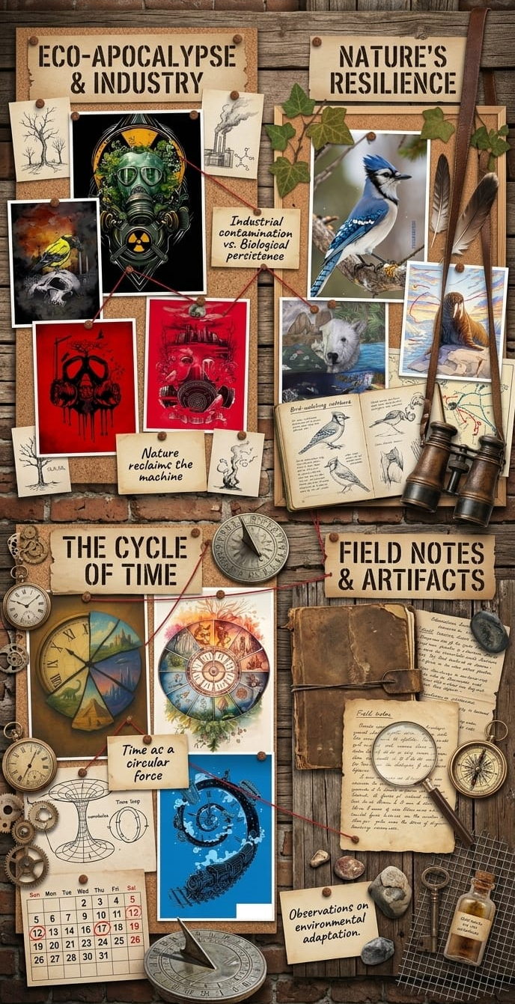

3.2 Rough Sketches of Paintings

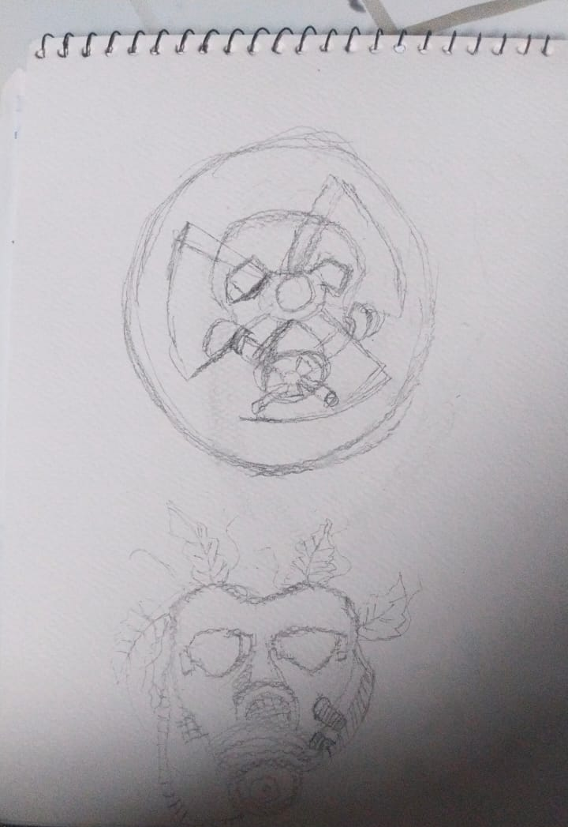

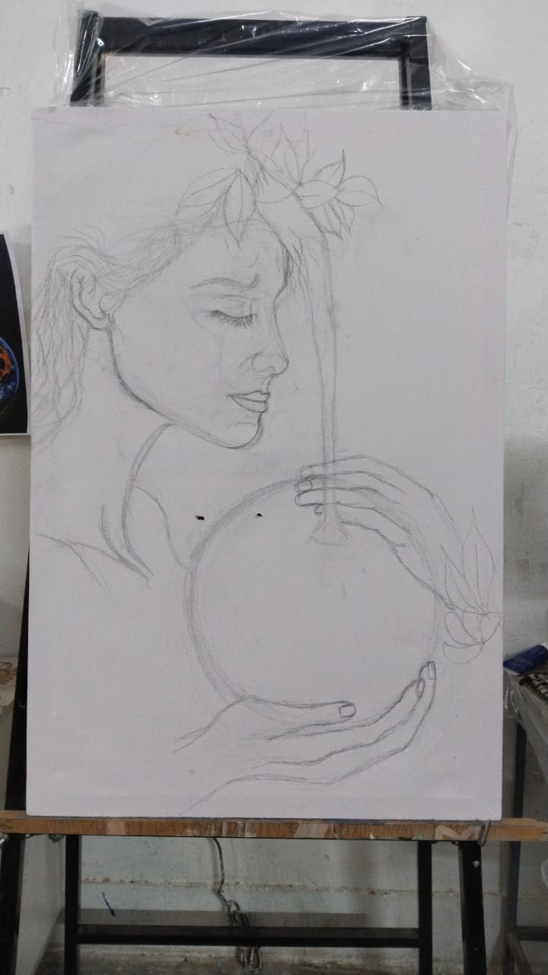

Work Progress

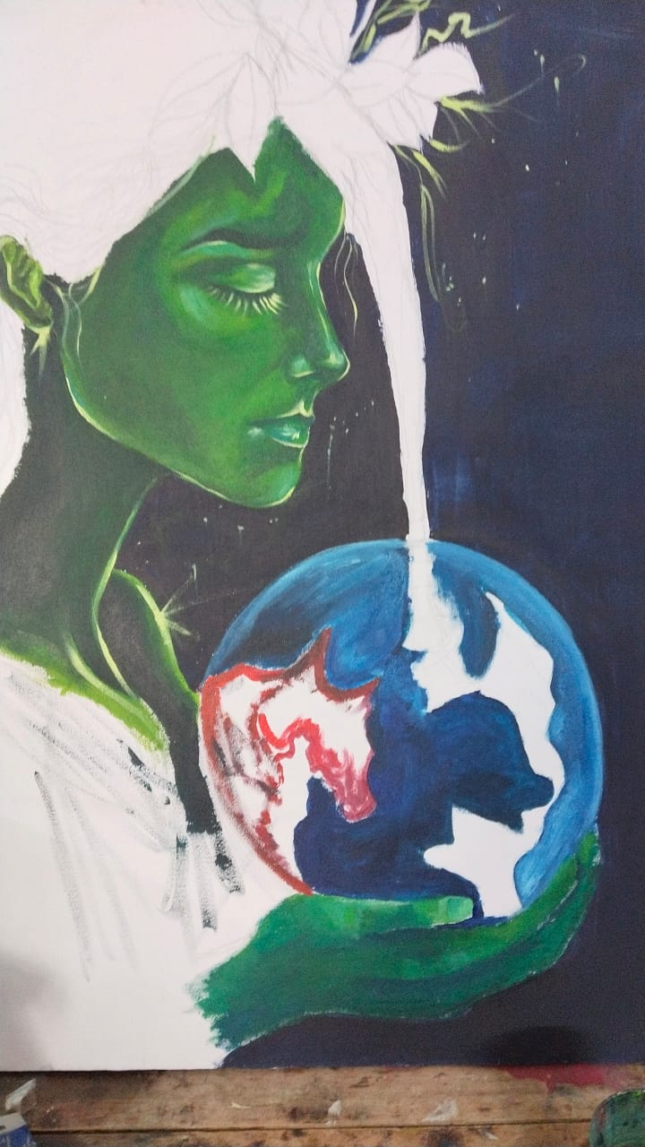

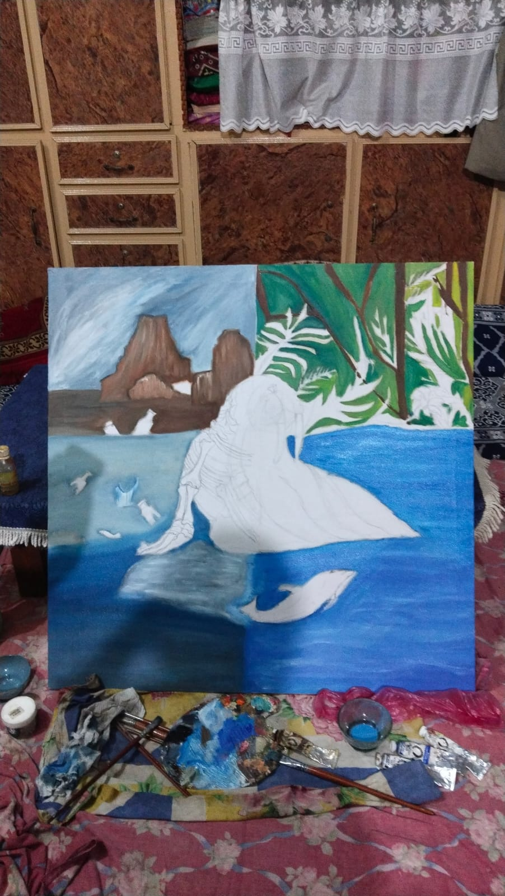

3.3 Introduction
This chapter presents the findings gathered through visual research, artwork analysis, studio experimentation, and reflective artistic practice conducted for the project titled Climate Change All Over the World. The findings were analyzed through thematic organization in order to identify visual elements, symbolic representations, and emotional qualities associated with climate change and environmental issues in painting.
The results are presented according to the major themes that emerged during the creative process. Each theme highlights specific observations, artistic discoveries, and visual strategies that contributed to the development of the final paintings. The findings focus on environmental symbolism, emotional expression, color relationships, composition, texture, and visual communication related to the representation of climate change.

3.4 Theme One: Climate Change as a Human Experience
Throughout the research process, climate change emerged not only as an environmental issue but also as a human experience that affects emotions, lifestyles, and future generations. During the early stages of experimentation, different visual approaches were explored to understand how environmental concerns, uncertainty, loss, hope, and resilience could be communicated through painting.
The visual studies revealed that climate change was more effectively expressed when human figures and emotional narratives were combined with environmental imagery. The interaction between people and nature created stronger emotional responses and encouraged viewers to reflect on the consequences of environmental degradation.
This finding suggests that climate change can be communicated as a personal and emotional experience rather than simply as a scientific phenomenon.

3.5 Theme Two: Use of Symbolism in Communicating Climate Change
Symbolism emerged as an important visual strategy throughout the artistic development process. Various symbols including trees, birds, flowers, water, clouds, light, cracked landscapes, and human figures were explored in sketches and painting experiments.
These symbols were selected because they represented environmental balance, biodiversity, hope, destruction, renewal, and the relationship between humanity and nature. The study found that symbolic imagery became more effective when integrated naturally into the composition rather than presented in a literal manner.
The findings indicate that symbolism helps communicate complex environmental issues while allowing viewers to develop personal interpretations and emotional connections with the artworks.

3.6 Theme Three: Role of Color in Expressing Environmental Change
Color played a significant role in communicating the atmosphere and emotional impact of climate change within the paintings. Different color palettes were tested during the experimentation stage to evaluate their visual effectiveness and emotional influence.
The findings showed that cool blues, greens, and natural earth tones successfully represented environmental harmony, while darker tones, muted colors, and dramatic contrasts conveyed environmental degradation, uncertainty, and ecological imbalance. Balanced color relationships helped establish visual unity and strengthened the narrative qualities of the artworks.
The use of tonal variation and atmospheric color transitions contributed to the overall communication of environmental transformation. These observations demonstrate that color functions as a powerful visual language within climate change-inspired paintings.

3.7 Theme Four: Importance of Composition and Visual Balance
The study revealed that composition and visual balance significantly influenced the communication of environmental messages. Paintings that contained clear focal points, balanced arrangements, and meaningful spatial relationships created stronger visual impact and encouraged viewer engagement.
Open spaces were found to be particularly important because they emphasized environmental emptiness, isolation, and reflection. Compositions that contrasted healthy natural environments with damaged landscapes effectively highlighted the consequences of climate change.
This finding suggests that composition plays a vital role in guiding viewer interpretation and strengthening environmental awareness through painting.

3.8 Theme Five: Texture and Environmental Expression
Texture emerged as another important component during the painting process. Through layering, brushwork, and surface experimentation, texture added visual depth and environmental character to the artworks.
Smooth textures were used to represent harmony, stability, and natural balance, while rough and layered textures suggested pollution, destruction, environmental stress, and ecological transformation. The interaction of different surface qualities enhanced the visual storytelling process and strengthened the emotional impact of the paintings.
The findings indicate that texture functions not only as a technical element but also as an effective tool for communicating environmental conditions and ecological change.

3.9 Summary of Findings
The findings revealed five major themes including climate change as a human experience, symbolism as a visual language, the role of color in environmental communication, the importance of compositional balance, and the contribution of texture to environmental expression.
The results indicate that climate change can be effectively communicated through painting by combining environmental symbolism, expressive color relationships, balanced composition, atmospheric qualities, and textured surfaces. These findings guided the development of the final artworks and support the idea that painting can function as a powerful visual medium capable of raising awareness about climate change through emotional and symbolic representation.

Chapter-4

CATALOGING

4.1 Artwork Layout Description
The layout of this catalog is carefully structured to guide the viewer through a visual and conceptual exploration of global climate crisis, industrialization, and ecological decay under the theme Climate Change All Over the World. The catalog is organized systematically, presenting each painting alongside its formal title, a visual description, its symbolic interpretation, and its relevance to current global environmental data. This deliberate arrangement allows viewers to follow a logical progression, moving from the historical acceleration of time and industrial progress to the direct, devastating impacts on ecosystems, wildlife, and planetary health.
At the beginning of the catalog, the title and introductory framework establish the urgency of the anthropocene. This section provides the necessary context, prompting viewers to engage with the art not merely as aesthetic expressions, but as visual evidence of environmental degradation. The main body of the catalog gives each painting dedicated visual space to ensure that complex details—such as industrial smoke blending into clock faces, toxic motifs, and anatomical splits—can be studied without distraction.
The accompanying text bridges creative expression and climate reality, translating surrealist and metaphorical imagery into clear, impactful statements on pollution, global warming, and habitat loss. Finally, the concluding section synthesizes these visual warnings, leaving the viewer with a profound sense of responsibility and a call for ecological preservation.

4.2 Color Theme Explanation of the Painting Series
The painting series relies on a deliberate, high-contrast color palette designed to evoke tension, urgency, and the stark duality between a healthy planet and industrial destruction. Rather than using purely harmonious tones, these artworks juxtapose vibrant, life-giving natural colors with harsh, artificial, or toxic hues to emotionally engage the viewer in the climate crisis.

Primary Color Drivers
- Industrial Blacks, Ash Greys, and Charcoal: Used consistently across the series to represent carbon emissions, fossil fuel dependency, smoke, pollution, and the dead soot of heavy machinery.
- Fiery Crimson, Orange, and Volcanic Yellow: These warm, aggressive tones dominate the skies and backgrounds of multiple pieces. They symbolize global warming, rising temperatures, destructive wildfires, and the literal "burning" of our atmospheric stability.
- Toxic Neon Yellow-Green (Chartreuse): This chemically charged color represents radioactivity, industrial waste, pollution, and ecological sickness, serving as a visual alarm.

Secondary and Contrasting Tones
- Vibrant Sky Blues and Forest Greens: Representing the pristine state of nature, biodiversity, and life. These colors are intentionally fractured, split, or placed in direct opposition to the darker industrial tones to show how rapidly natural habitats are being encroached upon.
- Stark Monochromatic White: Utilized in key focal points—such as melting icebergs, bleaching bones, gas mask highlights, and endangered birds—to symbolize vulnerability, mortality, and the fading purity of the natural world.
Through smooth yet jarring transitions between these color families, the series moves away from passive observation. The color relationships force the viewer to experience the environmental crisis visually and emotionally, contrasting what the world once was with the toxic reality it faces today.
Here is the formal, research-focused analysis for the first four paintings in your series, explicitly structured for your Climate Change All Over the World catalog. These entries connect your visual metaphors directly to global environmental issues, data, and ecological concepts.

4.2.1 Painting 1 – The Anthropocene Countdown
- Visual Description: A circular canvas designed as a clock face, fractured into irregular segments by thick, dark lines. The upper hemisphere depicts a chronological progression of human development: a clean atmosphere, an undisturbed river ecosystem, a dense modern cityscape, and a dark, ruined post-industrial landscape spewing thick soot. The lower hemisphere features a heavily textured, cracked golden sundial with Roman numerals, where a single black hand points downward.
- Symbolic Interpretation & Research Context: This painting serves as a visual metaphor for the Doomsday Clock and the concept of the Anthropocene—the current geological age wherein human activity is the dominant influence on climate and the environment. The fracturing of the clock represents the destabilization of planetary boundaries. The transition from pristine nature to an ash-covered wasteland illustrates the historical acceleration of global carbon emissions since the Industrial Revolution. The downward-pointing hand signifies that humanity is rapidly running out of time to mitigate catastrophic global warming.
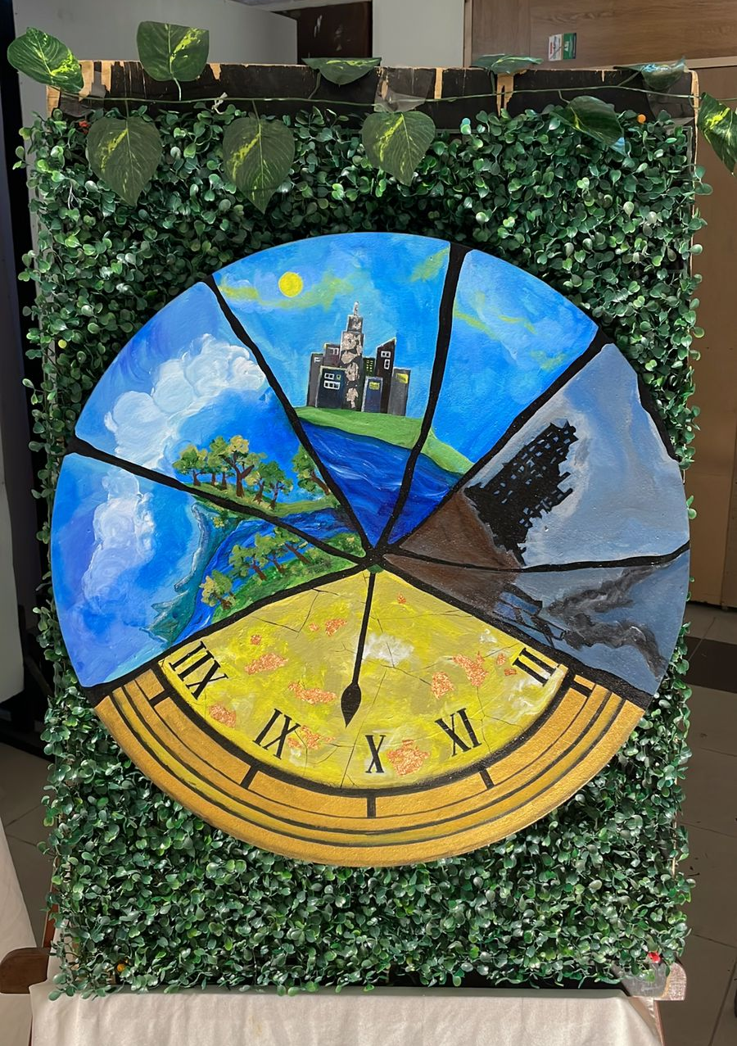

Painting 1 – The Anthropocene Countdown

4.2.2 Painting 2 – Atmospheric Toxicity and Urban Suffocation
- Visual Description: A vertical composition dominated by an intense crimson-red sky under a heavily cratered, grey full moon. A large, realistic black gas mask sits dead center, dripping dark fluid down the canvas. It is framed by the silhouettes of bare, skeletal trees and a modern high-rise city skyline. In stark contrast, two pristine white doves are perched symmetrically on the breathing filters of the mask.
- Symbolic Interpretation & Research Context: This artwork directly addresses ambient air pollution, greenhouse gas accumulation, and severe urban smog. The blood-red sky and dripping fluid symbolize the toxic heat-trapping greenhouse effect and fossil fuel dependency. The city skyline looming behind the gas mask highlights how unmonitored urbanization degrades air quality, posing a severe threat to public health and biodiversity. The doves represents environmental vulnerability; by perching on the very apparatus meant to filter toxicity, they symbolize the desperate struggle of fauna to survive in human-disrupted biomes.

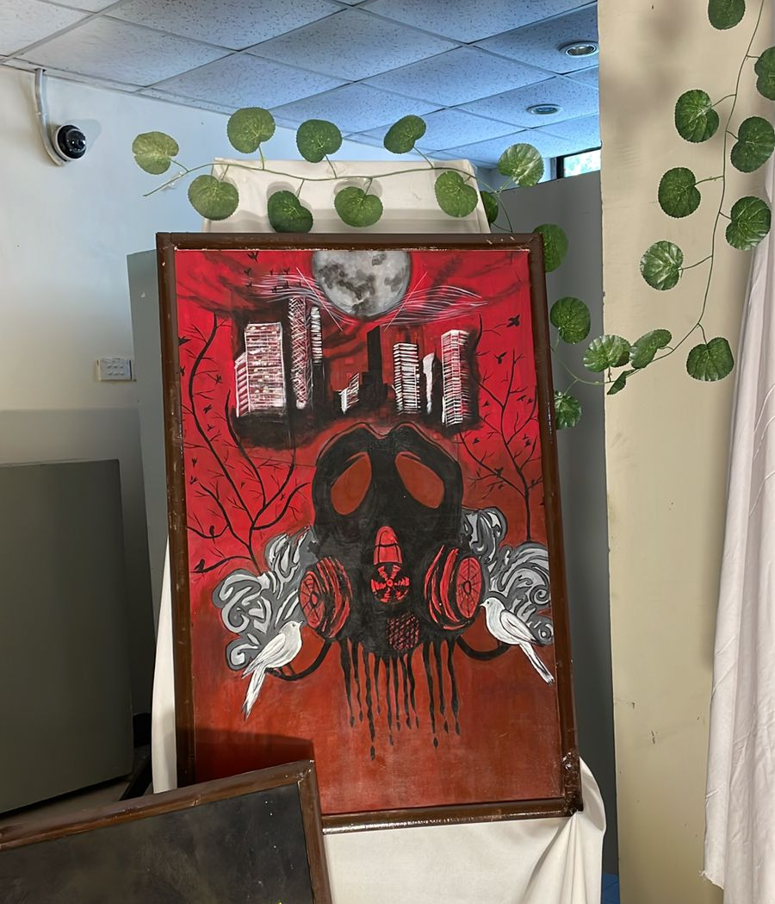

Painting 2 – Atmospheric Toxicity and Urban Suffocation

4.2.3 Painting 3 – Ecological Disruption and Species Displacement
- Visual Description: A detailed North American blue jay is depicted perched atop a weathered human skull. The background features a heavily polluted, hazy orange atmosphere filled with dark, silhouetted crows. In the distant landscape, industrial factory towers and skeletal infrastructure continuously vent emissions into the sky.
- Symbolic Interpretation & Research Context: This piece explores biodiversity loss, habitat fragmentation, and ecological collapse. The human skull acts as a dual symbol: it represents the destructive footprint of human greed and foreshadows the existential threat that climate change poses to humanity itself. The juxtaposition of the blue jay (a symbol of forest ecosystems) against the industrial backdrop highlights species displacement. As climate change alters habitats globally, native species are forced into hostile, polluted environments where invasive or opportunistic species (represented by the crows) thrive, disrupting established food webs.

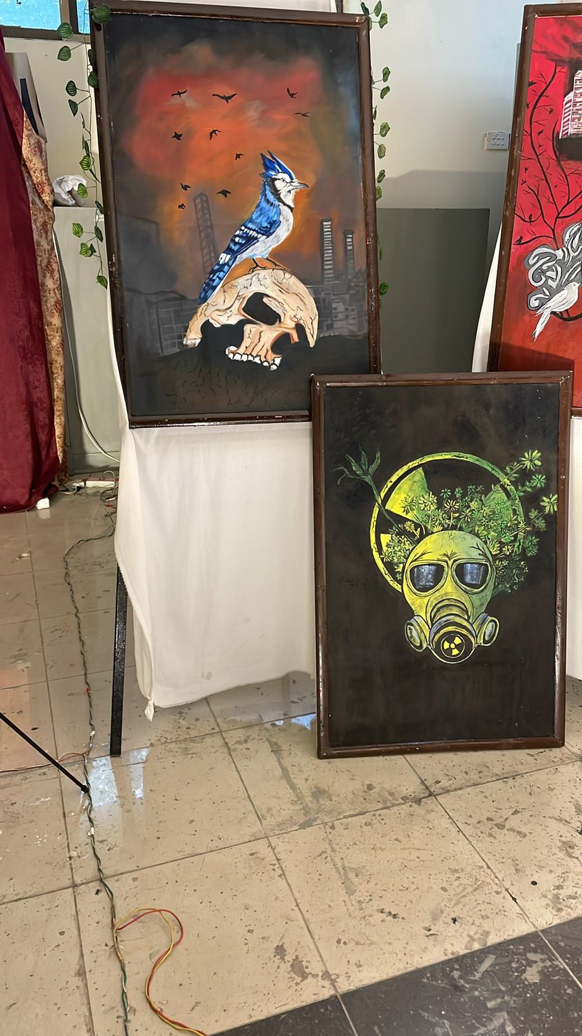

Painting 3 – Ecological Disruption and Species Displacement

4.2.4 Painting 4 – Anthropogenic Fallout and Ecocide
- Visual Description: A striking gas mask rendered in high-contrast, neon yellow-green tones sits against a stark, solid black background. A dense cluster of wild green foliage and small yellow wildflowers erupts directly from the top of the mask. Framing the figure from behind is a large, stylized yellow and black radioactive/nuclear hazard symbol.
- Symbolic Interpretation & Research Context: This painting references ecocide, industrial fallout, and nuclear/chemical pollution. The radioactive symbol and neon coloration represent the severe, long-lasting chemical interventions humans have inflicted upon the earth. However, the work introduces a powerful ecological concept: ecological succession and nature's resilience. The plants growing directly out of the toxic apparatus demonstrate how nature attempts to reclaim industrial waste sites and disaster zones (similar to the re-wilding observed in real-world exclusion zones), showing that life persists even after severe anthropogenic trauma.

Painting 4 – Anthropogenic Fallout and Ecocide

4.2.5 Painting 5 – Marine Ecosystem Bifurcation and Arctic Degradation
- Visual Description: A square canvas divided into four distinct quadrants, centering on a walrus resting on an isolated iceberg. The walrus is split completely down its axis: the anatomical right side shows a healthy, living marine mammal, while the left side is stripped down to its bare skeletal structure. The background mirrors this division. The healthy right hemisphere features a lush green jungle canopy and a vibrant blue ocean teeming with diverse marine life. The degraded left hemisphere depicts barren, eroded mountains and a murky, dark sea heavily polluted with floating plastic bottles, debris, and fish skeletons.
- Symbolic Interpretation & Research Context: This painting presents a stark visual data map of ocean acidification, marine plastic pollution, and the warming of the cryosphere. The walrus acts as an indicator species for Arctic and marine health. The sharp split across the canvas illustrates the accelerating bifurcation of global ecosystems due to human interference. The plastic debris and skeletal remains explicitly reference the crisis of anthropogenic marine litter and the resulting biodiversity collapse in global water bodies. It serves as a visual warning of what happens when planetary warming thresholds are crossed, contrasting a balanced holocene baseline with a dying, plastic-choked anthropocene future.
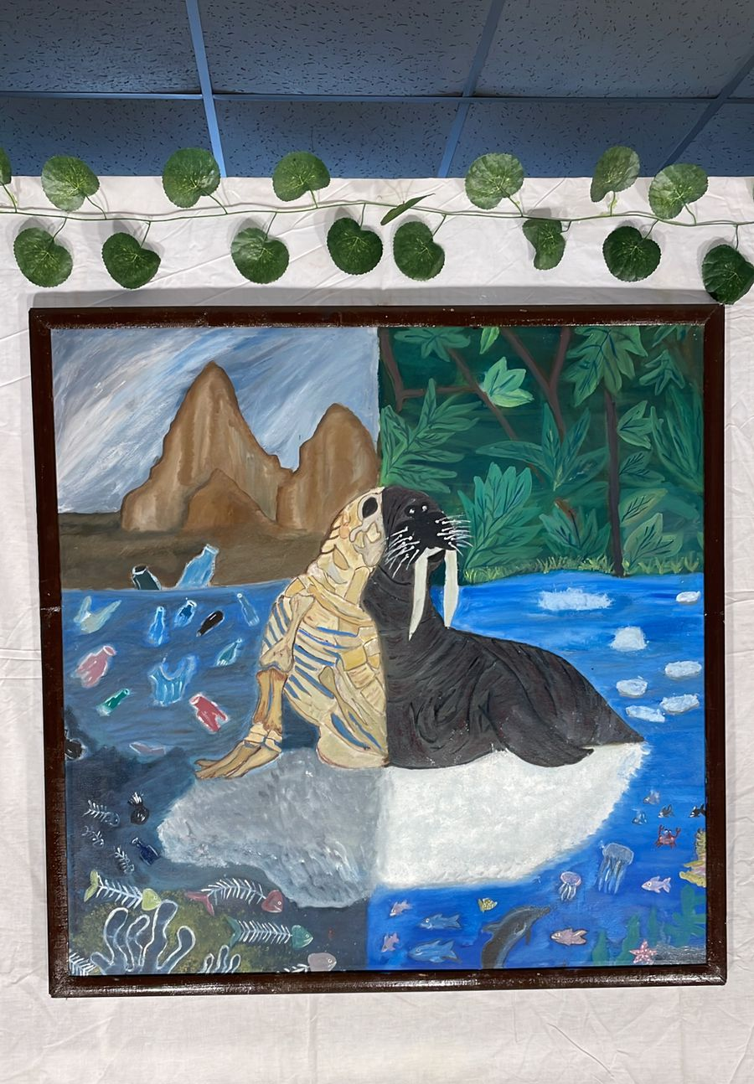

Painting 5 – Marine Ecosystem Bifurcation and Arctic Degradation

4.2.6 Painting 6 – Anthropogenic Grief and Planetary Boundary Overdrive
- Visual Description: A profile view of a green-skinned female figure representing Gaia (Mother Earth), depicted with her eyes closed in sorrow. Her hair is composed of thick, intertwining tree roots and vines that wrap around her face like a blindfold, shifting from natural brown to an ash-grey gradient. A pristine blue waterfall cascades from her crown, pouring down over a small globe cradled in her hands. This globe is engulfed in aggressive, fiery orange and red brushstrokes. The background transitions laterally, moving from a clean blue sky equipped with wind turbines on the left to a dark, soot-choked industrial landscape on the right.
- Symbolic Interpretation & Research Context: This painting represents the concept of ecological grief (eco-anxiety) and the physical toll of global environmental neglect. The burning globe held by the figure directly addresses global warming, escalating surface temperatures, and the global wildfire crisis affecting major biomes across Australia, the Amazon, and the boreal forests. The waterfall attempting to douse the flames symbolizes the earth's natural feedback loops trying desperately to regulate temperature, while the root blindfold represents humanity’s systemic refusal to address environmental degradation. The background contrasts the transition from sustainable green energy solutions (wind turbines) to heavily polluting, fossil-fuel-dependent industrial infrastructures.
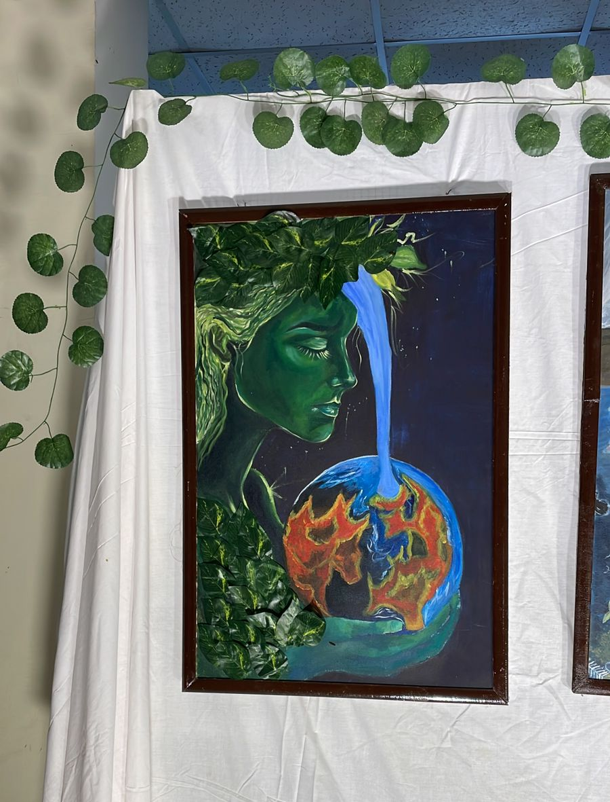

Painting 6 – Anthropogenic Grief and Planetary Boundary Overdrive

4.2.7 Painting 7 – The Industrial Revolution and Linear Degradation
- Visual Description: A vertical canvas dominated by a dramatic, fiery red and orange atmospheric sky filled with silhouetted, fleeing birds. A vintage steam locomotive powers forward along tracks, emitting dense columns of black smoke that settle over nuclear cooling towers and industrial power grids at the base. Positioned above the train is a surrealist, golden clock face that spirals inward toward a single green tree. The outer edge of this spiral transitions chronologically from a healthy, leafy green branch on the left into a fractured, dead, and barren vine on the right.
- Symbolic Interpretation & Research Context: This final painting synthesizes the historical trajectory of climate change, tracing it directly back to the Industrial Revolution. The locomotive train symbolizes the unstoppable, linear momentum of carbon-heavy industrial progress and economic expansion. The spiraling clock face illustrates how this rapid industrial acceleration has warped our relationship with time and natural resources, speeding up the destruction of ecological systems. The transition from a thriving green canopy to dead wood along the time spiral visually calculates the net loss of global forestry and carbon sinks over time, emphasizing that unchecked industrial momentum actively derails planetary stability.
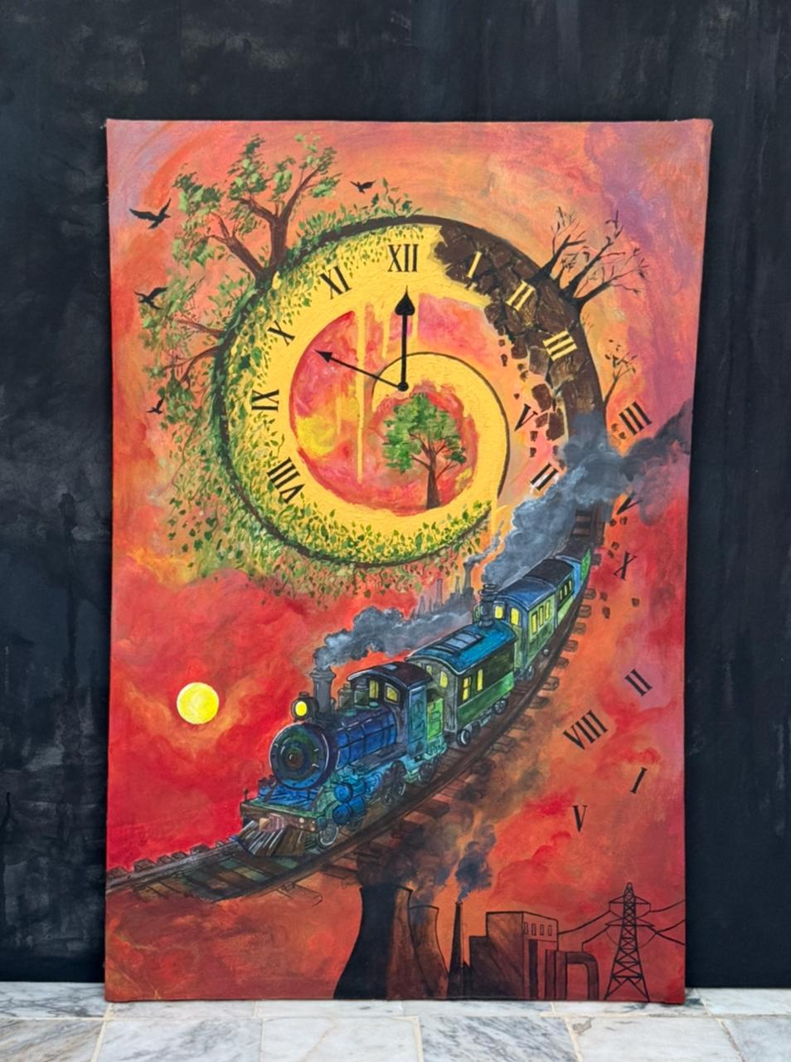

Painting 7 – The Industrial Revolution and Linear Degradation

4.2.8 Painting 8 – The Abstract Textures of Global Warmth
- Visual Description: An expressive, richly textured composition focusing heavily on color fields. It features deep, earthy ochre and gold undertones layered beneath stark charcoal slashes and hints of deep, cooling indigo blues at the base. The heavy application of paint creates a cracked, dry topography across the canvas surface.
- Symbolic Interpretation & Research Context: This painting represents an abstract visualization of desertification, soil degradation, and planetary heat retention. By removing literal figures, the piece forces the viewer to focus entirely on the physical texture of a parched, cracked earth surface under extreme thermal stress. The gold and amber tones evoke a sun-baked landscape stripped of its natural moisture, while the deep charcoal strokes represent the residual scarring left by industrial operations and resource extraction. It summarizes the overall series by shifting from specific ecological narratives to the raw, visceral state of a changing global climate
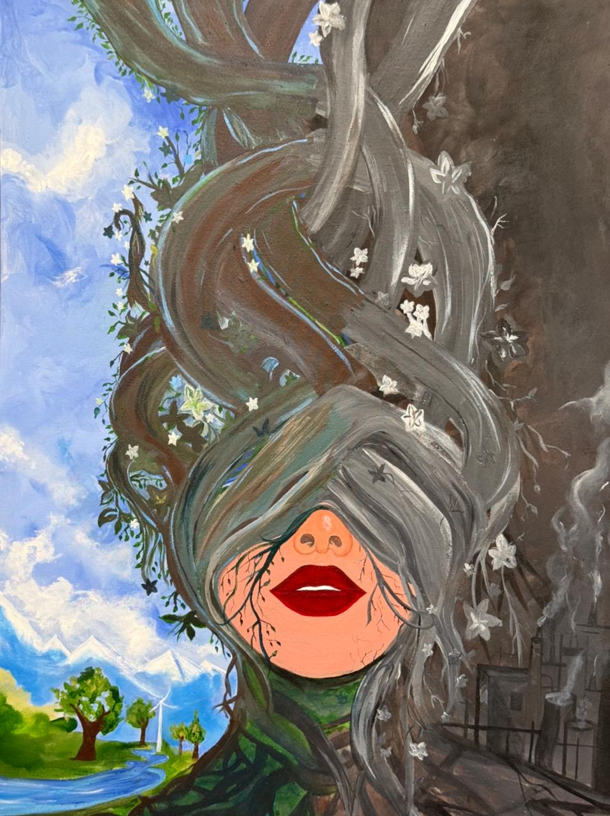
Painting 8 – The Abstract Textures of Global Warmth

4.3 Final Installation Display

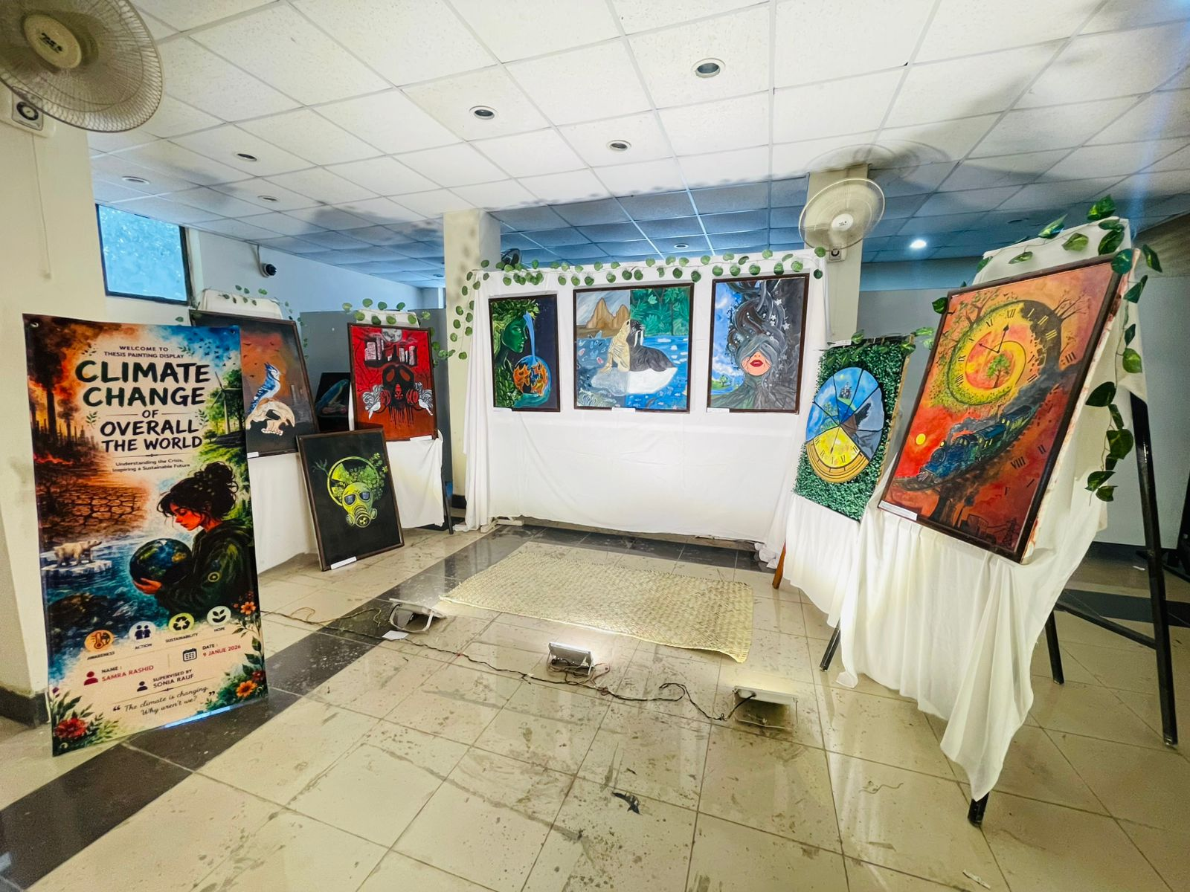
The final exhibition display effectively translates the academic framework of "Climate Change All over the World" into an immersive, three-dimensional spatial narrative by organizing the eight paintings into distinct thematic and chronological zones. A professional welcome standee establishes immediate educational context at the entrance, utilizing an illustration of Gaia holding a burning globe to anchor core pillars of awareness, action, and sustainability. To the left, a dense, low-level grouping of the industrial and gas mask canvases creates a claustrophobic atmosphere mirroring urban suffocation, while the center wall presents a balanced horizontal triptych of macro-environmental biomes. The curation concludes on the right wing, isolating the large circular clock canvas on an easel alongside the vintage locomotive painting to emphasize the accelerating timeline of the Anthropocene. This strategic layout, enhanced by low-angle floor spotlights that bring out the cracked, parched textures of the impasto paint, seamlessly integrates artificial green foliage across the partitions to visually emphasize how natural life is increasingly boxed in and constrained by industrial boundaries.

Chapter-5

CONCLUSION

5.1 SWOT Analysis

5.1.1 Strengths
The painting series developed in this study possessed several strengths that supported its purpose of creating awareness about climate change through visual art. One of the major strengths was its ability to communicate complex environmental issues through visual language, symbolism, and emotional expression. The paintings transformed scientific and environmental concerns into meaningful artistic experiences that could be understood by a wider audience.
Another strength was the use of environmental themes that were relevant to contemporary global concerns. Issues such as global warming, pollution, floods, droughts, melting glaciers, and wildfires were represented visually, making the artworks socially meaningful and educational. The combination of artistic creativity and environmental awareness strengthened the conceptual value of the project.
In the future, such artworks could contribute to environmental education, public exhibitions, and awareness campaigns aimed at encouraging reflection on climate-related challenges.

5.1.2 Weaknesses
The study also identified certain weaknesses within the project. One limitation was that the interpretation of paintings remained subjective because different viewers might understand the visual imagery in different ways. Some environmental messages could be interpreted differently depending on individual experiences and cultural backgrounds.
Another weakness was that the study focused primarily on artistic exploration and did not include audience evaluation or exhibition-based feedback. As a result, the effectiveness of the paintings in influencing public awareness could not be measured directly.
Time limitations also affected the number of artworks that could be developed during the research period. Future studies could expand the scope of experimentation and include larger painting series for deeper exploration.

5.1.3 Opportunities
The research highlighted numerous opportunities for future artistic and academic development. Growing public concern regarding climate change has increased interest in environmental communication and sustainability. This created opportunities for artists to contribute to environmental awareness through creative practice.
The paintings developed through this research could later be exhibited in galleries, educational institutions, environmental campaigns, and public awareness programs. Such opportunities could help communicate environmental concerns to broader audiences.
Future projects could also expand into interdisciplinary collaborations involving environmental scientists, educators, designers, and community organizations. These collaborations could strengthen the impact of environmental art and increase public engagement with climate-related issues.

5.1.4 Threats
The project could also face several external challenges. One major threat was the increasing volume of environmental information available through digital media and social networks. As a result, artworks addressing climate change might compete with many other forms of environmental communication.
Another challenge involved public indifference toward environmental issues. Some viewers might not fully engage with climate-related artworks because of limited interest in environmental concerns.
Changes in artistic trends and audience preferences could also influence the long-term visibility of environmental art. Therefore, artists addressing climate change would need to continuously explore innovative methods of visual communication to maintain audience engagement and relevance.

5.2 Introduction
This chapter discusses the major findings of the study in relation to previous literature, theoretical perspectives, and practical implications. The discussion explains how the research contributed to understanding the role of painting in communicating climate change and environmental awareness through visual expression.

5.3 Discussion of Major Findings
The findings demonstrated that painting effectively communicated environmental concerns through symbolism, color relationships, texture, and composition. The developed artworks translated climate-related issues into visual experiences that encouraged reflection and emotional engagement.
This finding supported previous research suggesting that visual art functioned as an important medium for communicating environmental and social concerns. Environmental themes became more accessible when represented through artistic interpretation rather than scientific information alone.
The study also revealed that symbolic imagery played a significant role in environmental communication. Visual elements such as melting forms, fragmented landscapes, polluted environments, and damaged ecosystems helped communicate the effects of climate change. These symbolic approaches strengthened the emotional impact of the paintings and encouraged deeper viewer engagement.
Another important finding involved the role of color and texture in representing environmental issues. Contrasting colors, layered surfaces, and expressive textures successfully communicated environmental instability, destruction, and ecological transformation. This finding supported theories of visual perception that emphasized the communicative power of artistic elements.
The paintings further demonstrated that environmental art could function as a bridge between scientific knowledge and public understanding. Through visual storytelling, climate change became more relatable and emotionally meaningful for viewers.

5.4 Practical Implications
The findings of this study provided valuable insights for artists, educators, researchers, and environmental advocates.
Artists could use environmental issues as sources of inspiration for developing meaningful and socially engaged artworks. Educational institutions could incorporate environmental themes into studio practice to encourage awareness and critical thinking among students.
The research also demonstrated that paintings could support environmental education by communicating climate-related concerns through visual language. Public exhibitions and awareness campaigns could use environmental artworks to promote discussion regarding sustainability and ecological responsibility.
Furthermore, the study highlighted the importance of integrating artistic practice with environmental awareness to address contemporary global challenges through creative means.

5.5 Limitations of the Study
This study was conducted within the scope of practice-based painting research and therefore had certain limitations.
The research focused primarily on the development of artworks and did not include audience surveys, exhibition evaluations, or large-scale public feedback. Consequently, the effectiveness of the paintings in influencing environmental awareness could not be measured quantitatively.
Time limitations also restricted the number of artworks that could be produced during the research period. Additionally, the interpretation of environmental themes remained subjective and could vary among different viewers.

5.6 Recommendations for Future Research
Future researchers may explore audience responses to climate change paintings and investigate how visual art influences environmental awareness and behavior.
Comparative studies between painting and other forms of environmental communication could provide deeper understanding of artistic effectiveness. Researchers may also examine interdisciplinary approaches that combine environmental science, digital media, and visual arts.
Future studies could further investigate the role of public exhibitions, community engagement projects, and environmental campaigns in strengthening the impact of climate-related artworks.
Research may also explore emerging technologies and multimedia approaches for communicating environmental concerns through artistic practice.

5.7 Conclusion
The study concluded that painting played an important role in communicating climate change and environmental awareness through visual expression. The research highlighted that climate change had become one of the most significant global challenges affecting natural ecosystems, human societies, and environmental sustainability. Issues such as global warming, pollution, floods, droughts, melting glaciers, and environmental degradation had created an urgent need for greater public awareness and engagement.
The developed painting series demonstrated that environmental concerns could be effectively translated into visual form through symbolism, color, texture, and composition. The artworks transformed complex environmental issues into meaningful visual experiences that encouraged reflection and emotional connection. Through artistic interpretation, climate change became more accessible and understandable for wider audiences.
The findings of the study showed that painting functioned as more than an aesthetic practice. It served as a powerful medium for environmental storytelling, social awareness, and conceptual communication. Symbolic imagery and visual experimentation strengthened the ability of the artworks to communicate environmental concerns while maintaining artistic depth and creativity.
Furthermore, the research contributed to the growing field of environmental art by integrating climate awareness with practice-based artistic exploration. The study demonstrated that painting could support environmental education and public engagement by translating ecological concerns into emotionally meaningful visual narratives.
Overall, the research demonstrated that visual art possessed significant potential for addressing contemporary environmental issues. Through thoughtful artistic practice, climate change could be communicated in ways that promoted awareness, encouraged reflection, and contributed to broader discussions regarding environmental responsibility and sustainability.

REFERENCES
Ambrose, G., & Harris, P. (2011). The fundamentals of creative design. AVA Publishing.
Arnheim, R. (1974). Art and visual perception: A psychology of the creative eye (Rev. ed.). University of California Press.
Berger, J. (1972). Ways of seeing. BBC and Penguin Books.
Bourriaud, N. (2002). Relational aesthetics. Les Presses du Réel.
Curtis, D. J. (2009). Creating inspiration: The role of the arts in creating empathy for ecological restoration. Ecological Management and Restoration, 10(3), 174–184.
Demos, T. J. (2016). Decolonizing nature: Contemporary art and the politics of ecology. Sternberg Press.
Eiseman, L. (2000). Pantone guide to communicating with color. Grafix Press.
Elkins, J. (2000). What painting is. Routledge.
Foster, H. (1996). The return of the real: The avant-garde at the end of the century. MIT Press.
Gablik, S. (1991). The reenchantment of art. Thames & Hudson.
Gombrich, E. H. (1995). The story of art (16th ed.). Phaidon Press.
Gray, C., & Malins, J. (2004). Visualizing research: A guide to the research process in art and design. Ashgate Publishing.
Grootenboer, H. (2005). The rhetoric of perspective: Realism and illusionism in seventeenth-century Dutch still-life painting. University of Chicago Press.
Harrison, C., & Wood, P. (Eds.). (2003). Art in theory 1900–2000: An anthology of changing ideas. Blackwell Publishing.
Intergovernmental Panel on Climate Change (IPCC). (2021). Climate change 2021: The physical science basis. Cambridge University Press.
Kagan, S. (2011). Art and sustainability: Connecting patterns for a culture of complexity. Transcript Verlag.
Klein, J. T. (2014). Interdisciplining digital humanities: Boundary work in an emerging field. University of Michigan Press.
Lacy, S. (Ed.). (1995). Mapping the terrain: New genre public art. Bay Press.
Mayer, R. (1991). The artist's handbook of materials and techniques (5th ed.). Viking Press.
McNiff, S. (1998). Art-based research. Jessica Kingsley Publishers.
Miles, M. (2014). Eco-aesthetics: Art, literature and architecture in a period of climate change. Bloomsbury Academic.
Moser, S. C., & Dilling, L. (2011). Communicating climate change: Closing the science-action gap. In J. S. Dryzek, R. B. Norgaard, & D. Schlosberg (Eds.), The Oxford handbook of climate change and society (pp. 161–174). Oxford University Press.
Ocvirk, O. G., Stinson, R. E., Wigg, P. R., Bone, R. O., & Cayton, D. L. (2012). Art fundamentals: Theory and practice (11th ed.). McGraw-Hill.
Paul, C. (2015). Digital art (3rd ed.). Thames & Hudson.
Reason, P., & Bradbury, H. (2008). The SAGE handbook of action research (2nd ed.). SAGE Publications.
Sullivan, G. (2010). Art practice as research: Inquiry in visual arts (2nd ed.). SAGE Publications.
Thompson, N. (2015). Seeing power: Art and activism in the twenty-first century. Melville House.
United Nations. (2021). United Nations climate action report. United Nations.
Weintraub, L. (2012). To life! Eco art in pursuit of a sustainable planet. University of California Press.
Wheeler, A. (2017). Designing brand identity (5th ed.). Wiley.
Wilson, S. (2002). Information arts: Intersections of art, science, and technology. MIT Press.

