  - FROM NARRATIVE TO FABRIC: TEXTILE DESIGN INSPIRED BY THE NOVEL MAALA


By
MASHAL
Roll No. 32
(Textile Design)


DEPARTMENT OF ART AND DESIGN
UNIVERSITY OF PESHAWAR
Session 2022-2026
  - FROM NARRATIVE TO FABRIC: TEXTILE DESIGN INSPIRED BY THE NOVEL MAALA
A thesis submitted to the Department of Art & Design in partial fulfilments for the requirements for the award of degree of BS Art & Design in Textile Design.

By
MASHAL

DEPARTMENT OF ART AND DESIGN
UNIVERSITY OF PESHAWAR
Session 2022-2026
  - FROM NARRATIVE TO FABRIC: TEXTILE DESIGN INSPIRED BY THE NOVEL MAALA
A thesis submitted to the Department of Art & Design in partial fulfillments for the requirements for the award of degree of BS Art & Design in Textile Design.
Bachelors in Art & Design in Textile Design
Submitted By: __________________________
Mashal
Bachelors in Art & Design
Textile Design
Session: 2022-2026

Research Supervisor: __________________________
Ms. Afsheen Zaman
Lecturer
Department of Art & Design
University of Peshawar

External Examiner: __________________________

DEPARTMENT OF ART AND DESIGN
UNIVERSITY OF PESHAWAR
Session 2022-2026

DECLARATION
I hereby declare that this thesis, titled “From Narrative to Fabric: Textile Design Inspired by the Novel Maala”, is my original work and has not been submitted for any degree, diploma, or other academic qualification in any institution or university.
The research, studio practice, and findings presented in this report are based on my personal work, and all references, ideas, and contributions from other sources have been properly acknowledged. I further declare that the textile designs and garments included in this thesis were created by me as part of this research project, and any visual or written sources consulted during the study have been appropriately cited.
This thesis was carried out under the supervision of Ms. Afsheen Zaman.

______________
Mashal

Date: ____ / ____ / 2026

ACKNOWLEDGMENT
All praise and gratitude are due to Almighty Allah for granting me the strength, patience, and ability to complete this thesis successfully.
I would like to express my sincere gratitude to my supervisor, Ms. Afsheen Zaman, for her valuable guidance, constructive feedback, and continuous support throughout this research and design project. Her encouragement, expertise, and insightful suggestions played a significant role in the successful completion of this study.
I am also thankful to the faculty members of the Department of Art and Design for their knowledge, assistance, and encouragement during my academic journey.
My heartfelt appreciation goes to my parents, family, and friends for their unwavering support, motivation, and understanding. Their encouragement helped me remain dedicated and focused throughout the completion of this thesis.
Finally, I would like to thank everyone who directly or indirectly contributed to the successful completion of this thesis entitled, “The Palace of Versailles: Transforming Historical Decorative Arts into Contemporary Textile Installation Design.”

MASHAL

TABLE OF CONTENTS

S.NO CONTENTS PAGE NO
ACKNOWLEDGMENT i
TABLE OF CONTENTS ii
ABSTRACT iv

Chapter-1 1
INTRODUCTION 1

1.1 Introduction 1
1.2 Statement of the Problem 5
1.3 Aim of the Study 5
1.4 Objectives of the Study 6
1.5 Scope of the Study 6

Chapter-2 8
RESEARCH METHODOLOGY 8

2.1 Methodological Approach 8
2.2 Research Design and Data Collection Methods 9
2.3 Materials and Studio Tools 11
2.4 Studio Practice and Artwork Development Process 12
2.5 Justification of Methodological Choices 13
2.6 Chapter Summary 14

Chapter-3 15
DESIDN PROCESS 15

3.1 Research Board 15
3.1.1 Research Board Explanation 16
3.2 Mood Board 17
3.2.1 Mood Board 18
3.3 Introduction 19
3.4 Conceptual and Design Development of Garments 19
3.5 Theme One: Translation of Narrative Elements into Textile Design 20
3.6 Theme Two: Effectiveness of Experimental Textile Techniques 20
3.7 Theme Three: Emotional Expression Through Fabric and Texture 21
3.8 Theme Four: Importance of Color and Visual Atmosphere 21
3.9 Theme Five: Integration of Traditional and Contemporary Textile Practices 22
3.10 Summary of Findings 22

Chapter-4 24
CATALOGING 24

4.1 Garment Collection Layout Description 24
4.2 Color Theme Explanation of the Collection 25
4.3 Final Projects 26
4.4 Narrative Connection – Mala 28
4.5 Garment 2 – Narrative Collage 31
4.6 Garment 3 – Allegorical Stains 33
4.7 Narrative Connection – Mala 33
4.8 Garment 4 – Chronicled Vest 38

Chapter-5 39
CONCLUSION 39

5.1 SWOT Analysis 39
5.1.1 Strengths 39
5.1.2 Weaknesses 39
5.1.3 Opportunities 40
5.1.4 Threats 40
5.2 Introduction 40
5.3 Discussion of Major Findings 41
5.4 Practical Implications 41
5.5 Limitations of the Study 42
5.6 Recommendations for Future Research 42
5.7 Conclusion 42

REFERENCES 44

ABSTRACT
Textile design is an evolving field that goes beyond surface decoration to become a medium for storytelling, emotional expression, and conceptual communication. However, in contemporary practice, literary narratives are often underexplored as direct sources of inspiration for textile-based garment development. This study, titled “From Narrative to Fabric: Textile Design Inspired by the Novel Maala,” aims to explore how a written narrative can be transformed into visual and tactile textile expressions through experimental surface design techniques.
For this purpose, research is conducted on narrative interpretation in design, textile storytelling, surface design techniques, and the role of fabric as a communicative medium. The novel Maala is analyzed to extract key themes, emotions, characters, and symbolic elements that can be translated into textile forms. Additionally, existing approaches in textile design, including traditional and contemporary practices, are studied to understand how narratives have been visually represented through fabric in different contexts.
Based on this research, a collection of garments is developed through studio practice, experimentation, sketching, and material exploration. Various textile techniques such as freehand painting, batik, reverse batik, patchwork, embellishment, and tea and coffee dyeing are explored to create layered textures and narrative-driven surfaces. These techniques are used to visually represent different aspects of the story, where fabric acts as a medium for storytelling and emotional expression. The use of tea and coffee dyeing further contributes to creating an aged, paper-like texture that strengthens the connection between literature and textile form.
The findings suggest that textile design can effectively communicate narrative content through material exploration, surface manipulation, and visual symbolism. The study highlights the importance of practice-based research in transforming abstract literary ideas into tangible textile outcomes. Overall, the project demonstrates that fabric can function as a powerful storytelling medium, allowing literature to be experienced in a visual and tactile form through garments.

Chapter-1

INTRODUCTION

1.1 Introduction

Textile design had increasingly been recognized as a medium for storytelling, cultural expression, and conceptual exploration rather than merely surface decoration. In contemporary practice, fabrics had been treated as expressive surfaces capable of communicating narratives, emotions, and symbolic meanings (Adamson, 2013; Barnard, 2002; Dormer, 1997). This thesis, titled *From Narrative to Fabric: Textile Design Inspired by the Novel Maala*, explored how a literary narrative could be translated into textile form. The study took inspiration from the novel *Maala*, which offered rich themes, emotional depth, and symbolic elements that could be visually interpreted through fabric. Literary narratives often provided visual metaphors, emotional atmospheres, and symbolic imagery that inspired innovative textile surfaces and garment construction (Barthes, 1977; Carter, 2003; Kawamura, 2005). The background of this research lay in the growing interest in narrative-based textile design, where designers integrated storytelling with material experimentation to create meaningful and concept-driven work (Gwilt, 2014; Fletcher, 2014; Quinn, 2008). Textiles had historically been used to convey stories through motifs, patterns, embroidery, and handcrafted techniques, and this tradition had continued in contemporary design practices where narrative and material were closely connected (Ginsburg, 2009; Parker, 2010; Harris, 2010).
Several researchers had explored the relationship between textiles, storytelling, and conceptual design practices. Adamson (2013) explained that craft and textile practices had evolved into important forms of cultural and conceptual expression. Barnard (2002) discussed textiles and fashion as systems of communication that reflected identity, culture, and symbolism, while Dormer (1997) emphasized that textile work should combine aesthetic beauty with conceptual meaning. Similarly, Ginsburg (2009) investigated textiles as carriers of culture, memory, and storytelling traditions. Barthes (1977) explored symbolism and interpretation in visual and written texts, explaining that narratives contained layered meanings that could be visually translated into artistic forms. Carter (2003) focused on material thinking and experimentation in creative practices, while Kawamura (2005) analyzed fashion as a social and cultural expression capable of communicating identity and emotion.
In recent years, textile and fashion designers had increasingly explored interdisciplinary approaches that connected literature, visual culture, memory, and craft practices (Ingold, 2013; Sennett, 2008; Berger, 1972). Fabric surfaces were no longer viewed only as decorative elements but as carriers of identity, emotion, and cultural meaning (Barnard, 2002; Miller, 2010). Through texture, color, layering, and surface manipulation, textiles communicated experiences and narratives in ways similar to written or visual storytelling (Udale, 2014; Briggs-Goode, 2013). Parker (2010) discussed embroidery and textile crafts as forms of visual storytelling, while Harris (2010) explored the role of texture and pattern in expressing narratives and emotions. Ingold (2013) examined making and materiality in creative practices and argued that materials actively shaped artistic outcomes during experimentation. Sennett (2008) emphasized the importance of craftsmanship and handmade production in creating emotional connections between objects and people, whereas Berger (1972) explored visual interpretation and symbolic communication in art and design. Miller (2010) further explained that garments and textile objects could preserve memory and identity.
This shift toward conceptual textile practice had encouraged designers to experiment with narrative interpretation through both traditional and contemporary techniques (Steed & Stevenson, 2012; Colchester, 2007). Udale (2014) focused on textile printing, dyeing, and surface manipulation techniques, explaining how layered textures enhanced storytelling within fabrics. Briggs-Goode (2013) investigated experimental textile surface design practices and emphasized conceptual development through material experimentation. Steed and Stevenson (2012) highlighted the importance of combining traditional and modern textile techniques, while Colchester (2007) explored layered textile treatments and symbolic fabric compositions. As a result, practice-based textile research had become an important method for developing new forms of creative expression and material understanding (Nimkulrat, 2012; Gray & Malins, 2004). Nimkulrat (2012) explained that knowledge in textile design emerged through the process of making, while Gray and Malins (2004) emphasized reflective practice and experimentation as essential components of creative research methodologies.
Despite these developments, a significant problem remained in the field of textile design: many designs continued to focus primarily on aesthetic appeal rather than meaningful storytelling (Dormer, 1997; Barnard, 2002). There was limited structured exploration of how literary texts could systematically be transformed into textile surfaces and garments. In many cases, inspiration from literature remained superficial and did not fully engage with narrative structure, symbolism, or emotional depth (Carter, 2003; Barthes, 1977). Furthermore, Quinn (2008) explored innovation and experimentation in conceptual fashion design and highlighted the role of narratives and emotions in collection development. Clark (2008) investigated sustainable fashion and ethical textile practices, encouraging eco-friendly experimentation in textile production. Wilson (2003) examined fashion as a form of artistic and emotional expression, while Jenkinson (2003) focused on embellishment and decorative textile techniques that enhanced symbolic meaning in surface design.
In addition, traditional techniques such as batik, reverse batik, embellishment, embroidery, and patchwork were often used independently rather than as integrated tools for narrative expression, creating a gap between conceptual ideas and their material execution (Udale, 2014; Briggs-Goode, 2013). Existing research highlighted that textiles functioned as carriers of cultural identity, memory, and emotion (Barnard, 2002; Miller, 2010), and that practice-based approaches—where knowledge was developed through making and experimentation—were essential in textile design (Nimkulrat, 2012; Gray & Malins, 2004). Studies also emphasized the importance of surface techniques such as dyeing, embroidery, printing, and fabric manipulation in adding depth and meaning to textile work (Udale, 2014; Steed & Stevenson, 2012; Colchester, 2007). Furthermore, recent explorations in sustainable textile practices encouraged the use of experimental and eco-friendly methods, including natural dyeing processes, to create unique textures and visual effects (Fletcher, 2014; Gwilt, 2014; Clark, 2008).
Narrative-inspired textile design also reflected broader contemporary discussions about slow fashion, emotional durability, and handcrafted processes (Fletcher, 2014; Gwilt, 2014). Handmade techniques such as patchwork, hand painting, resist dyeing, and embellishment introduced individuality and emotional connection into garments, allowing textiles to become personal and symbolic artifacts rather than mass-produced products (Sennett, 2008; Parker, 2010). Tea and coffee dyeing, for example, created aged and organic textures that resembled historical manuscripts or worn paper, symbolically linking fabric with written narratives and memory (Briggs-Goode, 2013; Udale, 2014). Similarly, patchwork techniques visually represented fragmented storytelling, layered memories, and emotional complexity, while batik and reverse batik created depth and contrast that echoed the hidden meanings and transitions within literary texts (Colchester, 2007; Steed & Stevenson, 2012). These approaches demonstrated how textile surfaces could move beyond decoration to become communicative and interpretive mediums.
However, there was still a lack of research that specifically focused on translating a single literary narrative into a complete textile collection using a combination of traditional and experimental techniques (Nimkulrat, 2012; Quinn, 2008). Few studies examined how narrative themes, emotions, symbols, and characters could systematically inform motif development, color palettes, texture exploration, and garment construction within textile practice (Carter, 2003; Berger, 1972). Renfrew and Renfrew (2009) discussed conceptual thinking and collection development in fashion design, explaining how themes and narratives inspired garment collections. McKelvey and Munslow (2011) explored fashion and textile development processes from concept to production and highlighted experimentation, storytelling, and visual research within collection development. Sorger and Udale (2017) examined fashion research methods and practical experimentation, emphasizing sketchbooks, material sampling, and visual exploration in textile practice. Hodge (2011) explored conceptual garment development and fashion illustration, while Black (2012) investigated experimental fashion design and contemporary textile innovation.
This study aimed to address this gap by exploring how the narrative elements of *Maala*—including its themes, characters, emotions, and symbolic imagery—could be transformed into visual and tactile textile designs. The main aim of this research was to develop a collection of garments that visually represented the story while preserving its emotional and conceptual essence. To achieve this, the study adopted a practice-based methodology that involved analyzing the novel, developing design concepts, and experimenting with various textile techniques (Gray & Malins, 2004; Nimkulrat, 2012). These techniques included freehand painting to depict narrative imagery, batik and reverse batik to create layered effects, patchwork to represent fragmented storytelling, embellishment to highlight key symbolic elements, and tea and coffee dyeing to produce aged, paper-like textures that conceptually connected fabric with written narrative (Udale, 2014; Fletcher, 2014; Briggs-Goode, 2013). Through this ongoing process of experimentation and making, the research sought to demonstrate that textile design could function as a powerful storytelling medium, bridging the gap between literature and fashion while producing garments that were both visually engaging and conceptually meaningful (Adamson, 2013; Quinn, 2008; Kawamura, 2005.

1.2 Statement of the Problem
Despite the growing use of conceptual approaches in contemporary textile design, narrative-based inspiration is often translated into surface decoration rather than deeper storytelling and emotional expression. Literary works are frequently used as general inspiration, but there is limited practice-based research that systematically explores how a complete narrative can be transformed into textile design through integrated surface techniques and garment development. In particular, techniques such as batik, reverse batik, freehand painting, patchwork, embellishment, and natural dyeing are often applied separately rather than combined as a unified visual language for storytelling. This creates a gap in contemporary textile practice between conceptual narrative inspiration and its material execution. This study addresses this gap by exploring how the narrative of the novel Maala can be meaningfully translated into textile designs and garments through experimental and practice-based approaches.

1.3 Aim of the Study
The main aim of this study is to explore how the narrative of the novel Maala can be translated into textile design by developing a coherent collection of garments that visually communicate the story through emotional, symbolic, and conceptual expression using experimental textile techniques.

1.4 Objectives of the Study
The study aims to achieve the following objectives:
- To explore narrative-based textile design as a conceptual and emotional approach within contemporary textile practice.
- To investigate the role of textile design and fabric as a medium of storytelling and visual communication.
- To analyze the themes, emotions, characters, and symbolic elements present in the novel Maala.
- To examine the use of symbolism, composition, texture, and color in translating literary narratives into textile forms.
- To experiment with different textile techniques such as freehand painting, batik, reverse batik, patchwork, embellishment, and tea and coffee dyeing.
- To develop a series of garments that visually interpret the narrative of Maala through conceptual and expressive textile surfaces.
- To contribute to practice-based textile research by integrating theoretical understanding with studio experimentation and material exploration.

1.5 Scope of the Study
This study focuses on the exploration of literary narrative translation into textile design practice, specifically inspired by the novel Maala. The research is limited to a practice-based investigation and concentrates on the development of textile surfaces and garments that express narrative themes through visual and tactile elements. The study examines relevant theoretical and design perspectives related to narrative-based textile practices to support the conceptual development of the work.
The practical component of the research involves visual analysis of the novel, conceptual sketching, material exploration, surface experimentation, and the production of garments using techniques such as freehand painting, batik, reverse batik, patchwork, embellishment, and tea and coffee dyeing. These techniques are used to create layered textures and narrative-driven compositions that visually represent the story of Maala. The study remains focused on textile design and garment development and does not extend to other design fields such as installation art, sculpture, digital media, or performance.
Furthermore, the research focuses on the conceptual and emotional interpretation of narrative rather than literal illustration or commercial fashion production. It does not include quantitative analysis or audience measurement. Instead, it emphasizes studio-based practice, material exploration, and the transformation of literary narrative into expressive textile outcomes.

Chapter-2

RESEARCH METHODOLOGY

2.1 Methodological Approach

This study adopted a qualitative and practice-based research methodology to explore how the narrative of the novel Maala could be translated into textile design and visual garment forms. The methodology was selected because the research focused on emotional interpretation, symbolism, visual storytelling, and conceptual development rather than measurable or statistical outcomes. Since the study aimed to transform literary narrative into expressive textile surfaces, qualitative inquiry provided the most suitable framework for understanding and interpreting meaning through design practice.
Qualitative research is commonly used when the focus of a study is on meanings, interpretations, experiences, and emotional understanding rather than numerical analysis. In contrast to quantitative research, which depends on statistical data, qualitative inquiry emphasizes depth, context, and subjective interpretation. Within textile and fashion design research, qualitative methods are particularly relevant because design meaning is often visual, symbolic, and culturally constructed.
The present research did not aim to measure the impact of the novel Maala numerically. Instead, it explored how its themes, emotions, and narrative structure could be visually represented through textile techniques such as freehand painting, batik, reverse batik, patchwork, embellishment, and tea and coffee dyeing. Narrative was approached as a multidimensional concept involving memory, emotion, symbolism, and storytelling rather than literal illustration.
A practice-based methodology was adopted because the study centered on the creation of textile samples and garments as both artistic outcomes and research evidence. Practice-based research recognizes that knowledge can emerge through making, material exploration, and design experimentation. Rather than separating theory and practice, this approach integrates conceptual inquiry with studio-based experimentation.
Gray and Malins (2004) explain that creative practice is a valid form of research because knowledge is generated through experimentation and reflection. Similarly, Sullivan (2010) argues that studio practice functions as a method of inquiry capable of producing new understanding in visual arts and design. These perspectives strongly informed the methodological direction of this study.
This approach was particularly appropriate because literary narrative cannot be fully understood through verbal explanation alone. The emotional and symbolic depth of Maala required translation into visual and tactile form. Textile design therefore became the medium through which narrative meaning was explored, tested, and communicated.
The study was further informed by interpretivist research principles, which suggest that meaning is not fixed but constructed through interpretation. From this perspective, textile outcomes do not represent a single meaning but allow multiple interpretations based on viewer perception, cultural context, and emotional response.
The methodological process remained flexible and exploratory throughout the research. Initial ideas derived from the novel were continuously refined through sketching, sampling, experimentation, and reflection. This iterative process allowed design outcomes to evolve gradually rather than being fixed at the beginning of the study.
The qualitative and practice-based methodology therefore aligned closely with the aims of the research. Since the study focused on narrative expression, symbolism, and emotional communication through textiles, quantitative methods would not have been appropriate.

2.2 Research Design and Data Collection Methods
The research design combined theoretical investigation, visual research, and studio-based textile practice. This integrated design was selected to maintain a strong connection between conceptual understanding and material exploration.
The study used both secondary and primary sources of data. Secondary data supported theoretical and contextual understanding, while primary data was generated directly through textile experimentation and design practice.
Secondary data was collected through books, journal articles, research papers, and online academic sources related to textile design, narrative-based design, surface design techniques, and practice-based research. These sources provided a foundation for understanding how storytelling has been used in design and how textiles function as communicative surfaces.
The novel Maala was also analyzed in detail as a primary conceptual source. Themes, emotions, characters, and symbolic elements were identified and interpreted for translation into textile form. This narrative analysis formed the conceptual foundation for design development.
Visual research was conducted by studying relevant textile artworks, fashion collections, and traditional craft practices such as batik, embroidery, patchwork, and natural dyeing techniques. These references helped in understanding how narrative and symbolism can be visually expressed through fabric.
Primary data was generated through studio-based textile experimentation. Unlike scientific research, where data is numerical, practice-based textile research produces data through making, sampling, and material exploration. The studio functioned as a research space where ideas were tested visually and physically.
Mood boards were developed to organize themes, color palettes, textures, and emotional references derived from the novel Maala. These boards helped in translating abstract narrative ideas into visual directions for textile development.
Sketching and sampling played an important role in the research process. Initial design ideas were explored through hand sketches, followed by textile sampling using different materials and techniques. These experiments helped refine visual direction before final garment construction.
Repeated sampling allowed exploration of surface effects such as layering, dye absorption, texture variation, and composition balance. This process ensured that design decisions were developed through experimentation rather than assumption.
The research design therefore integrated theoretical knowledge with hands-on textile practice, ensuring that both conceptual and material aspects of design were developed simultaneously.

2.3 Materials and Studio Tools
The practical component of this research required a variety of textile materials and studio tools selected according to both technical and conceptual requirements.
The primary fabric materials included cotton, muslin, and other natural fabrics suitable for dyeing, painting, and surface manipulation. These fabrics were selected because they effectively absorbed dyes and supported experimental techniques such as batik, painting, and patchwork.
Textile techniques used in this study included freehand painting, batik, reverse batik, patchwork, embellishment, and tea and coffee dyeing. Each technique contributed to different aspects of visual storytelling and surface expression.
Acrylic and fabric paints were used for painting and surface detailing. These materials allowed flexibility in layering, transparency, and texture creation. Natural dye materials such as tea and coffee were used to achieve aged, paper-like textures that symbolically connected fabric to literary pages.
Tools such as brushes, sponges, needles, threads, stamps, and wax application tools were used for surface development. Each tool contributed to different textural and visual effects within the textile samples.
Additional materials included sketchbooks, pencils, markers, rulers, scissors, and photographic tools for documentation. These supported both conceptual development and visual recording of the process.
Material experimentation played a central role in this research because texture, layering, and surface quality were directly linked to narrative expression. Fabric was treated not only as a material but as a storytelling surface capable of communicating emotion and meaning.
Color selection was also an important aspect of material practice. Soft, muted, and layered color palettes were explored to reflect emotional depth and narrative atmosphere inspired by Maala.

2.4 Studio Practice and Artwork Development Process
Studio practice formed the core of this research and functioned as the primary space for investigation, experimentation, and design development. The textile pieces were developed through an iterative process rather than a fixed production plan.
The process began with conceptual exploration of the novel Maala. Themes such as emotion, memory, identity, and symbolism were identified and translated into visual ideas for textile interpretation.
Visual references were collected from nature, textures, cultural motifs, and abstract forms that aligned with the emotional tone of the narrative. These references helped in developing visual associations for textile design.
Mood boards and concept mapping were used to organize visual and thematic ideas. These tools helped connect narrative elements with possible textile expressions such as texture, color, and composition.
Initial sketches were developed to explore garment structures, motifs, and surface layouts. These sketches served as visual experiments rather than final designs.
Textile sampling was then conducted using various techniques. Freehand painting was used to express narrative scenes and emotions, while batik and reverse batik created layered visual storytelling. Patchwork represented fragmented narrative elements, while embellishment highlighted symbolic details. Tea and coffee dyeing was used to create aged, paper-like textures connected to literary themes.
Each sample was evaluated and refined through continuous reflection and revision. Successful experiments were developed further, while less effective ones were modified or replaced.
The final garment designs emerged through this process of continuous experimentation and refinement. Each piece represented a different aspect of the narrative of Maala, translated into textile form through surface manipulation and material exploration.
Documentation through photography was maintained throughout the process to record development stages, material changes, and design evolution.
Studio practice therefore functioned as both a creative and research process, where knowledge was generated through making and reflection.

2.5 Justification of Methodological Choices
The qualitative and practice-based methodology was selected because it aligned directly with the aims of the study, which focused on narrative translation, emotional expression, and textile experimentation.
Quantitative methods were not suitable for this research because the study did not aim to measure data or test numerical relationships. Instead, it focused on interpreting meaning, symbolism, and visual storytelling through textiles.
The qualitative approach allowed flexible interpretation of the novel Maala, enabling exploration of emotional and symbolic dimensions rather than literal representation.
Practice-based research was particularly valuable because it allowed textile knowledge to emerge through making, experimentation, and reflection. The studio became a space of inquiry where design decisions developed organically.
However, it is acknowledged that textile interpretation is subjective and may vary according to viewer perception. Practice-based outcomes are also reflective and interpretive rather than universally generalizable.
Despite these limitations, the chosen methodology provided strong alignment with the research aims. It enabled the transformation of literary narrative into textile form through a structured yet flexible design process.

2.6 Chapter Summary
This chapter presented the methodological framework of the study. A qualitative and practice-based approach was adopted to explore how the narrative of Maala could be translated into textile design and garments. The chapter discussed research design, data collection methods, materials, studio tools, and the artwork development process.
The study combined theoretical research with studio experimentation, allowing textile outcomes to emerge through both conceptual understanding and material practice. The following chapter will present the design development process and final textile outcomes produced through this research.

Chapter-3

DESIDN PROCESS

3.1 Research Board
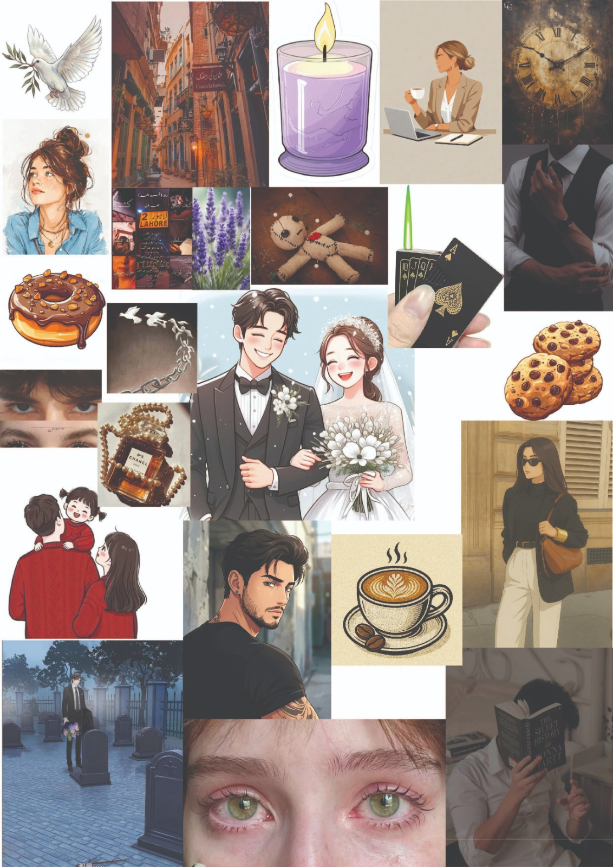

3.1.1 Research Board

This research board was created during the initial brainstorming phase of the thesis project. It contains a collection of source images gathered to explore different visual directions, layout styles, and design inspirations related to the narrative-to-fabric textile design project. The board includes references for character aesthetics, cultural streetscapes, atmospheric settings, symbolic motifs, dark academia fashion elements, and illustrative narrative patterns. These references were selected to study composition, color schemes, typography, visual hierarchy, and overall design aesthetics.

The purpose of collecting these source images was to help develop creative ideas and understand how different design elements can be combined in the final outcome. Through this visual exploration, various styles and approaches were analyzed before moving toward the final design process. The research board also helped in identifying suitable layouts, tactile material structures, and branding directions that align with the concept of literary storytelling, romance, mystery, and cultural heritage embedded within the novel.

This stage played an important role in organizing ideas visually and building a strong design foundation for the thesis project. By observing and comparing these references, a clearer understanding of the future design execution, garment development, and visual communication was developed.

3.2 Concept Board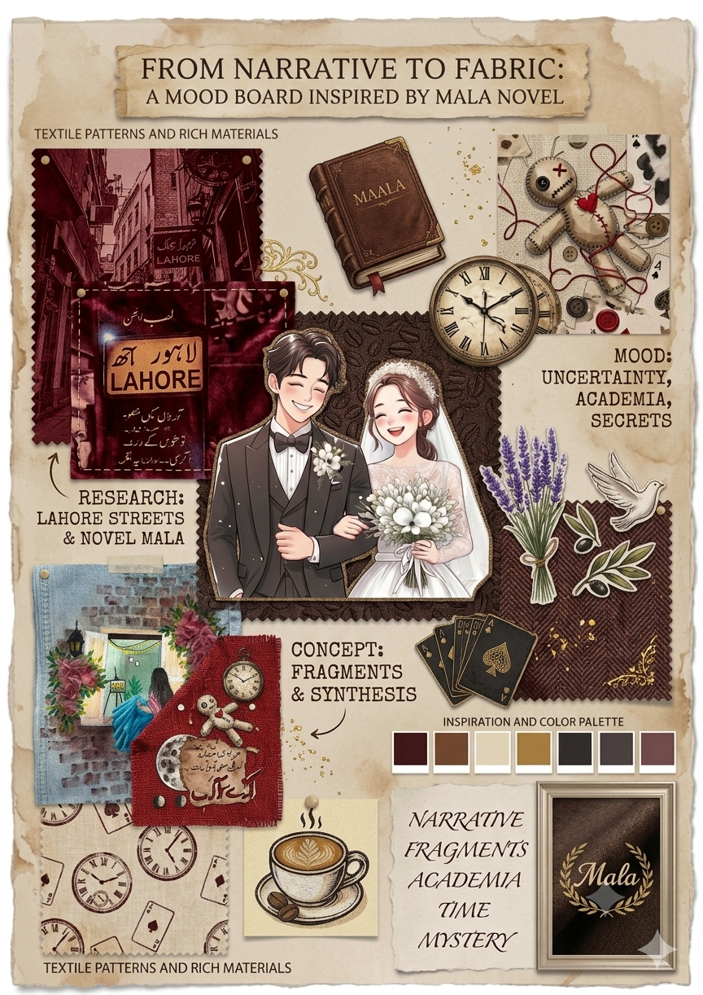

3.2.1Thesis Concept Board: Design Explanation

This concept board illustrates a progressive visual journey that bridges the gap between text and tactile form, moving from narrative research on the left to physical materialization on the right. At the literal and emotional center is the character illustration of the protagonists, anchored on a dark, coffee-stained texture with pinked edges to symbolize how characters born from text morph into design anchors. The left column honors the geographic setting with deep burgundy swatches of Lahore's historic architecture, transitioning directly into the hand-painted window denim jeans to demonstrate how a structural concept transfers to a commercial fabric surface. Balancing this, the right column captures the psychological layers of Nemrah Ahmed's novel—uncertainty, secrets, and time—using textured herringbone tweed overlaid with a stitched voodoo doll, playing cards, clock gears, and lavender sprigs, while a delicate white dove injects a thematic layer of hope. Finally, the base synthesizes the collection with a focal red patchwork fragment, a precise six-color technical palette, and an elegant book-cover-inspired signature layout, demonstrating how disparate literary memories are physically stitched back together into a cohesive textile narrative.

3.3 Mood Board

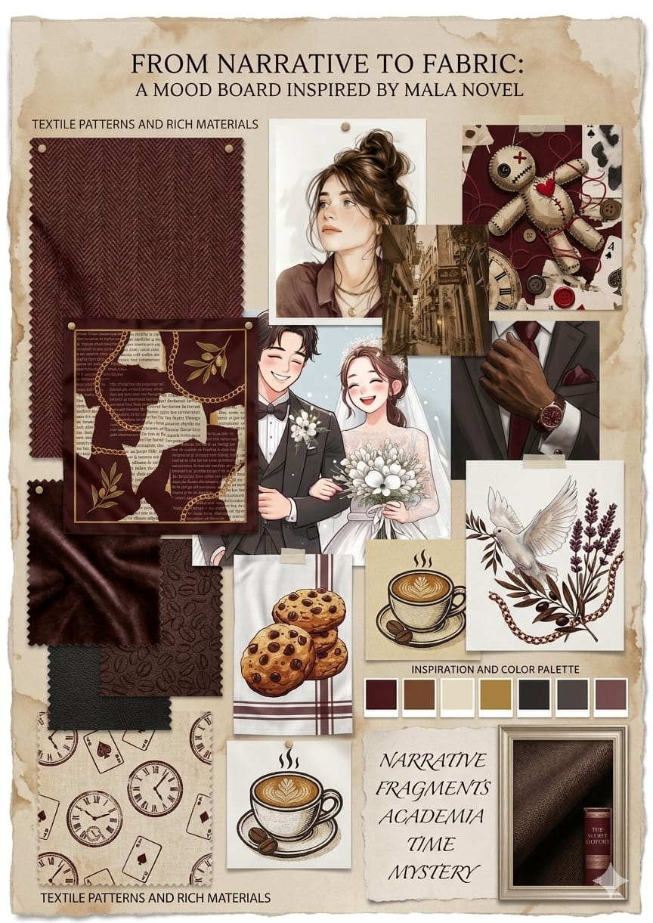

3.3.1 Mood Board

This final mood board represents the refined visual direction of the thesis project and combines all the selected design elements into a unified creative identity. After completing the research board and concept board stages, the most suitable visual references, styles, and design components were finalized and organized in this mood board to guide the overall design development of the project.

The composition in this mood board is structured around narrative framing and tactile layering, which reflects the transition of a literary story into tangible material form. This layout approach also connects with the dramatic, mystery-driven, and romantic themes of the Mala novel. The selected color palette primarily consists of deep maroon, crisp white, and rich coffee-effect tones, alongside contrasting accents like deep emerald green, vintage gold, and textured charcoal. These colors were carefully chosen to evoke a sense of deep emotion, antiquity, suspense, and sophisticated academia throughout the textile design system.

The patterns and textures used in the mood board are inspired by detailed character illustrations, cultural aesthetics, and symbolic motifs featured within the narrative—such as hand-stamped linens, intricate herringbone weaves, coffee-bean textures, and symbolic line art like clocks, keys, and birds. These elements help strengthen the visual connection with the storytelling process and cultural heritage while also adding tactile depth, aesthetic consistency, and decorative value to the overall fabric development.

The layout style follows an elegant, editorial, and artistic collage composition. The design structure mainly focuses on overlapping textures, balanced swatches, and an organized visual hierarchy that mimics a designer’s workspace. Pin-board placements, taped swatches, and clear content alignment were explored to create an engaging and professional appearance for fabric collections, editorial fashion spreads, lookbooks, and textile product mockups related to the thesis project.

The typography style selected for the project is a combination of a classic, high-contrast serif and an elegant script font. Different font weights and stylized italics were chosen to create hierarchy, readability, and visual clarity across different branding and editorial applications. The typography supports a literary, sophisticated, and professional visual identity while maintaining structural simplicity and easy readability for the audience.

The mood board also includes final textile mockups and material swatches that demonstrate the possible visual and tactile outcome of the project. These swatches provide a clearer understanding of how the selected maroon and coffee colorways, literary typography, structural layouts, and narrative patterns will work together in the final woven, printed, or embroidered thesis garments and accessories.

The primary keywords identified for the project include Storytelling, Dark Academia, Time, and Symbolism. These keywords helped define the conceptual direction and visual communication of the thesis. Additionally, the illustrative icon and motif set was inspired by novel elements—including vintage clocks, keys, coffee cups, and natural elements—to maintain strict thematic consistency throughout the project. Overall, this final mood board successfully establishes the visual identity and creative direction of the thesis project by combining rich textile aesthetics with narrative-driven and health-focused design elements.

3.4 Color Palette Development

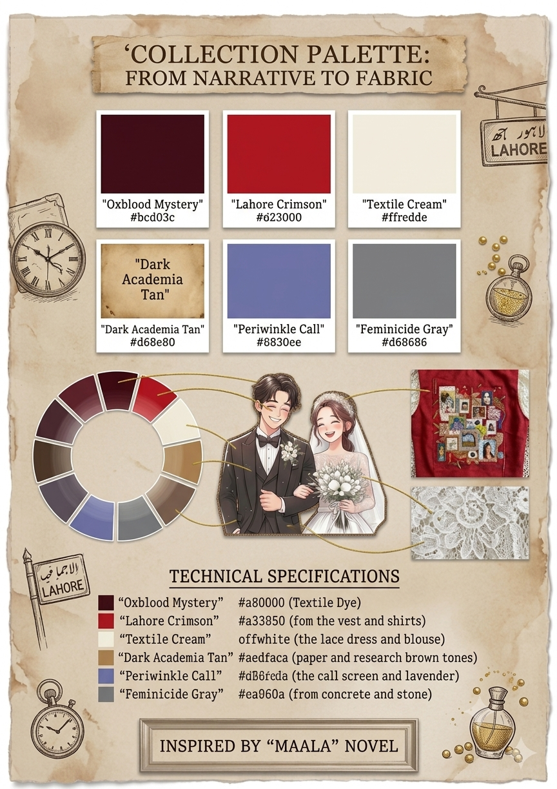

3.4.1Thesis Color Palette: Design Explanation
The color palette board acts as the structural foundation of the collection, establishing a systematic link between the emotional weight of Nemrah Ahmed’s novel, Maala, and the physical execution of the textile garments. By anchoring the palette in a vintage, aged-parchment background, the design presents color not merely as an aesthetic choice, but as a primary storytelling medium.

The Core Color Spectrum
The collection relies on six carefully balanced hues that capture the mood of academic mystery and narrative transition:
- Oxblood Mystery (#a80000): Represented by the deep, dramatic wine tones found in the custom textile dyes, capturing the undercurrents of secrets and gravity in the story.
- Lahore Crimson (#a33850): A vibrant, commanding red drawn directly from the base fabrics of the embroidered vest and statement shirts, grounding the collection in a distinct cultural landscape.
- Textile Cream (Off-White): A soft, breathing neutral taken from the intricate lace dress, ivory blouses, and delicate base layers, providing high-contrast clarity against the heavier red tones.
- Dark Academia Tan (#d68e80): A warm, grounding mid-tone mirroring raw paper, vintage book spines, and coffee-stain washes used throughout the research phase.
- Periwinkle Call (#6830ee): A cool, contemplative shade of slate blue and lavender, extracted from the digital call-screen illustrations, the hand-painted window denim, and the embroidered lavender sprigs.
- Feminicide Gray (#d68686): A somber, structural concrete tone that speaks directly to the harsher thematic realities of the novel, reflecting elements of stone, shadow, and finality.

3.5 Introduction
This chapter presents the findings gathered through visual analysis, sketchbook exploration, material experimentation, and studio-based practice conducted for the development of textile designs inspired by the novel Maala. The findings were analyzed through thematic organization in order to identify narrative elements, visual strategies, and material approaches used to translate literary content into textile form and garment development. The results are presented according to the major themes that emerged during the creative and experimental process. Each theme highlights specific observations, conceptual interpretations, and design explorations related to storytelling, symbolism, texture, color, and textile techniques used in the study.

3.6 Conceptual and Design Development of Garments
A total of multiple textile samples and garment concepts were developed during the research process. These designs were based on the emotional tone, narrative structure, and symbolic elements of the novel Maala. The design development process involved different experimental techniques including freehand painting, batik, reverse batik, patchwork, embellishment, and tea and coffee dyeing. Most design explorations focused on translating emotional scenes and narrative themes into visual textile expressions. It was observed that different participants (design evaluations and peer feedback during studio critique) supported the idea that narrative-based textile work enhances emotional and conceptual depth in fashion design. The study also revealed that textile experimentation helped in understanding how literary ideas can be transformed into fabric-based storytelling.

3.7 Theme One: Translation of Narrative Elements into Textile Design
Most design explorations expressed the importance of understanding narrative structure before translating it into textile form. The themes, characters, and emotional moments of Maala were interpreted into visual compositions. It was observed that abstract emotions such as sadness, hope, memory, and identity could not be directly illustrated but were effectively represented through texture, color, and layering. One design reflection noted:
“Each story element required a different textile technique to express its emotional meaning.”
Another observation explained:
“Symbolic interpretation was more effective than literal illustration in textile storytelling.”
These findings indicate that narrative-based textile design requires deep conceptual analysis before visual execution.

3.8 Theme Two: Effectiveness of Experimental Textile Techniques
The research findings highlighted that experimental textile techniques played a crucial role in visual storytelling. Techniques such as batik and reverse batik created layered visual depth, while patchwork represented fragmented narrative structures. Freehand painting allowed direct emotional expression, and embellishment highlighted symbolic details. Tea and coffee dyeing contributed to creating aged, paper-like textures that strengthened the connection between literature and fabric. One observation stated:
“Tea and coffee dyeing gave the fabric a storytelling quality similar to old manuscript pages.”
Another reflection noted:
“Each technique added a different emotional layer to the final textile composition.”
These findings suggest that combining multiple techniques enhances narrative expression in textile design.

3.9 Theme Three: Emotional Expression Through Fabric and Texture
The study revealed that fabric texture, layering, and surface quality strongly influenced emotional interpretation of the designs. Soft textures, layered surfaces, and controlled brushwork created a sense of depth and reflection. It was observed that emotional states from the novel Maala such as longing, silence, and memory could be effectively translated through material manipulation. One design note stated:
“Texture becomes a silent language that communicates emotion without words.”
Another observation explained:
“Layered surfaces reflect the complexity of human emotions within the narrative.”
These findings demonstrate that textile materials can function as emotional carriers in design practice.

3.10 Theme Four: Importance of Color and Visual Atmosphere
Color played a significant role in expressing mood and narrative identity within the textile designs. Muted, earthy, and soft tonal palettes were frequently used to reflect emotional depth and storytelling atmosphere. It was observed that color harmony helped in creating visual unity across different textile samples. One reflection stated:
“Soft and faded tones helped in expressing memory and emotional distance within the narrative.”
Another observation noted:
“Color selection directly influenced the mood and storytelling quality of the textile surface.”
These findings suggest that color functions as a key storytelling element in textile design.

3.11 Theme Five: Integration of Traditional and Contemporary Textile Practices
The study found that combining traditional textile techniques with contemporary experimental approaches created more meaningful design outcomes. Traditional methods such as batik and patchwork provided cultural and technical depth, while experimental practices such as tea and coffee dyeing introduced innovation and conceptual uniqueness. One observation stated:
“The combination of old and new techniques created a balanced narrative expression in textile form.”
Another reflection explained:
“Traditional craft methods gave authenticity while experimental methods added creativity and innovation.”
These findings highlight the importance of integrating diverse textile practices in narrative-based design.

3.12 Summary of Findings
The findings revealed five major themes including translation of narrative elements into textile design, effectiveness of experimental textile techniques, emotional expression through fabric and texture, importance of color and visual atmosphere, and integration of traditional and contemporary textile practices. The results indicate that narrative-based textile design can successfully transform literary content into expressive garments by combining conceptual analysis with material experimentation. The study demonstrates that textiles can function as a powerful storytelling medium where fabric, texture, and technique work together to communicate emotion, symbolism, and narrative meaning.

3.13Characters Extraction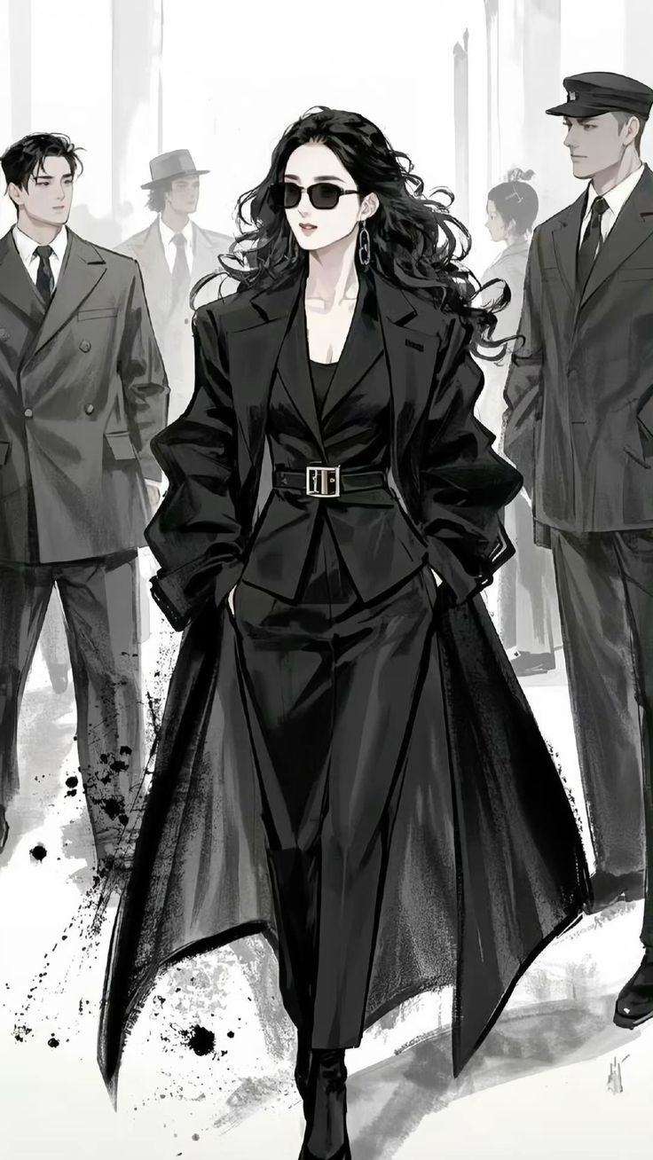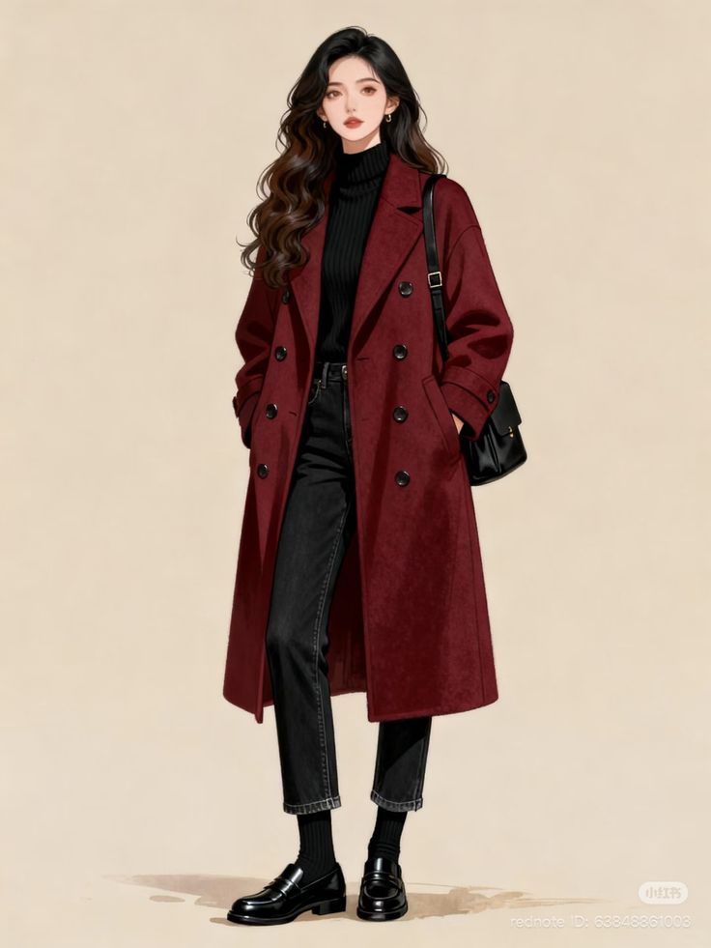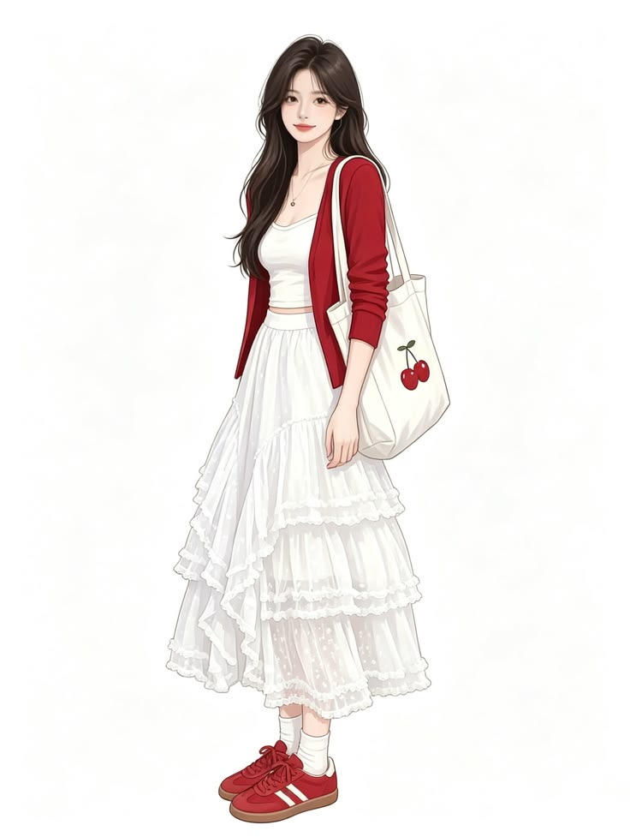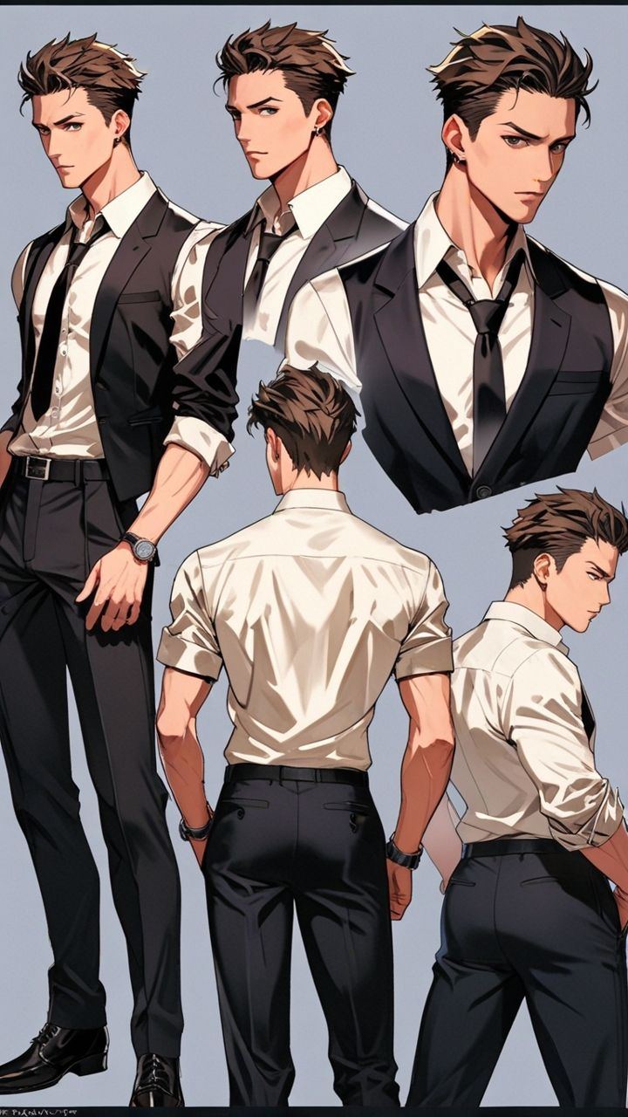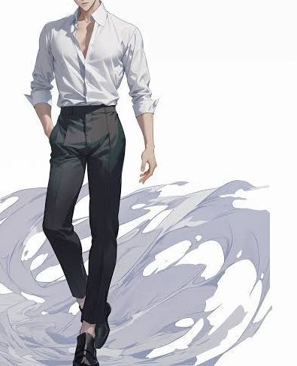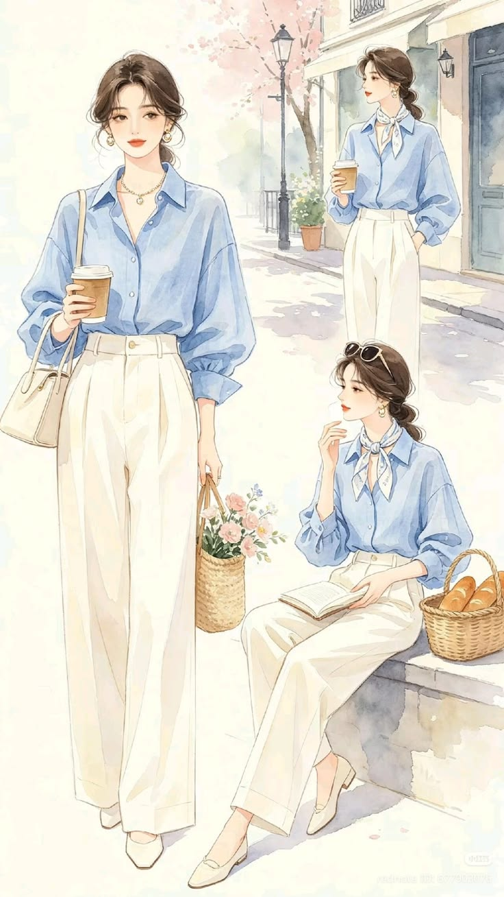

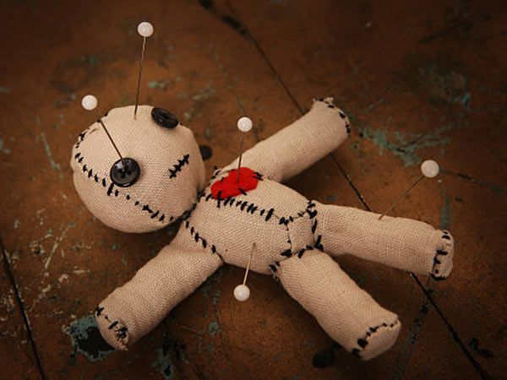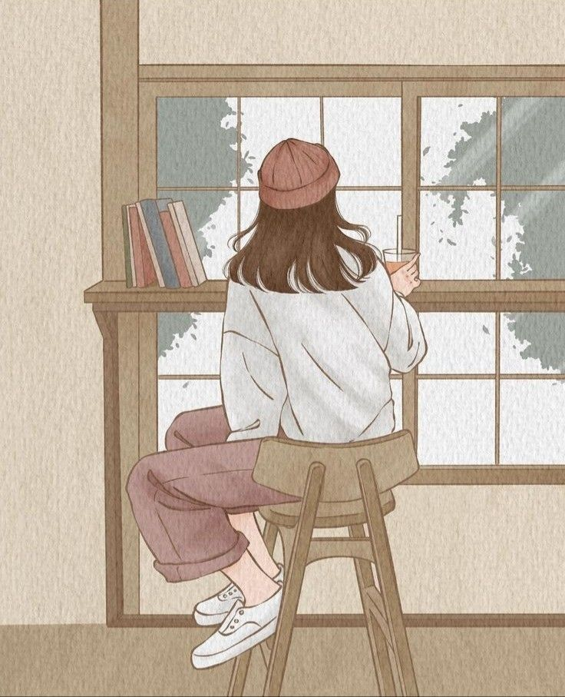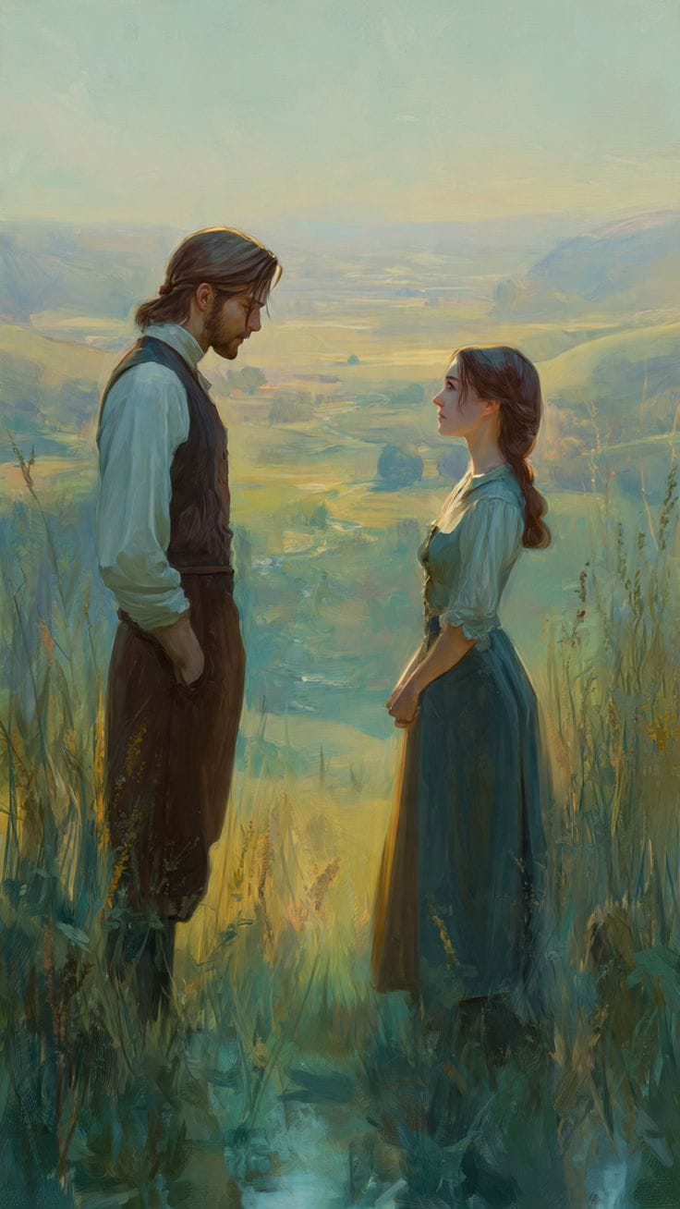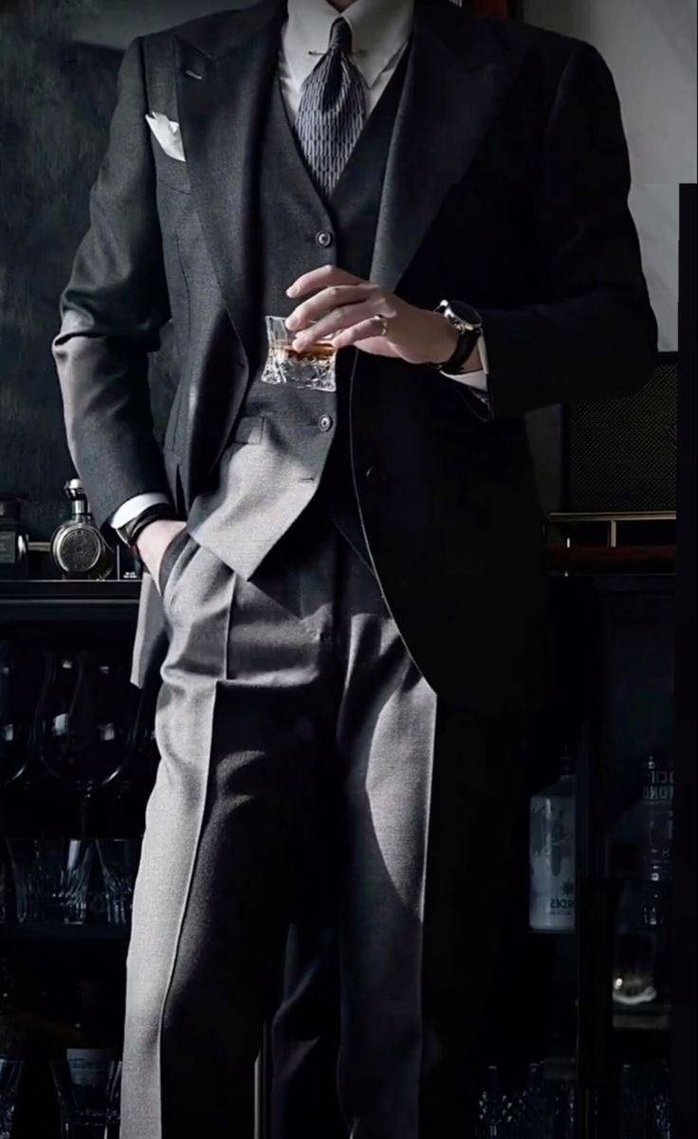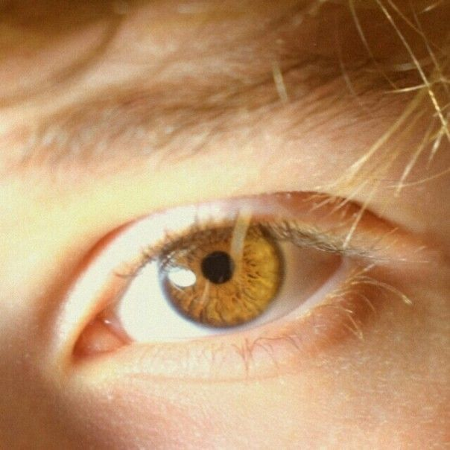

Chapter-4

CATALOGING

4.1 Garment Collection Layout Description
The layout of this textile collection is carefully planned to translate the narrative of the novel Maala into visual and wearable forms. Each garment is designed as a storytelling surface that communicates specific themes, emotions, and symbolic elements from the novel. The collection is organized in a sequential manner, allowing viewers to experience the narrative gradually through textile design, color, texture, and surface manipulation. This structured arrangement supports the main concept of transforming literature into fabric by presenting the story through a series of interconnected garments.
The initial garments in the collection introduce the narrative and establish the emotional atmosphere of the novel. These designs focus on key themes, symbolic imagery, and visual elements that represent the beginning of the story. Surface treatments and textile compositions are carefully arranged to create curiosity and encourage visual engagement.
The middle section of the collection explores the emotional and symbolic development of the narrative. These garments incorporate layered textures, freehand painting, batik, reverse batik, patchwork, and embellishment to represent important events, memories, and emotional transitions within the story. The arrangement of motifs and surface details helps create visual movement and narrative continuity across the collection.
The later garments focus on the climax and emotional resolution of the narrative. Here, textile techniques are used more expressively to communicate transformation, reflection, and personal growth. Surface compositions become more refined and visually balanced, creating a sense of completion and harmony within the collection.
The final garment serves as the concluding visual statement of the project. It brings together the major themes, symbols, and emotions explored throughout the collection, acting as a summary of the narrative journey. This final design reinforces the concept of storytelling through textile design and leaves a lasting impression on the viewer.

4.2 Color Theme Explanation of the Collection
The collection uses a carefully selected color palette inspired by the emotional atmosphere and symbolic content of the novel Maala. Colors such as beige, cream, brown, sepia, muted gold, soft grey, and earthy tones are prominently used throughout the collection. These colors were selected because they create a visual connection with aged paper, memory, storytelling, and emotional reflection.
Tea and coffee dyeing techniques played a significant role in establishing this color palette. The naturally aged appearance created through these processes helped strengthen the relationship between literature and textile surfaces by making the fabric resemble old manuscript pages and preserved memories. These tones also contribute to a sense of warmth, nostalgia, and authenticity.
Soft and muted colors were used to communicate emotional depth and subtle narrative transitions. Earthy brown tones symbolize memory, history, and connection to the written narrative, while cream and beige shades represent simplicity, reflection, and continuity. Selected darker tones were introduced in certain garments to represent moments of tension, emotional complexity, and character development within the story.
The overall color palette creates visual harmony throughout the collection while supporting the narrative concept. The combination of natural dyes, layered tones, and hand-crafted surface treatments allows the garments to function as expressive storytelling mediums. Through color, texture, and material experimentation, the collection visually communicates the emotional and symbolic essence of Maala, transforming literary narrative into textile form.

4.3 Final Projects

4.3.1 Narrative Connection – Mala

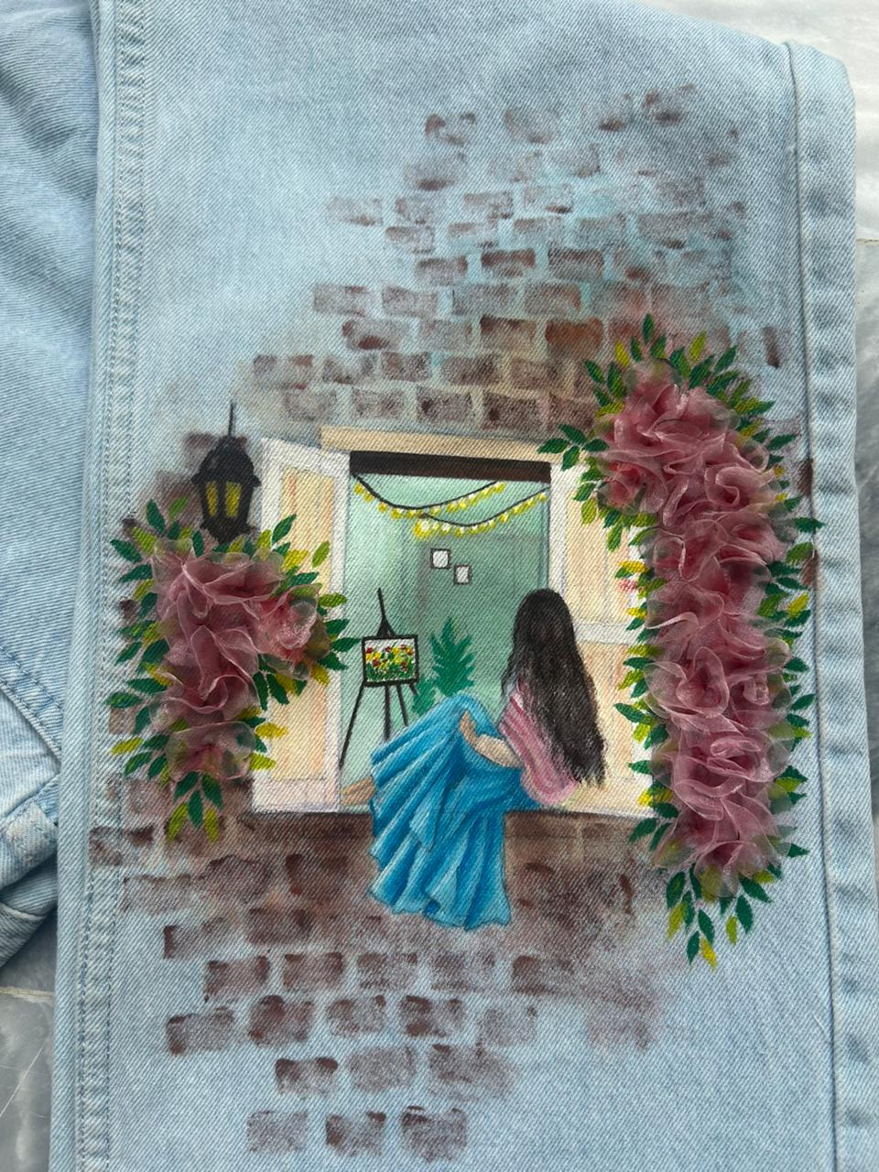

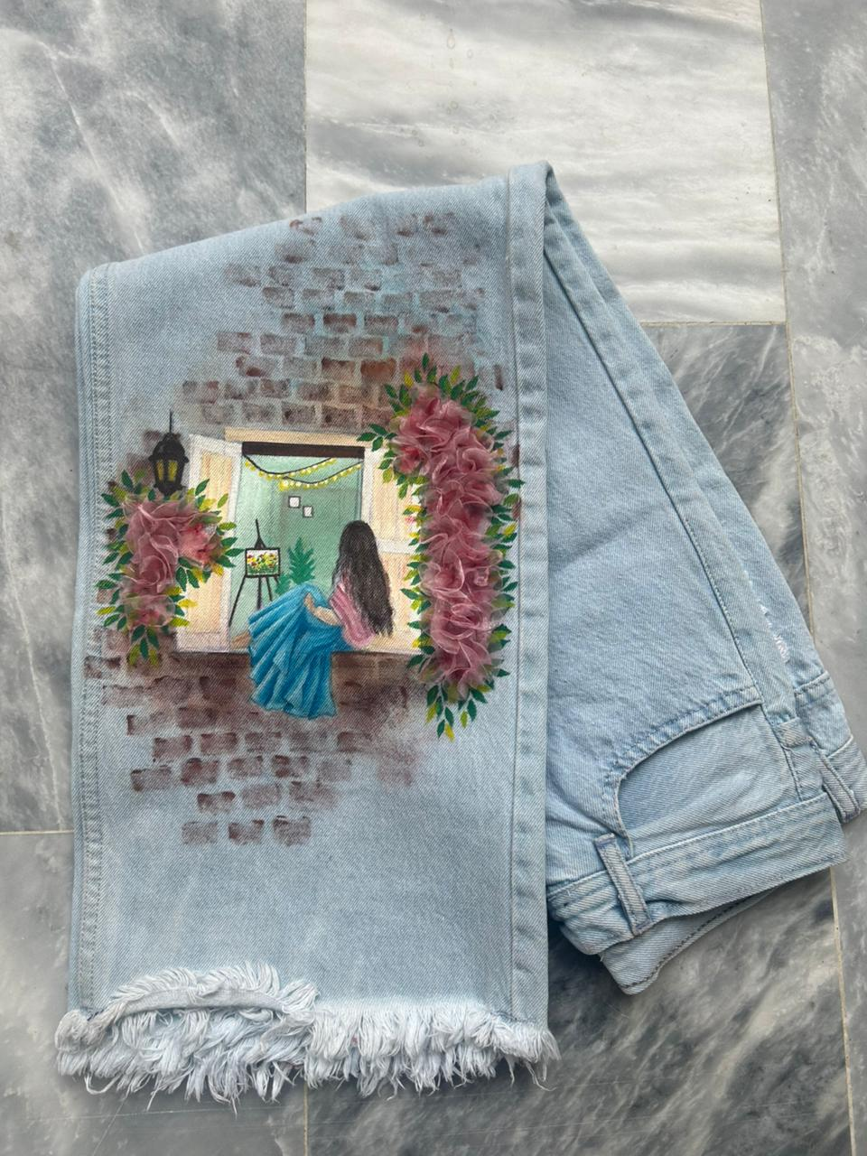

4.3.1 Narrative Connection – Mala

This garment illustration directly translates the psychological depth and thematic essence of the novel Mala into a wearable textile format. The central imagery of a lone female figure seated at a window reflects the core themes of isolation, quiet resilience, and emotional longing that define the protagonist's journey. It visually captures a character suspended between her secretive internal world and the external conflicts of the plot. The rough, distressed brick wall surrounding the window represents the rigid societal boundaries, family secrets, and mysterious pasts that shroud the narrative, giving the design a grounded, atmospheric weight.

The primary thematic connection is established through the vibrant, three-dimensional pink floral vines framing the window, which symbolize the unfolding of romance, hope, and vulnerability amidst harsh circumstances. Inside the window frame, the glowing interior lights and the artist's easel speak directly to the novel's elements of hidden identity, creative passion, and the pursuit of an internal sanctuary. Together, these narrative components work in harmony to transform the fabric into a literal storytelling canvas. By embedding these specific literary motifs into the textile art, the garment successfully bridge the gap between text and texture, allowing the viewer to experience the emotional and visual spirit of Mala.

4.3.2 Garment 2 – Narrative Collage

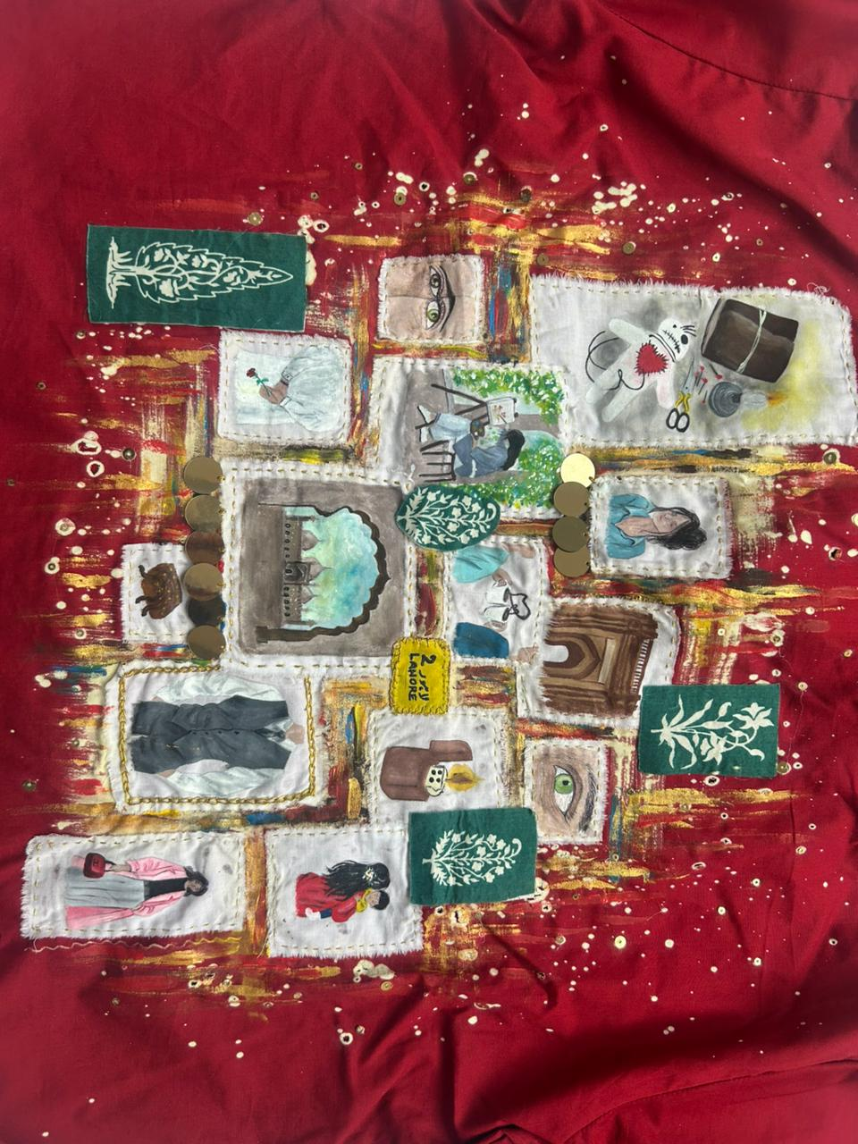

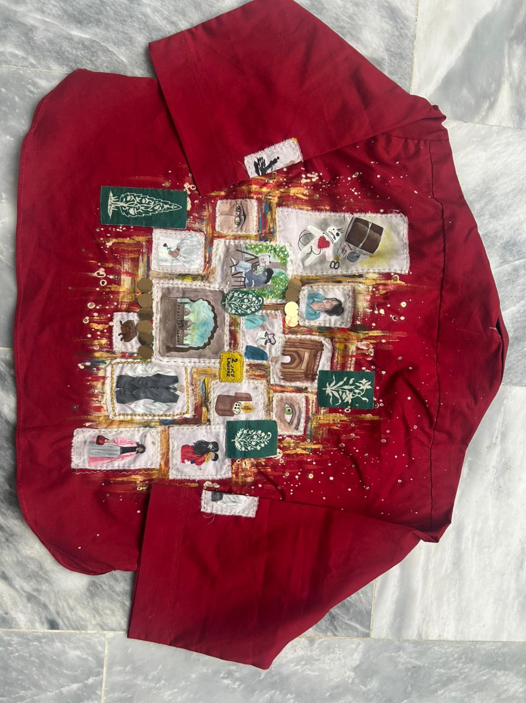

4.3.2 Garment 2 – Narrative Collage
This garment uses a bold combination of deep maroon, raw white patches, and expressive multi-colored illustration fragments to create a highly dramatic and complex narrative atmosphere. Deep maroon is commonly associated with intense emotion, passion, danger, and psychological depth, which immediately establishes a heavy, suspenseful mood for the piece. White is used in the raw, frayed fabric patches to provide stark contrast, acting as clean pages torn from a book to isolate specific memories or moments. The varying greens, golds, and earth tones within the stitched illustrations introduce layered visual fragments that evoke memory, culture, and dark academic intrigue. Together, these colors and textured patches visually communicate a complex web of interconnected storylines, almost telling the viewer to piece together a fragmented mystery.
The primary color used in this garment design is a rich, dominant maroon fabric base, while the off-white frayed patches, deep emerald greens, and metallic gold brushstrokes are used as secondary colors to keep the layout intensely expressive without losing its organized visual hierarchy.

4.3.3 Garment 3 – Allegorical Stains

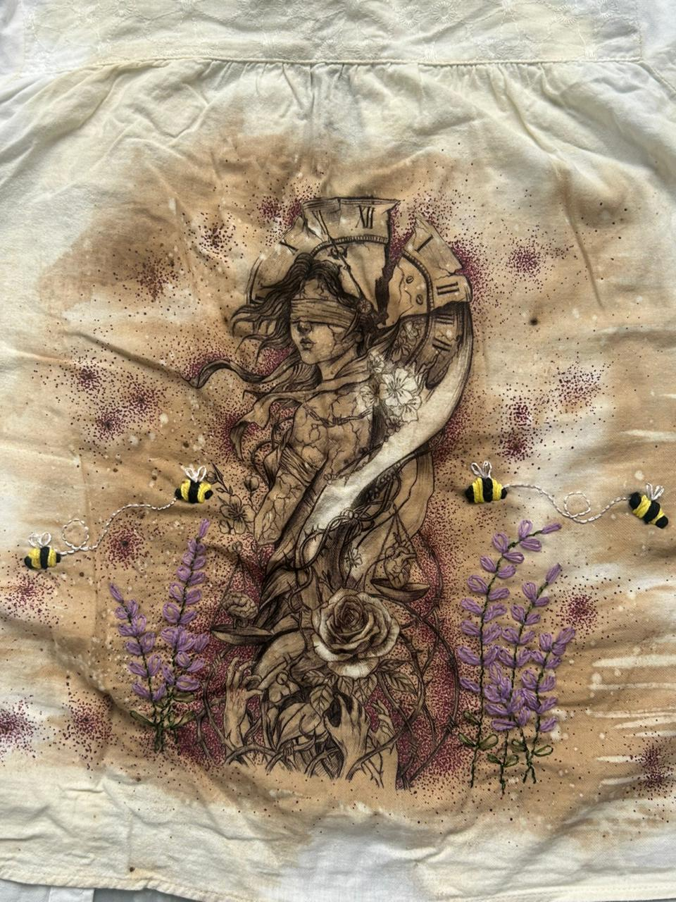

​4.3.3 Garment 3 – Allegorical Stains
This garment illustration directly translates the psychological depth and thematic essence of the novel Mala into a wearable textile format. The central imagery of a blindfolded female figure intertwined with a shattered Roman numeral clock reflects the core themes of blind faith, psychological manipulation, and the inescapable trap of time that define the protagonist's emotional turmoil. It visually captures the character’s inability to see the true nature of the events unfolding around her, while her life and destiny literally fragment under the pressure of hidden secrets. The sharp, thorny vines wrapping around her body represent the painful attachments, psychological trauma, and suffocating relationships she endures throughout the story, giving the design an intimate, vulnerable weight.
​The primary thematic connection is established through the specific narrative illustrations—such as the scales of justice hanging unevenly, the reaching hands at the base, and the blooming rose amidst thorns—which symbolize the themes of unfair judgment, a desperate cry for help, and the preservation of beauty or love despite a dark, toxic environment. Surrounding the central figure, the meticulously hand-embroidered lavender sprigs and wandering bumblebees speak directly to the novel's themes of nature, fleeting moments of sweetness, and the painful sting of reality. Together, these narrative components work in harmony to transform the fabric into a literal storytelling canvas. By embedding these specific literary motifs into the textile art, the garment successfully bridges the gap between text and texture, allowing the viewer to experience the emotional and visual spirit of Mala.

4.3.4 Garment 4 – Chronicled Vest

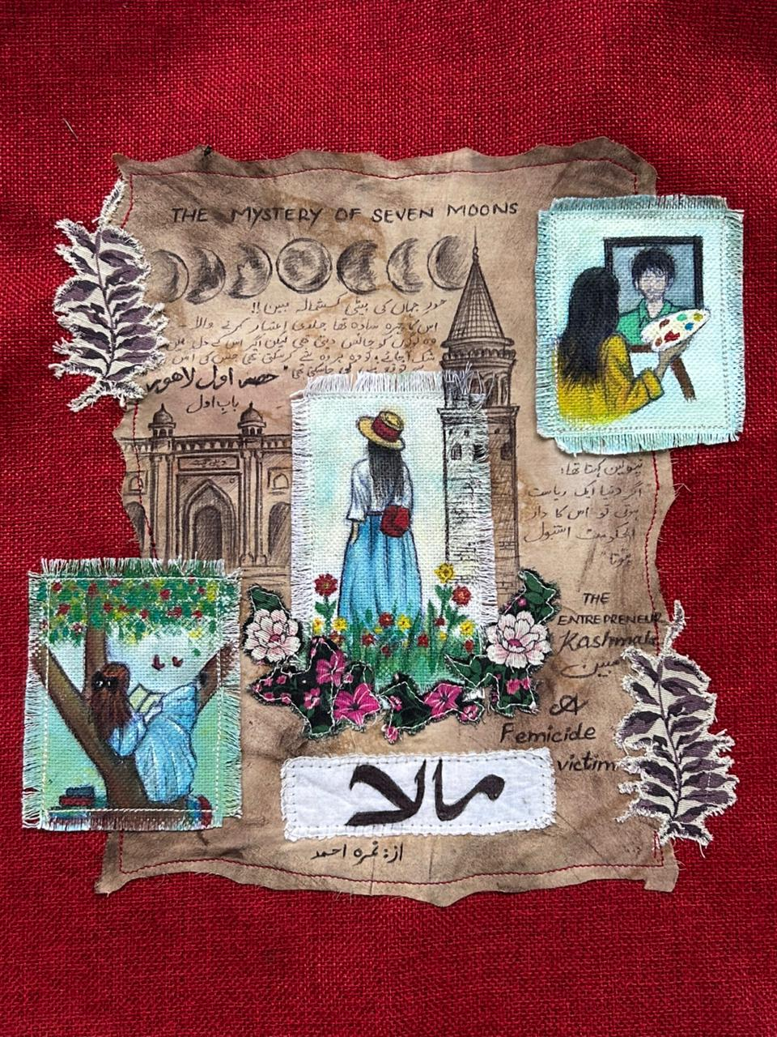

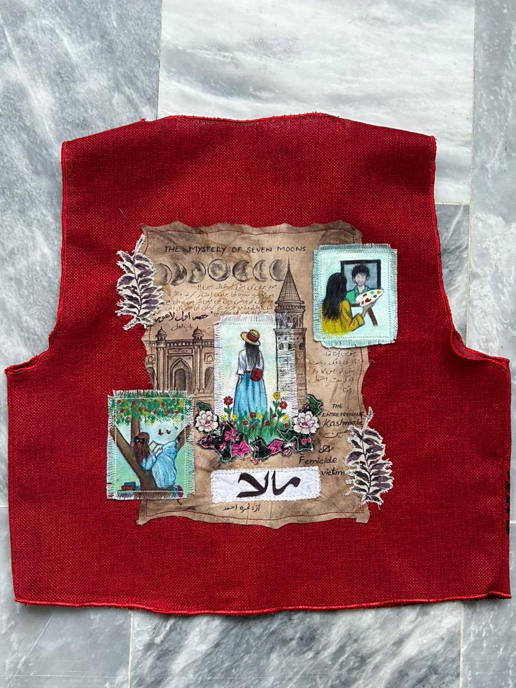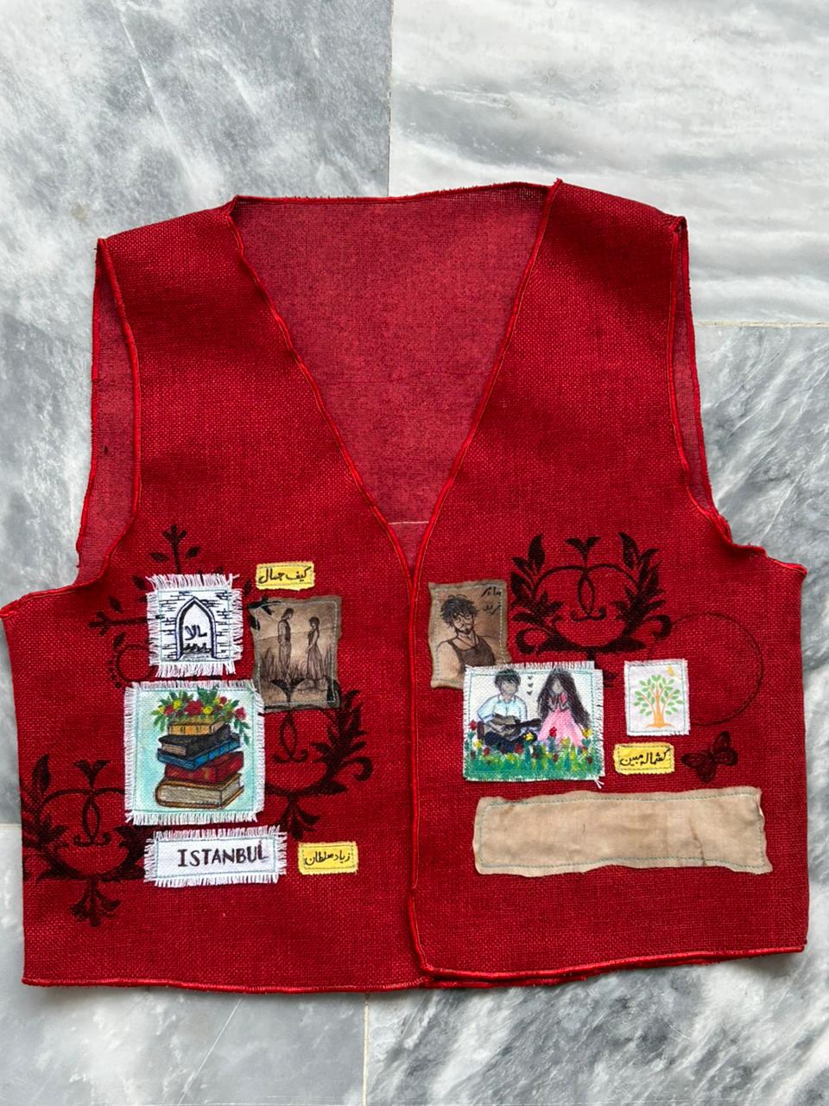

4.3.4 Garment 4 – Chronicled Vest
​This garment uses a striking combination of a textured maroon base, coffee-stained parchment fabrics, and raw edge-fringed pictorial patches to create an archival, highly literary, and evocative narrative atmosphere. The deep maroon jute-like texture is commonly associated with cultural warmth, structural intensity, and deep-seated emotion, serving as a commanding foundation for the layered story pieces. The central coffee-dyed backing introduces a weathered, historical scroll effect that evokes the feeling of reading an ancient manuscript or an old journal. The multi-colored painted patches and localized Urdu script inject a sense of personal identity, memory, and geographic realism. Together, these colors and distressed fabric layering techniques visually communicate a beautifully archived chronicle, almost telling the viewer to read through the chapters of a deeply personal journey.
​The primary color used in this garment design is the deep, rich maroon of the vest body, while the sepia coffee tones, sky blues, olive greens, and stark white of the calligraphic title block are used as secondary colors to build a highly organized visual hierarchy across the collage.
​

4.3.5 Garment 5 – Interaction Display (Calling Screen Display)

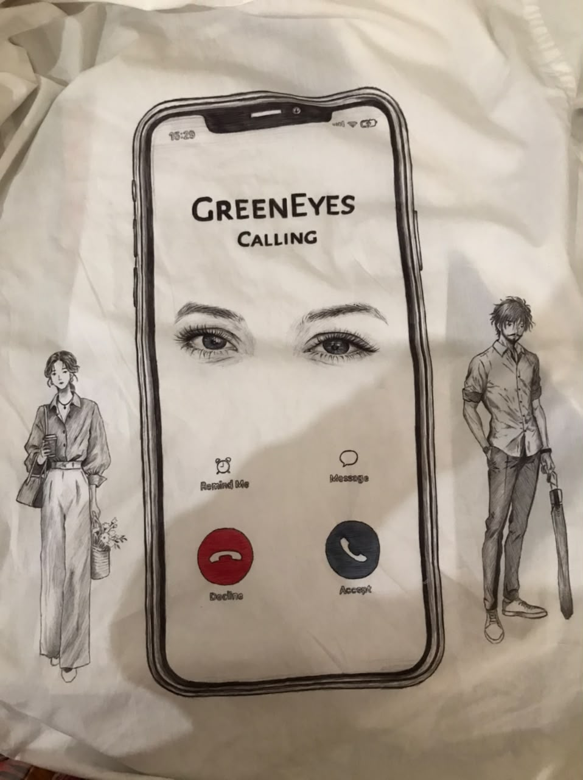

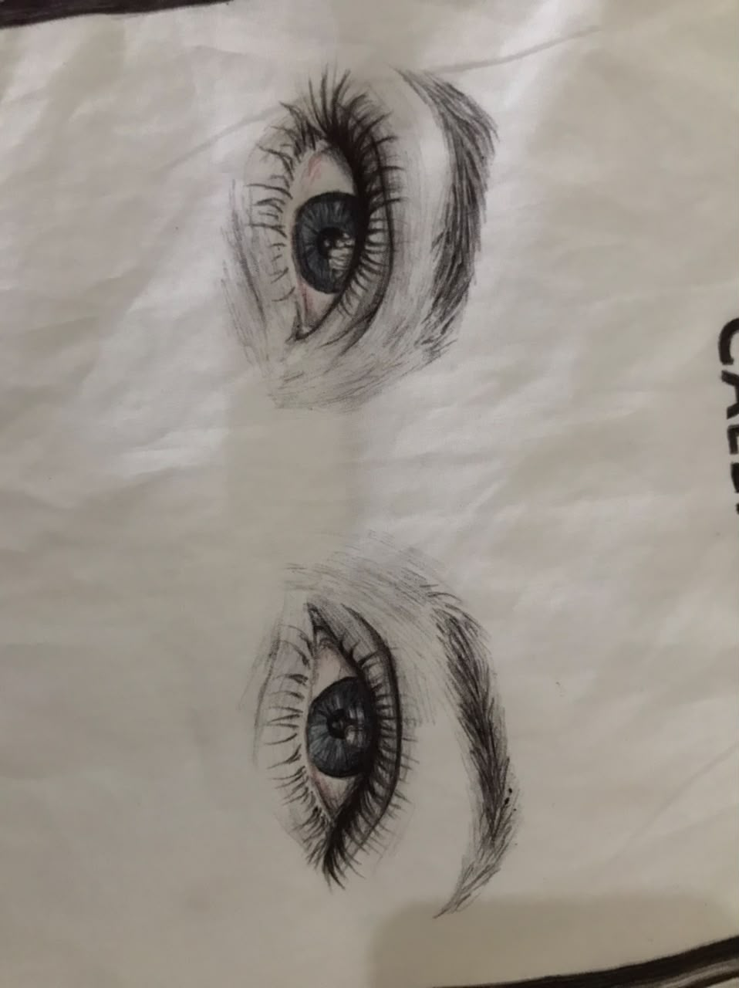

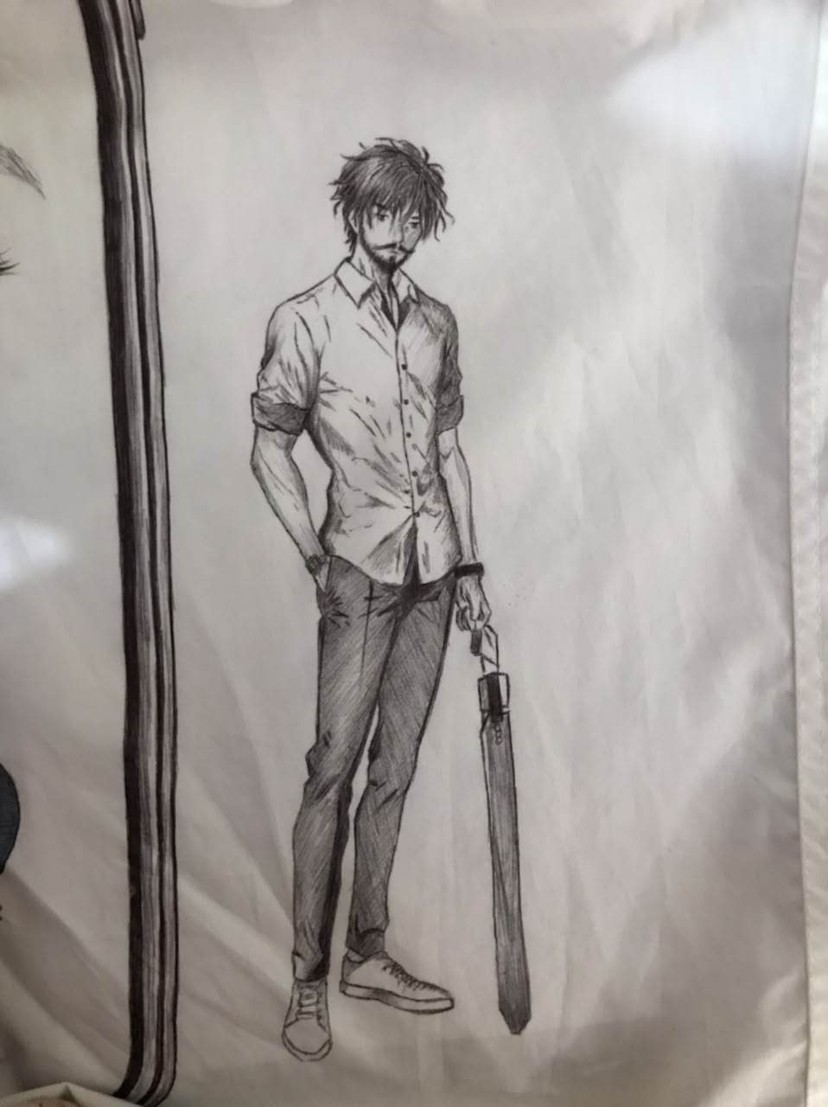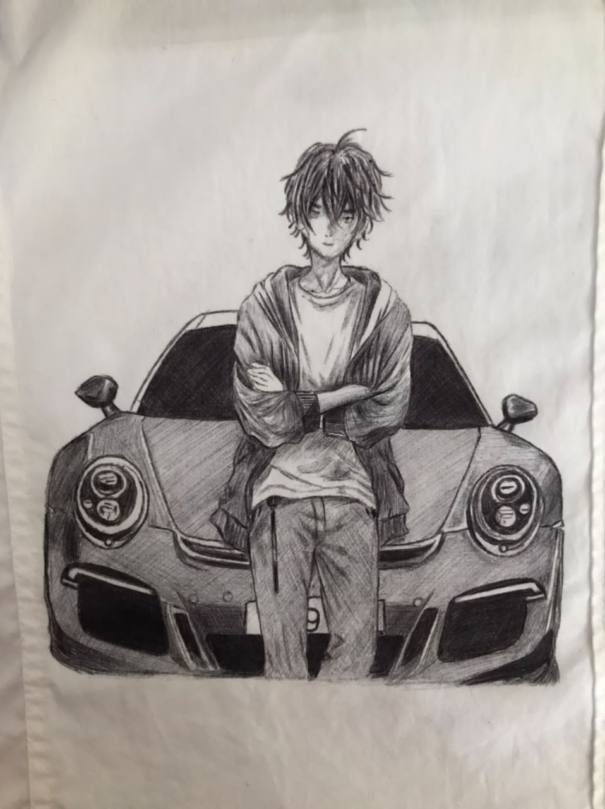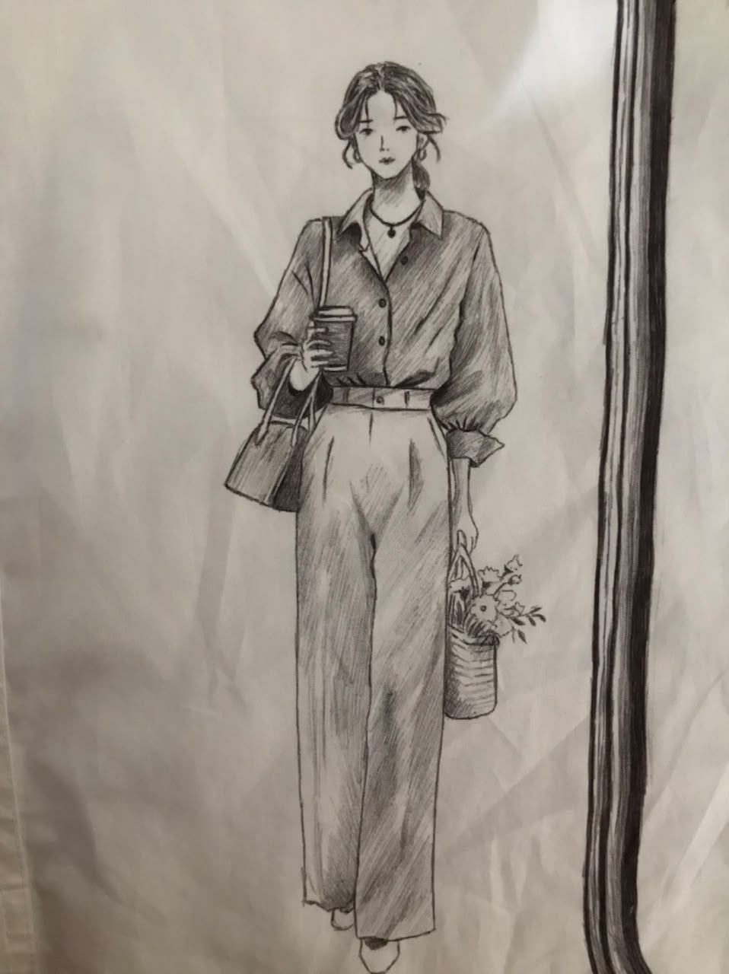

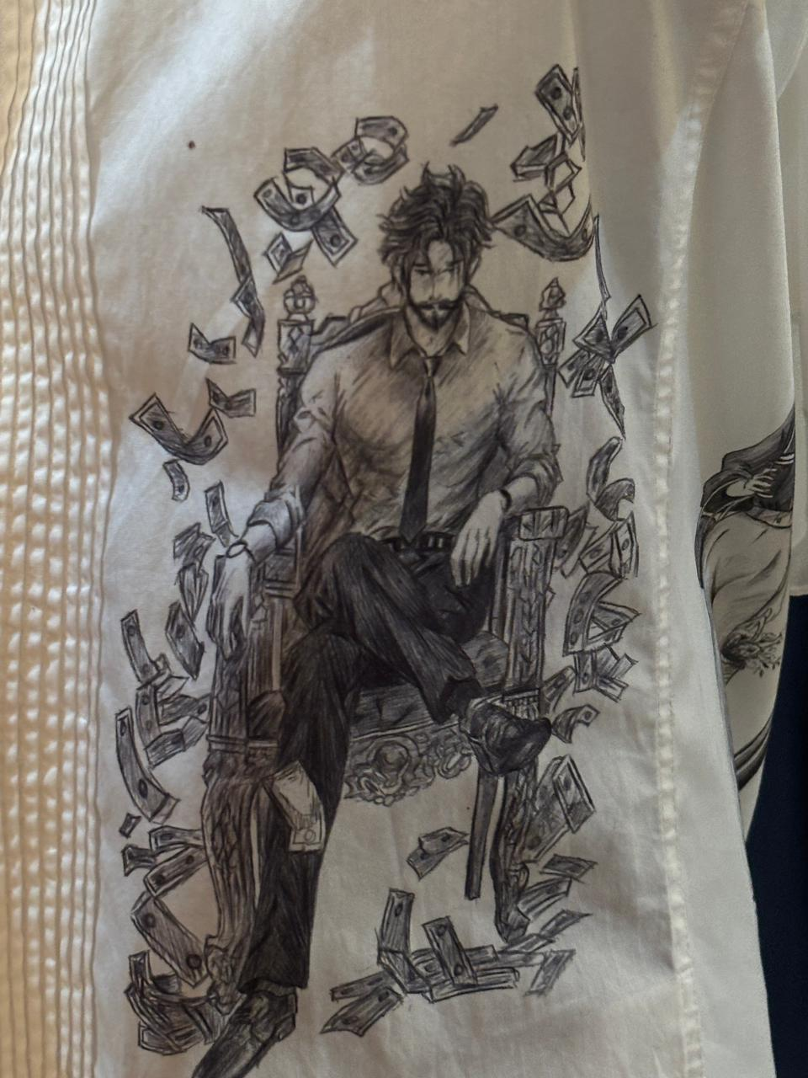

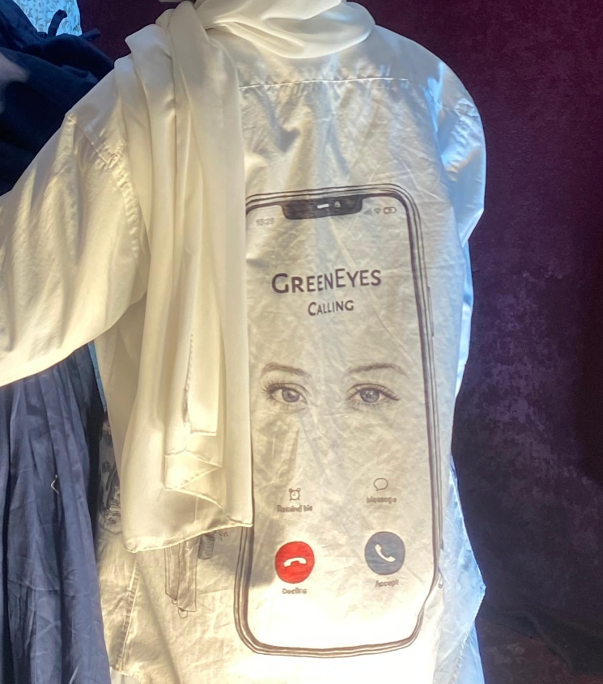

4.3.5 Garment 5 – Interaction Display (Calling Screen Display)
This garment segment shifts the narrative perspective from a landscape collage to an intimate, close-up character interaction, utilizing a stark off-white canvas backdrop to emulate a raw sketchbook page. The focal point of the composition is a highly detailed, hand-drawn smartphone screen displaying an incoming call interface from the contact "GREENEYES." This element injects a tense, hyper-modern digital narrative twist directly onto the traditional, organic fabric medium. The realistic, expressive rendering of the eyes looking through the screen acts as a heavy psychological anchor, capturing the intense themes of surveillance, connection, and emotional suspense central to the novel Maala.
Flanking the central smartphone graphic are two finely detailed, pen-and-ink character illustrations that ground the digital interaction in human reality. On the left, a female character is captured in a casual, reflective stance holding a coffee cup, while the right depicts a male character holding an umbrella, their isolated positions subtly hinting at a profound distance or unspoken connection. The localized use of primary red and deep blue on the user-interface buttons breaks the monochromatic scheme, introducing high-contrast focal points that direct the viewer’s eye through the narrative sequence. Together, these meticulous line-art techniques and contemporary motifs visually illustrate a moment of crucial transition, mimicking a graphic novel layout on a textile substrate.
The primary backdrop relies on the crisp, clean ivory tones of the base cotton shirt, while the sharp black line-work, subtle graphite shading, and selective primary pops of red and blue on the calling interface serve as secondary elements to establish a clinical, highly organized visual hierarchy across the surface design.

4.3.6 Shadows and Shards: A Memoryscape

This hand-painted artwork transforms the back of a deep red button-down shirt into a complex tapestry of memory and relationship history. The piece is anchored by a central portrait of a green-eyed woman whose expression is both determined and reflective, framed by a symbolic crown of chained doves that represents a struggle between a longing for peace and the constraints of past attachments. Surrounding this central figure is a kaleidoscope of fractured narrative scenes depicted in a looser, illustrative style; these include moments of romance and conflict, collaborations in a workshop setting, and subtle symbols of control like a voodoo doll and gravestones. Crucially, a small inset window features a self-reflexive moment where the artist is shown actively painting, emphasizing that the entire composition is a form of self-examination—a literal framing of personal experience and the mental weight of memory, painted directly onto a wearable canvas.

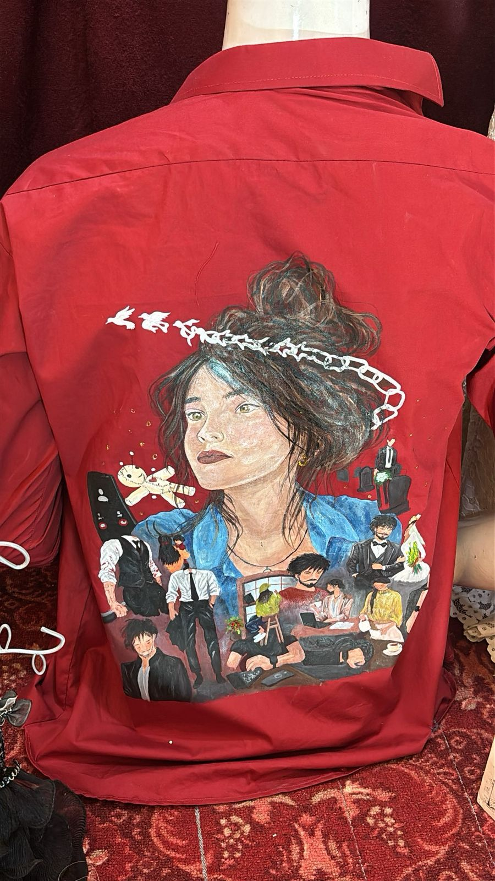

4.3.6 Shadows and Shards: A Memoryscape

4.3.7 Celestial Reverie: The Story on Canvas

This custom, hand-painted baseball cap featured in 1000569841.jpg beautifully blends fine artistry with wearable fashion to tell a poetic, deeply reflective story. The crown of the hat showcases a serene portrait of a woman nestled within tall grass and purple lavender blooms, positioned beneath a sequence of changing moon phases that arches through a dark night sky to symbolize the passage of time and transformation. Complementing this visual narrative, the brim of the cap serves as a literal manuscript covered in elegant Urdu calligraphy framed by rustic, weathered textures. The script reads, "Her face was simple, quick to trust. Her eyes were sharp, but not clever. The eyes that were once kind, do not seek revenge; they just turn away," transforming the accessory in 1000569841.jpg into a poignant canvas about innocence, heartbreak, and quiet resilience.

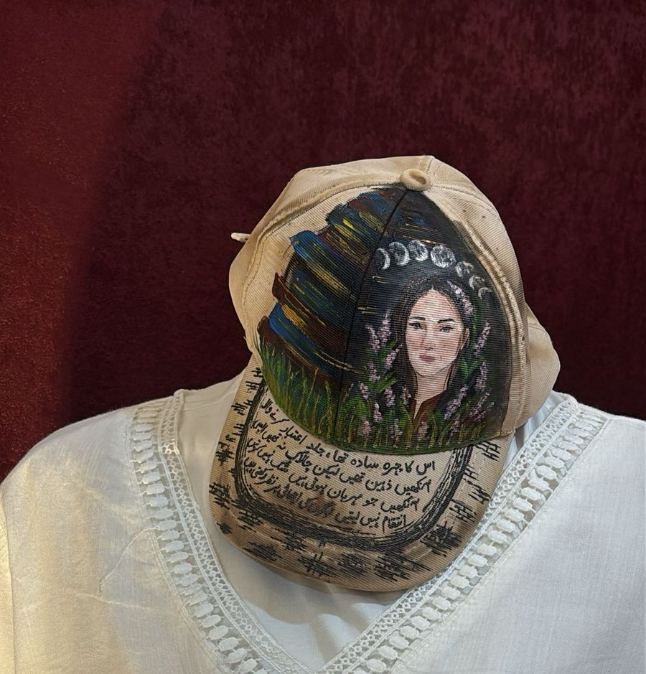

4.3.7 Celestial Reverie: The Story on Canvas

4.3.8 Final Installation Display

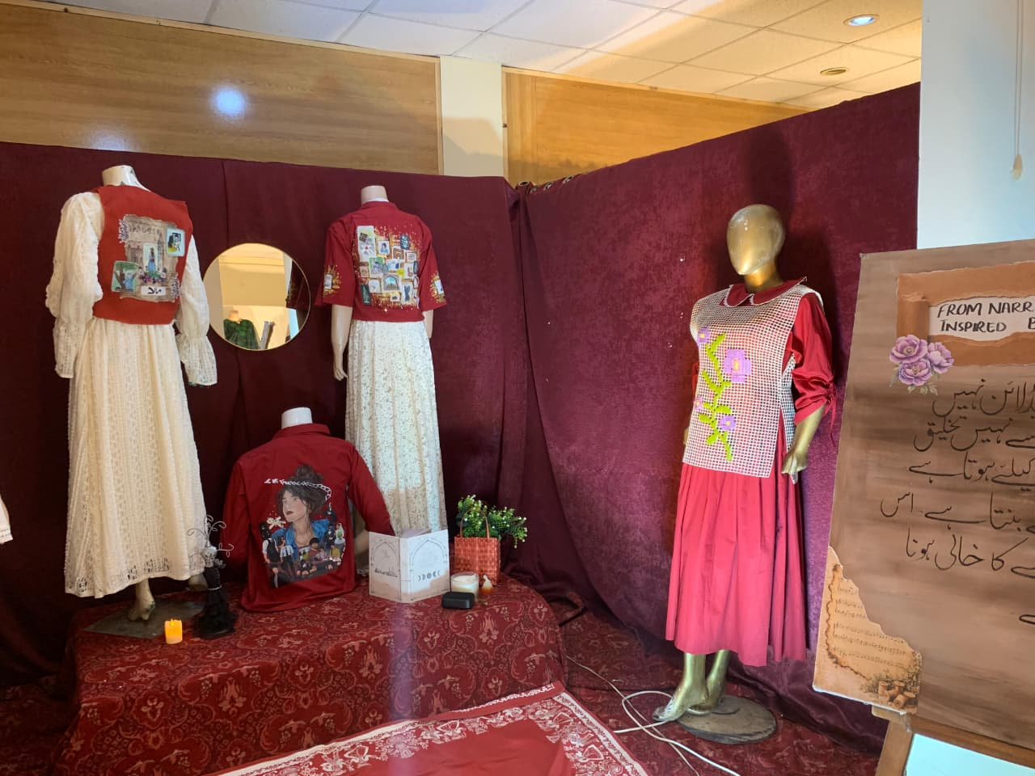

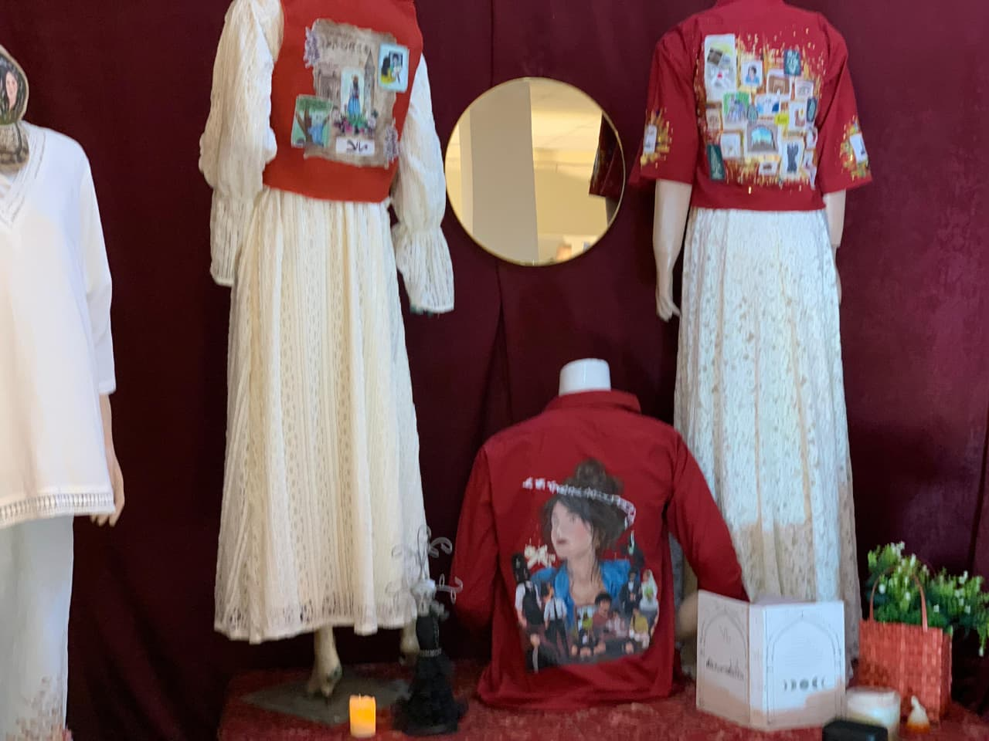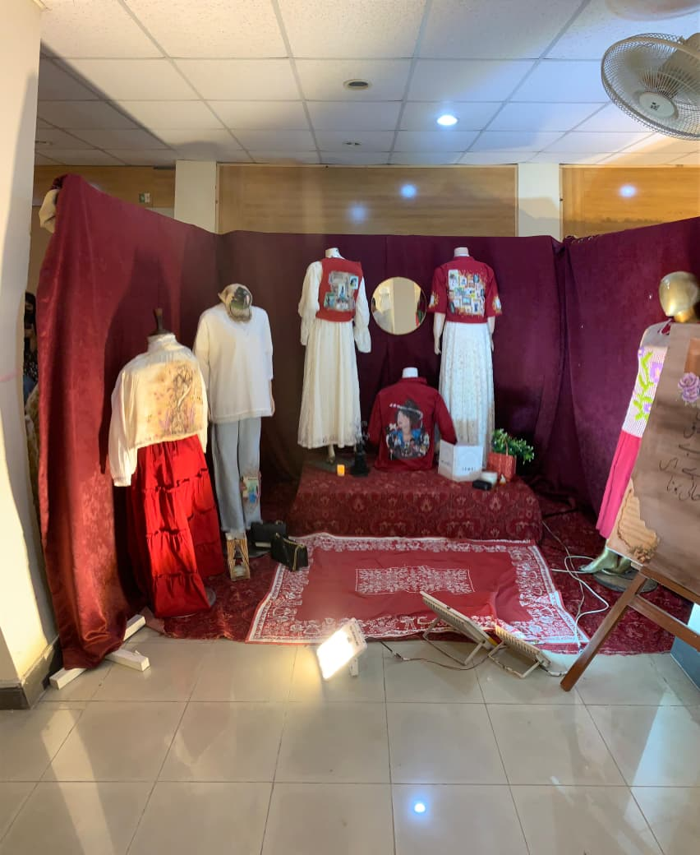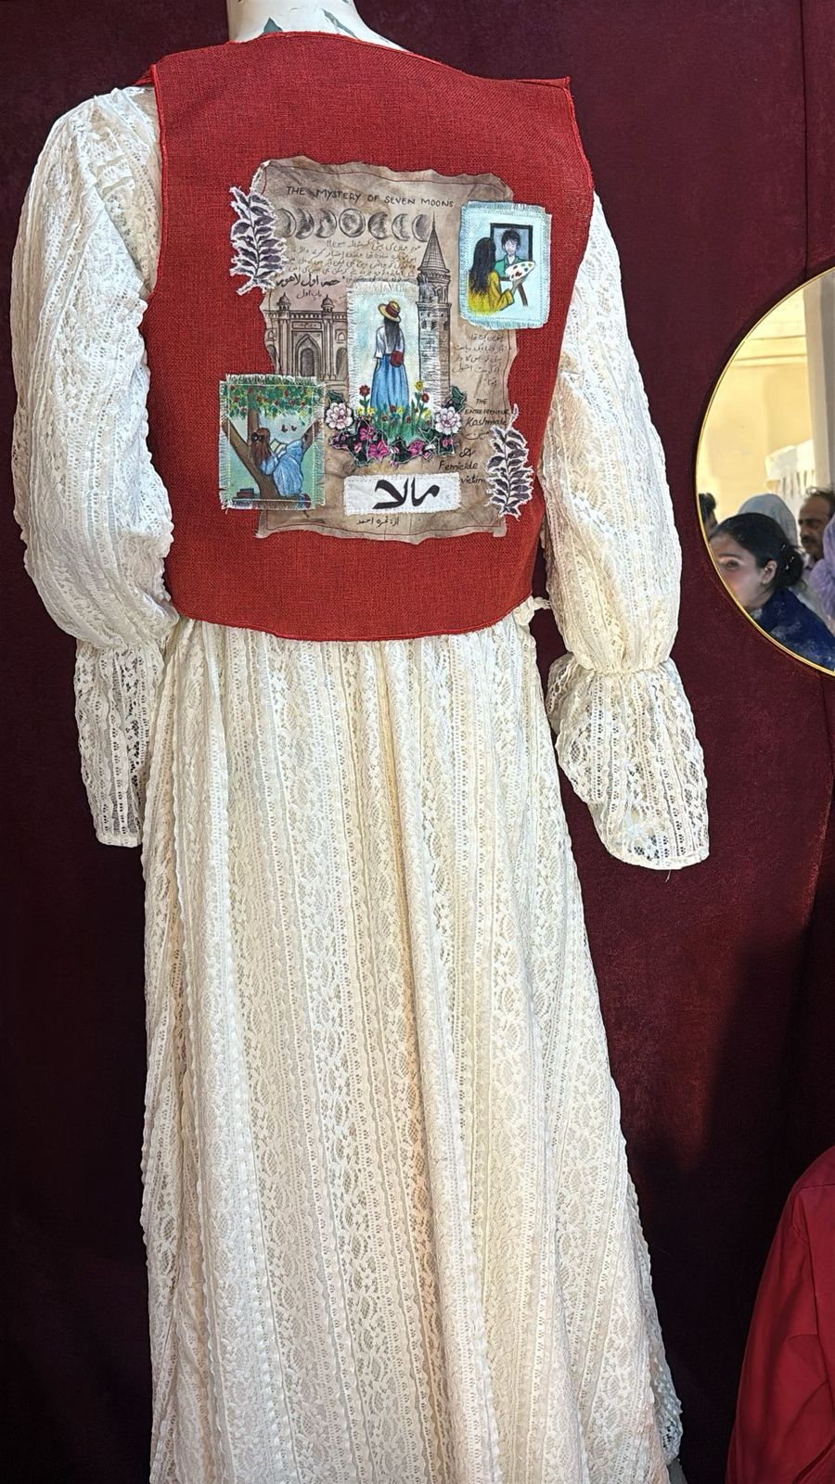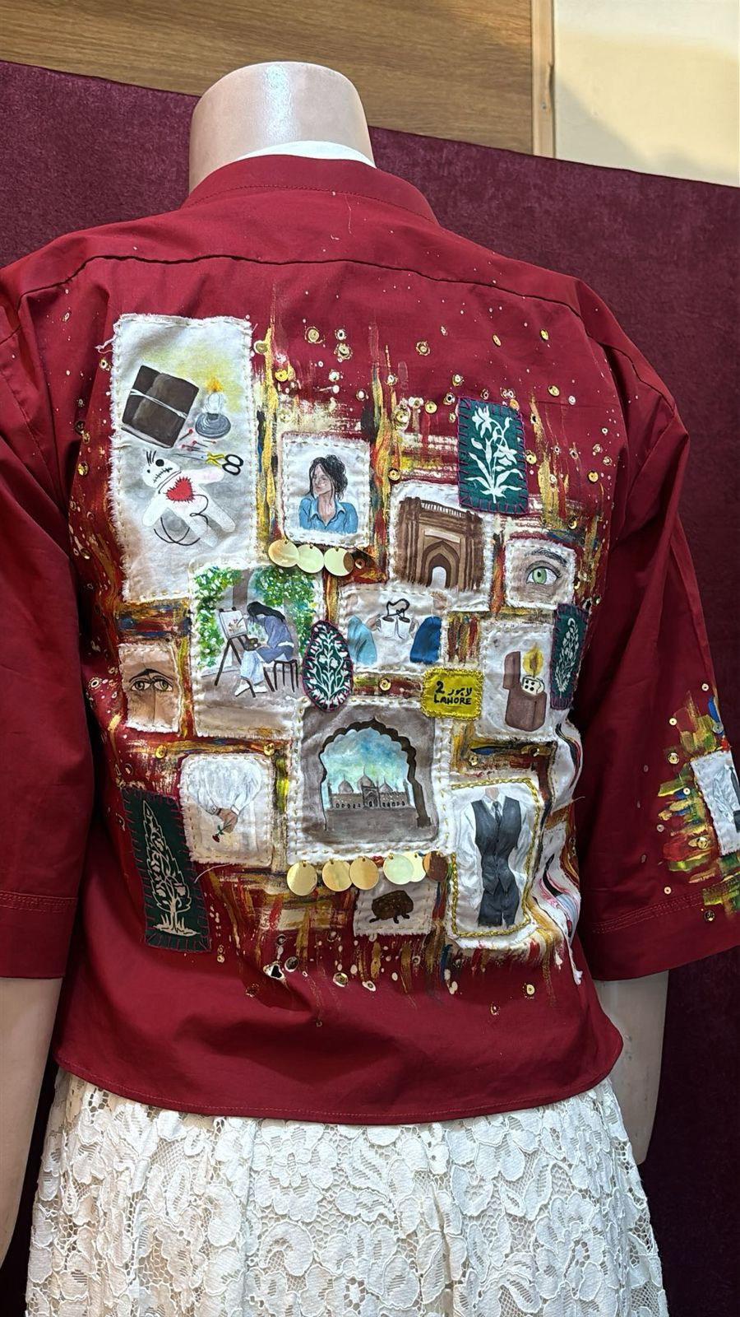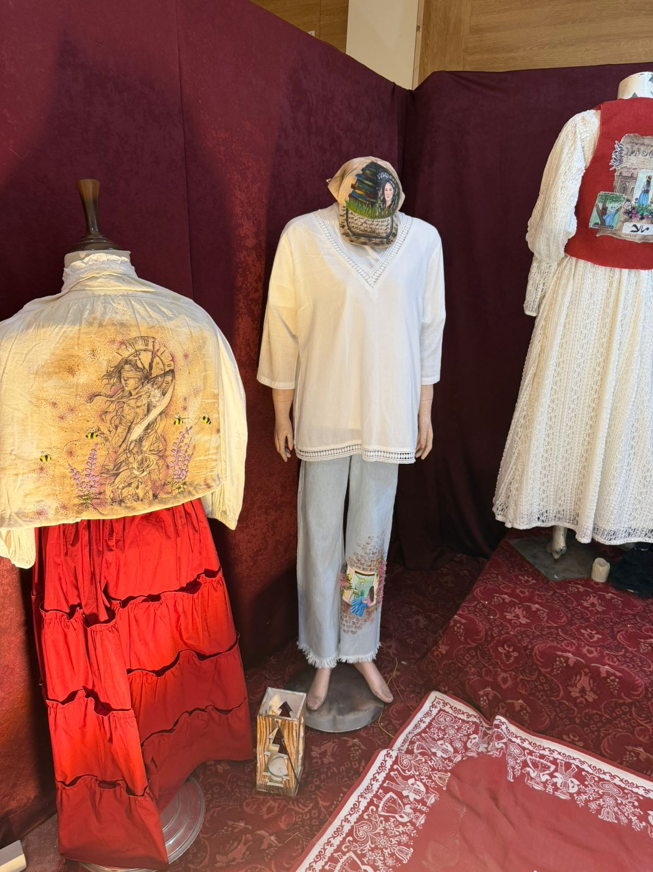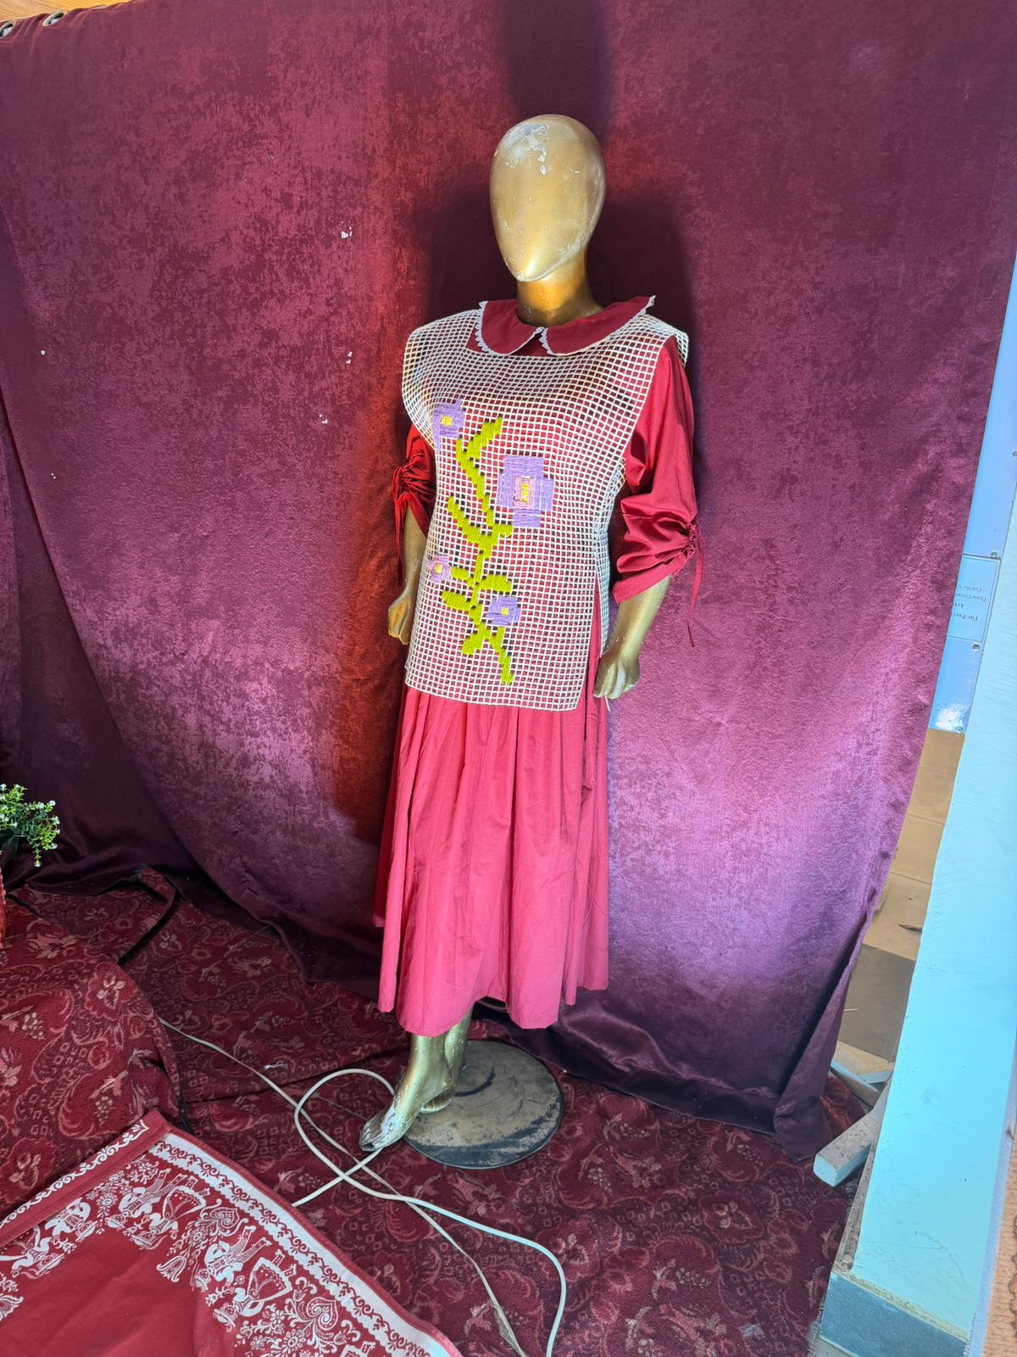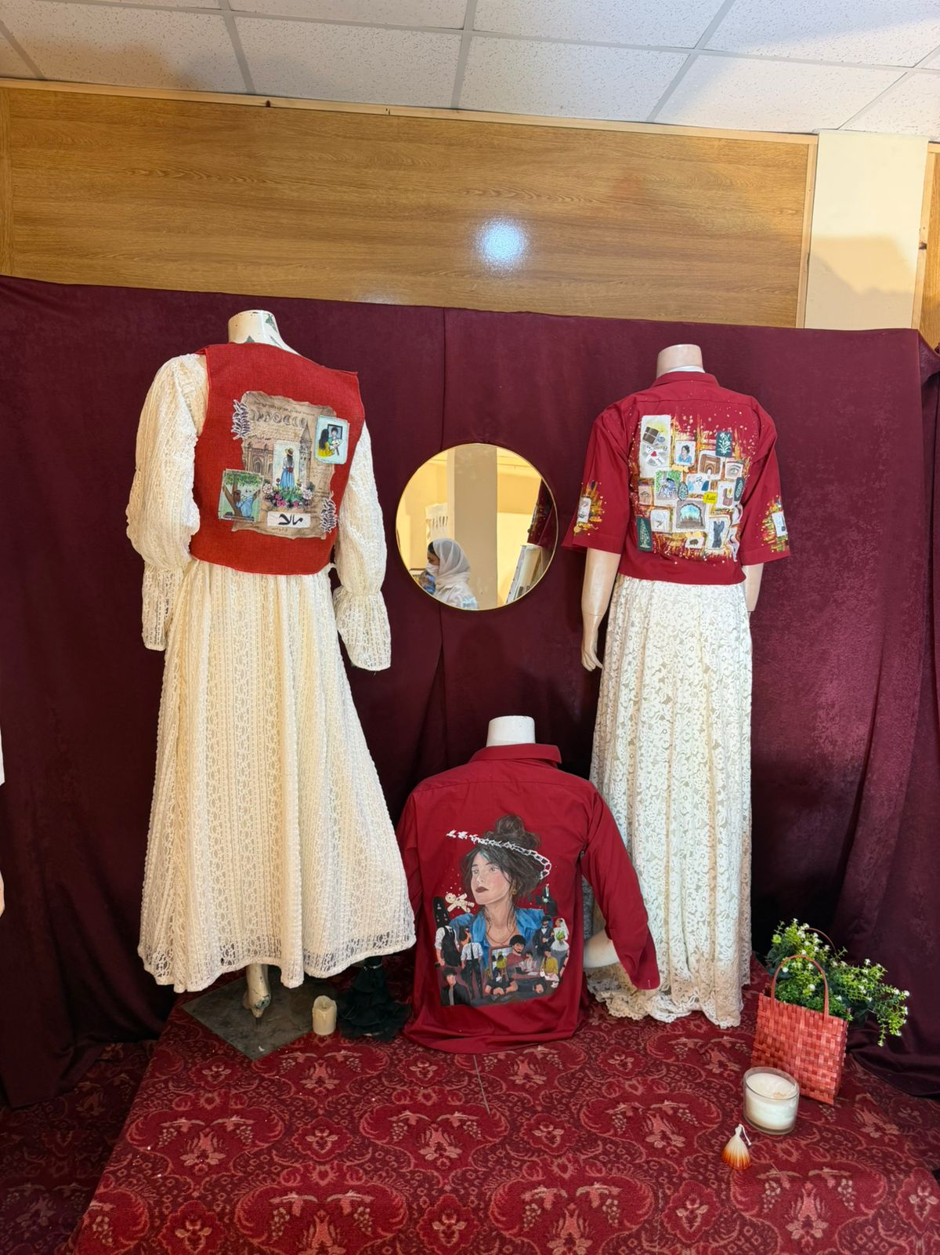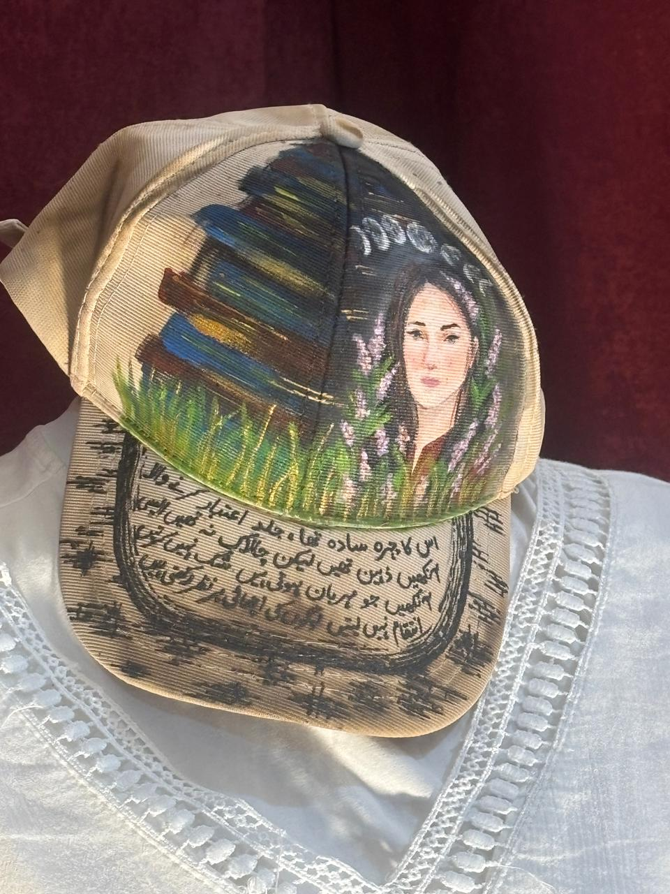

Chapter-5

CONCLUSION

5.1 SWOT Analysis

5.1.1 Strengths
The proposed textile design project, “From Narrative to Fabric: Textile Design Inspired by the Novel Maala,” had many strengths that supported its conceptual and practical outcomes. One of the main strengths was its strong narrative foundation, where the novel Maala provided rich emotional depth, symbolism, and storytelling structure that guided the entire design process. The project successfully translated literary content into textile-based visual expressions, making storytelling more tangible through fabric. Another strength was the use of diverse textile techniques such as freehand painting, batik, reverse batik, patchwork, embellishment, and tea and coffee dyeing, which allowed for rich surface experimentation and layered visual effects. The combination of traditional and experimental methods strengthened the uniqueness and conceptual value of the designs. The work also demonstrated how garments can function as narrative carriers, transforming literature into wearable visual stories. In the future, this approach has strong potential in conceptual fashion, exhibition work, and narrative-driven textile collections.

5.1.2 Weaknesses
The study also identified some limitations in the textile design process. One of the main weaknesses was the difficulty in fully translating complex emotions and abstract narrative elements from the novel Maala into clear visual textile forms. Some symbolic meanings required interpretation, which made direct representation challenging. Another limitation was the time-consuming nature of manual textile techniques such as dyeing, painting, and embellishment, which restricted the number of fully developed final garments. Variations in fabric behavior, dye absorption, and layering effects also created inconsistencies in some samples. At the current stage, the project remained practice-based and exploratory and had not been evaluated through audience feedback or commercial testing. Further refinement and extended experimentation would improve technical precision and design outcomes.

5.1.3 Opportunities
The research highlighted several opportunities for future development in textile and fashion design. Narrative-based textile design has strong potential in contemporary fashion, art exhibitions, and cultural storytelling projects. The concept of transforming literature into fabric can be expanded into larger fashion collections, museum displays, and interdisciplinary art practices. Experimental techniques such as tea and coffee dyeing can also contribute to sustainable and eco-friendly textile practices. There is further opportunity to collaborate with fashion designers, textile industries, and literary platforms to create culturally rich and concept-driven collections. Digital textile printing and mixed-media approaches can also be integrated in future research to expand visual possibilities and production methods.

5.1.4 Threats
The project may also face certain external challenges. One major threat is the dominance of fast fashion and mass production, which often undervalues conceptual and handmade textile work. Another challenge is strong competition within the fashion and textile industry, where many designers are also exploring narrative and experimental design approaches. The increasing use of digital production methods may also reduce appreciation for traditional textile techniques. Additionally, misinterpretation of narrative themes by viewers may affect the intended meaning of the designs. In the future, maintaining originality, strong conceptual clarity, and proper documentation will be essential to overcome these challenges.

5.2 Introduction
This chapter discusses the major findings of the study in relation to the research objectives, conceptual framework, and practical textile development process. It explains how the narrative of the novel Maala was transformed into textile design through experimental surface techniques and practice-based studio work. The discussion highlights the contribution of the research to narrative-based textile design and creative practice-led research.

5.3 Discussion of Major Findings
The findings demonstrated that literary narratives can be effectively translated into textile design through conceptual analysis and material experimentation. The novel Maala provided strong emotional, symbolic, and thematic content that influenced color selection, texture development, and overall design direction. This supports existing design theories that emphasize storytelling as an important aspect of textile practice.
The study also revealed that textile techniques such as batik, reverse batik, patchwork, freehand painting, and embellishment are effective tools for narrative expression. Each technique contributed differently to storytelling, where painting expressed direct emotion, batik created layered depth, and patchwork represented fragmented narrative structures. Tea and coffee dyeing added an aged, paper-like effect that strengthened the connection between literature and fabric.
Another important finding was that practice-based research allows continuous learning through experimentation and reflection. The iterative process of sampling, revising, and refining played a key role in improving the quality of textile outcomes. This supports the idea that creative practice itself is a valid form of research.
The study also found that emotional expression in textile design is strongly influenced by texture, layering, and color harmony. Muted and soft tones helped communicate emotional depth and narrative atmosphere, while layered surfaces added symbolic meaning and visual complexity.
Overall, the findings suggest that narrative-based textile design is an effective approach for creating meaningful, expressive, and concept-driven garments.

5.4 Practical Implications
The findings of this study provide valuable insights for textile designers, fashion students, and creative practitioners. Designers should integrate narrative thinking into textile development to create more meaningful and expressive outcomes. The study highlights the importance of combining traditional techniques with experimental approaches to achieve innovative textile surfaces. Educational institutions can also use narrative-based textile design as a method to teach conceptual development, visual storytelling, and material experimentation. Additionally, sustainable practices such as natural dyeing can be further explored in eco-conscious textile design.

5.5 Limitations of the Study
This study was limited to a single literary source, the novel Maala, which restricts the findings to one narrative context. The research was practice-based and qualitative in nature, meaning the outcomes are interpretive and subjective. Time limitations restricted the number of final garments and samples developed during the study. Additionally, the research did not include audience evaluation or commercial testing of the final textile collection.

5.6 Recommendations for Future Research
Future researchers may explore multiple literary texts for comparative narrative-based textile design studies. Further research can also investigate the integration of digital textile printing with traditional hand techniques to expand creative possibilities. Studies on sustainable textile practices using natural dyes and recycled materials can strengthen environmental aspects of design. Additionally, audience perception studies may help understand how viewers interpret narrative-based textile garments.

5.7 Conclusion
The study concludes that textile design can function as a powerful storytelling medium by transforming literary narratives into visual and tactile forms. The novel Maala provided a strong conceptual foundation for exploring emotion, symbolism, and narrative structure through fabric. The research demonstrated that techniques such as freehand painting, batik, reverse batik, patchwork, embellishment, and tea and coffee dyeing can successfully translate literary ideas into expressive textile surfaces.
The findings showed that narrative-based textile design enhances creativity, conceptual thinking, and emotional expression in garment development. The integration of storytelling with material experimentation allowed the creation of meaningful textile pieces that go beyond decorative value. Overall, the study contributes to textile design practice by presenting a method that bridges literature and fabric, showing that garments can serve as visual narratives carrying emotional and conceptual meaning.

REFERENCES
Adamson, G. (2013). The invention of craft. Bloomsbury.
Barnard, M. (2002). Fashion as communication. Routledge.
Barrett, E., & Bolt, B. (2010). Practice as research: Approaches to creative arts enquiry. I.B. Tauris.
Bastola, M. U. (2021). Formulation and writing of the discussion section in a research dissertation.
Bishop, C. (2012). Artificial hells: Participatory art and the politics of spectatorship. Verso.
Clark, H., & Brody, D. (Eds.). (2009). Design studies: A reader. Berg.
Cross, N. (2011). Design thinking: Understanding how designers think and work. Berg.
Dissanayake, E. (2000). Art and intimacy: How the arts began. University of Washington Press.
Fletcher, K. (2014). Sustainable fashion and textiles: Design journeys. Routledge.
Ginsburg, M. (2009). The fabric of cultures: Fashion, identity and globalization. Routledge.
Golden-Biddle, K., & Locke, K. (2007). Composing qualitative research (2nd ed.). SAGE Publications.
Gray, C., & Malins, J. (2004). Visualizing research: A guide to the research process in art and design. Ashgate.
Gwilt, A. (2014). Fashion design for living. Routledge.
Ingold, T. (2013). Making: Anthropology, archaeology, art and architecture. Routledge.
Kawamura, Y. (2018). Fashion-ology: An introduction to fashion studies. Bloomsbury.
Kvale, S., & Brinkmann, S. (2009). InterViews: Learning the craft of qualitative research interviewing. SAGE Publications.
Labani, A., & Wadhwa, G. (2022). How to write the results section of a research paper. Indian Journal of Continuing Nursing Education.
Lancaster, G. (2015). The discussion chapter in a thesis. University of the West of England.
Lawson, B. (2006). How designers think. Routledge.
Leavy, P. (2015). Method meets art: Arts-based research practice. Guilford Press.
Masibo, E. M. (2023). Common mistakes to avoid in the writing and presentation of research findings results and discussion.
McLuhan, M. (1964). Understanding media: The extensions of man. McGraw-Hill.
Nimkulrat, N. (2012). Hands-on intellect: Integrating craft practice into design research. International Journal of Design, 6(3).
Oyibo, S. O. (2024). Demystifying research: How to write the results presentation and discussion chapters.
Prown, J. D. (1982). Mind in matter: An introduction to material culture theory and method. Winterthur Portfolio, 17(1), 1–19.
Pykett, A. (2016). Narrative and textiles: Storytelling through fabric. Textile: The Journal of Cloth and Culture.
Riley, S. (2008). Contemporary art and the cinema. Manchester University Press.
Sanders, E. B.-N., & Stappers, P. J. (2008). Co-creation and the new landscapes of design. CoDesign, 4(1), 5–18.
Schön, D. A. (1983). The reflective practitioner. Basic Books.
Schwarz, M. (2016). Textile culture: Materiality and identity. Bloomsbury.
Sennett, R. (2008). The craftsman. Yale University Press.
Shenoy, S. (2024). How to write the results findings section of a research paper. Paperpal Blog.
Steedman, C. (2001). Dust: The archive and cultural history. Rutgers University Press.
Sullivan, G. (2010). Art practice as research: Inquiry in visual arts. SAGE Publications.
Thomson, P., & Kamler, B. (2016). Detox your writing: Strategies for doctoral researchers. Routledge.
Tilley, C. (2006). Handbook of material culture. SAGE Publications.
Turner, V. (1982). From ritual to theatre. PAJ Publications.
Udale, J. (2014). Textiles and fashion. Bloomsbury.
Wong, W. (1993). Principles of form and design. Wiley.

